The Project Gutenberg EBook of Blood Brothers, by Colonel Eugene C. Jacobs

This eBook is for the use of anyone anywhere at no cost and with
almost no restrictions whatsoever. You may copy it, give it away or
re-use it under the terms of the Project Gutenberg License included
with this eBook or online at www.gutenberg.org

** This is a COPYRIGHTED Project Gutenberg eBook, Details Below **
** Please follow the copyright guidelines in this file. **

Title: Blood Brothers

Author: Colonel Eugene C. Jacobs

Posting Date: August 13, 2012 [EBook #8423]
Release Date: July, 2005
First Posted: July 9, 2003

Language: English

Character set encoding: ISO-8859-1

*** START OF THIS PROJECT GUTENBERG EBOOK BLOOD BROTHERS ***

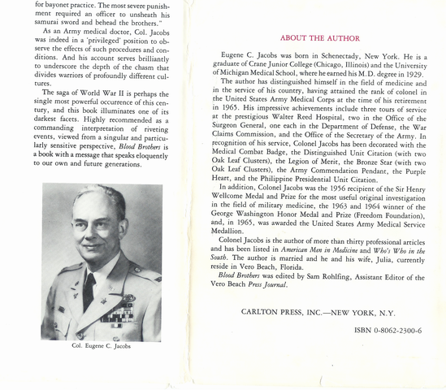
BLOOD BROTHERS

A Medic's Sketch Book

By

Colonel Eugene C. Jacobs

Edited by Sam Rohlfing,
Vero Beach, Florida

A Hearthstone Book

Carlton Press, Inc. New York, N.Y.
DEDICATION

To my wife, Judy, a beautiful person.

Limited Edition

© 1985 by Colonel Eugene C. Jacobs
ALL RIGHTS RESERVED
Manufactured in the United States of America
ISBN 0-8062-2300-6
PREFACE*

The purpose of Blood Brothers is to acquaint the reader with a series of harrowing incidents experienced by the isolated U.S. Armed Forces in the Far East during World War II.
We might well be voicing the words of Saint Paul which were recorded in his Second Letter to the Corinthians, Chapter I) verse 8:
"For we would not, brethren, have you ignorant of our trouble which came to us in Asia, that we were pressed out of measure, above strength, insomuch that we despaired even of life!”
Of his First Guerrilla Regiment, General Douglas MacArthur stated that "He had acquired a force behind the Japanese lines that would have a far reaching effect on the war in the days to come"; that it had kept "Freedom's Flames burning brightly throughout the Philippines"; that it had produced a "human drama with few parallels in military history"; and later, during the landing in Lingayen Gulf, had "accomplished the purposes of practically a front line division."
MacArthur further stated that "the courageous and splendid resistance maintained by you and your command filled me with pride and satisfaction."
Of the Hell Ship Oryoku Maru, Gen. James O. Gillespie stated "it was probably the most horrible story of suffering endured by prisoners of war during World War II."
Gen. John Beall further stated, "You say a lot of things that need to be said, lest the United States forgets the horrors of the way the Japanese treated our prisoners."
In writing Blood Brothers, I found it necessary to resort to frequent flashbacks; and to keep the reader aware of the history taking place around the world, I tried to make reference to these

"General Harold K. Johnson, a former Chief of Staff of the United States Army, had been a former Japanese prisoner-of-war, had experienced each and every event as it happened to other P.O.W.s, and had been an excellent friend through more than thirty years of Army service; he had agreed to write this PREFACE; unfortunately, this was followed by a long hospitalization ending in terminal cancer.
events as they happened, even when they were merely rumors.
This story has not been pleasant to write; I'm glad it is finally finished.
In Blood Brothers, there are no heroes. The survivors of the Philippines arrived home in 1945, quietly and without recognition, to be admitted to hospitals near their homes.
With winners and heroes everywhere, there was no time for "Losers.”

Eugene C. Jacobs

"Our senses can grasp nothing that is extreme! Too much noise deafens us! Too much light blinds us! Too far or too near prevents our seeing! Too long or too short is beyond understanding! Too much truth stuns us!"

Blaise Pascal

CONTENTS

I Bombs Fall on Camp John Hay, Rest
and Recreation Center, in the Philippines............................... 9
II The Orange Plan (WPO III)…................................................. 20
III MacArthur's First Guerrilla Regiment………………………. 29
Col. Warner Surrenders the 14th Infantry…………………… 39
Japanese Prisoner of War Camp No.1, Cabanatuan……….... 43
IV Japanese Atrocities……………………………………..…… 73
V Americans……………………………………………………. 76
VI "Old" Bilibid Prison................................................................. 78
VII Japan Detail - Oriental Tour – Strictly Third Class…….......... 81
X Japan……………………………………………………........ 100
XI Camp Hoten, Mukden, Manchuria…………………………... 104
XII Japan Surrenders …………………………………………….. 108
XIII Start Home …………………………………………………… 110
XIV The Good Old U.S.A………………………………………… 114
XV Borrowed Time………………………………………………. 116
Appendix …………………………………………………………… 122
Acknowledgments…………………………………………………. 123
*MY SKETCHES

During the first few weeks of our incarceration in Japanese Prisoner-of-War Camp No.1 in the Philippines, 1,500 (25% of our 6,000 captives) died of starvation, malnutrition, various vitamin deficiencies, malaria, diphtheria and various wounds that would not heal. I knew that within another 6 to 8 months, we would all be dead, and there would be no record of it. There was no paper to keep any record of events.
Within a few weeks, I was able to obtain a" nickel school notebook. In it, I drew many sketches, depicting the lifestyle in prison camp.
Of course, I had to be secretive. There was a penalty for keeping records in camp; if I'd been caught, I would have been beheaded.
By the time we were being processed for transfer to Old Bilibid Prison in late October 1944, I had made some 110 sketches. I rolled them up and placed them in a Mason jar. I buried the jar at the east end of building No. 12, planning to come back after the war and dig it up.

...
When the war was over, I was flown from Mukden, Manchuria to Kunming, China and on to Manila, P.I., where I was housed in a tent at Reple Depot # 29 south of the city. The next day I was flown in a Piper Cub back to Cabanatuan to look for my drawings, landing at an airfield we had built as prisoner-labor. A battalion of Engineers furnished a bulldozer.
The camp buildings were all gone. I figured out where building # 12 had been. We dug for hours and found nothing.
As fate would have it, one year after I returned to Active Duty at Walter Reed General Hospital in Washington, D.C., I located my 110 sketches at the Pentagon. MacArthur's Sixth Army Rangers had retrieved the buried drawings when they liberated Camp #1 in late January 1945.
All of my sketches had been carefully numbered, and marked on the back "Unidentified Artist." I had been officially declared an artist.
INTRODUCTION

In Japanese prisoner of war camps, all prisoners were divided into groups of ten, called "blood brothers."
If anyone of the ten "blood brothers" made any attempt to escape, the other nine would be punished "Sevelery!"
Typical punishments:
Tie the blood brothers to fence posts and require each passing Japanese soldier to slap and kick them.
More severe punishment required recruits to use the bound brothers for bayonet practice.
The most severe punishment required an officer to unsheathe his samurai sword and behead the "brothers."
My ten blood brothers, all Medical Officers of the Regular Army, were:
Lt. Col. William Draper North
Major James Bahrenberg
Wilbur Berry
Wesley Bertz*
Eugene Jacobs
Emmert Lentz
Steven Sitter
Clarence Strand *
Clarence White*
Captain Robert Lewis

The blood brothers with the asterisk (*) were killed or died on "Hell Ships" enroute to Japan.
The other brothers survived the rigors of Bataan, the "Death March" Japanese prison camps, labor details, the "farm," and "Hell Ships" to return to the United States. Since the war, all have died, except the author, who is anxious to tell his story before the first reunion of the "brothers."
STAFF Camp John Hay Baguio, Mountain Province, P.I.

Lt. Col. John P Horan, Commanding Officer
Capt. Hubert (Sandy) Ketchum (Cav. Adjutant)
Major Henderson Allen, (Q.M.C.) Supply
Major James Blanning (Cav.)
Major Ronald McDonald, Company A
Captain Ralph Rumbold, Company B
Captain Francis Fellows, Post Exchange Officer
Captain Everett Warner, Provost Officer
Captain Parker Calvert,
Captain Eugene C. Jacobs, Post Surgeon and Hospital Commander
Captain Ruby Bradley, A.N.C., Chief Nurse
Lieut. Beatrice Chambers, A.N.C.
Lieut. Clifford Simenson, Enlisted Men's Dormitories
Lieut. Harold Everman, Signal Officer
Lieut. Cowan,
Lieut. Evans,
Sgt. R.M. Trent
Sgt. Bennet
Sgt. King
Sgt. Hayes
Sgt. Beck
Sgt. Farmer
Sgt. Sibert
Sgt. Adkins

Regret that I can not remember the names of some 200 others on duty at Camp John Hay; they were all very dedicated personnel.
Chapter I
BOMBS FALL ON CAMP JOHN HAY, REST AND RECREATION CENTER IN THE PHILIPPINES

The phone next to my bed was ringing with a great deal of determination. Half-asleep, I raised the receiver:
"WE ARE AT WAR WITH JAPAN! PEARL HARBOR IS BEING BOMBED! REPORT TO HEADQUARTERS AT ONCE!" It was 0500 hours, December 8th, 1941.
Hawaiian time, it was 1030 hours, December 7th. The bombing was still going on, lasting from 0755 to 1050 hours.
Greatly surprised and quite groggy, I tried to collect my thoughts while getting into my freshly starched uniform, Medical Corps, U.S. Army: "Knocking out the Pacific Fleet at Pearl Harbor could clear the way for Japan to conquer the Philippine Islands, without any outside interference. Of all the Pacific territories of the United States, the Japanese most wanted the Philippines. General MacArthur, as well as the Japanese, believed that the Philippine Islands were the 'Key to the Orient'; Japan would have to take the Philippines before attempting to conquer any other countries in Southeast Asia. Some Navy admirals had recently remarked that the 'Pacific Fleet belongs in San Diego!' If the Japanese should sink one ship in Pearl Harbor (the so-called Mouse Trap), they could bottle up the entire fleet. Now, with the Pacific Fleet crippled, there could be no rescue attempt. For several years we had been aware that in the event of an invasion, all our defending military forces would hole-up on the Bataan Peninsula, where supplies and equipment had previously been stored, until the U.S. Navy, the most powerful in the world, could come to our rescue (Orange Plan-WPO III). "
By 0530 hours, I was standing in the office of Lt. Col. John Horan, Post Commander of Camp John Hay, waiting for instructions. I was a captain and a doctor, the C.O. of the thirty five bed station hospital.
Saluting the colonel, I was told to sit down and wait for further instructions. It was dark and cold. Maps and orders were on the colonel's dimly lighted desk. Other officers were beginning to arrive.
Don Bell's voice blared forth from Radio KZRH in Manila: "Those dirty little bastards have struck Pearl Harbor! Reports remain sketchy, but there is no doubt! “Oh God!" Bell was actually crying, near hysteria, as he continued: "The yellow-bellied Japs have hit our ships at anchor!"
Everyone was extremely excited; the air was becoming blue with cigarette smoke. No one was talking; we were all intently listening-for any late news. Several junior officers were openly nipping on pocket flasks. I thought to myself, "This is one time when I'm going to need all my marbles." We had recently returned two junior officers for alcoholism; they couldn't cope with the tropics even in peacetime. Or did they outsmart me and get back to the States to sit out the war?
No news was coming in; we were all anxious to get back to our units to make necessary preparations for war, but had to await instructions. For months we had anticipated war with Japan. We were the nearest U.S. base to Japan, so were very sensitive to any war-like talk or gestures. Actually, the thoughts of war hadn't bothered me too much; a farmer had once told me, "If you are going to get kicked by a mule, it is best to be close to the mule!" Over the last forty years, we knew the Japanese had been preparing for war, taking scrap iron and raw materials from the Philippines to Japan. Now, we had a strange feeling that we might be getting some of these materials back in a more sophisticated form.
We had no idea how, when or where this war would begin in the Philippines. The last place we expected it would happen was Camp John Hay, a Rest and Recreation Center (R.&R.), offering a delightful climate for military and naval personnel and their dependents on duty in the Far East, desiring temporary relief from the intense heat and humidity of the lowlands.
Camp John Hay was pleasantly located one mile above sea level amongst the pine trees of Mountain Province in Baguio, the summer capital of the Philippines. It was only twenty miles from the beautiful white sand beaches, the stately palms and the sweltering sun of Lingayen Gulf. Camp Hay actually had no real military value. It had been set
aside in 1903 as a recreation area by President Theodore Roosevelt, and named after his Secretary of State, John Milton Hay. The same year Roosevelt designated Baguio as the summer capital of the Philippines.
In December, 1941, there were only two companies of the 43rd Infantry of Philippine Scouts (P.S.), a housekeeping detachment, stationed there. The camp had no fortifications and no large weapons, only a few wooden barracks and some one hundred or so obsolete rifles of W. W. I. vintage. There was one small salute cannon for raising and lowering "Old Glory."
Looking back several months to July, 1941, when General MacArthur was appointed Commanding General of the U.S. Armed Forces in the Far East (USAFFE), he recruited 110,000 young Filipinos for the Philippine Army (P.A.). It would be many months before they could be trained as they spoke some sixty dialects. They looked more like boy scouts than soldiers with their fiber helmets, sport shirts and tennis shoes.
About the same time, War Plan Rainbow 5 was adopted by Roosevelt's Joint Army-Navy Board: first the Allies would conquer Germany and Italy. As for Japan, the Allied strategy in the Far East was purely defensive. MacArthur opposed the idea of the Philippines being abandoned, but agreed with the plan "to defend all Philippine soil." He told his officers: "The beaches must be defended at all costs; prevent the enemy from making any landing!"
We at Camp John Hay believed ourselves reasonably safe in this mountain resort, even when war seemed imminent. President Manuel Quezon also must have considered himself secure in Camp Hay as he was in residence at the beautiful presidential mansion.
Finally, Colonel Horan, standing tall behind his desk, announced: "I have been unable to obtain any new information from USAFFE in Manila. I understand the damage done to the Pacific Fleet in Pearl Harbor has been extensive. Captain Warner (CO. of Military Police (M.P.): take your M.P.s and any scouts that you need, round up all Japanese civilians in the Baguio area, and bring them into camp!
"Lieutenant Velasco: build an eight-foot fence around Barracks
8 and 9; confine all Japanese internees there!
"Other officers: acquaint your troops with the present war situation, and War Plan Rainbow 5. Stay near your telephones!"
At 0730 hours, with a lump in my throat and a complete loss
of appetite, I tried to swallow a few bites of breakfast at the Officers' Mess, overlooking the gorgeous valleys below. Everyone was excited, wondering what the next news would be. Normally I would have walked the few blocks from the hospital to the mess hall and back, just for the exercise; this morning I drove my1936 Model A coupe. Time might become very important at any moment.
At 0800 hours I was in my office in the hospital, on a hill overlooking Camp Hay, carefully studying my orders and maps.
At 0805 hours our two Army nurses, Captain Ruby Bradley and Lieutenant Beatrice Chambers, entered my office. I inquired, "Do you know that we are at war with Japan?"
Before either could answer, bombs were falling on all sides of the hospital. "There they are!" I exclaimed. Not yet realizing how dangerous the bombs could be, we casually walked to the windows and watched the tremendous explosions moving across the camp-toward headquarters-raising clouds of dust to the rooftops. The war arrived at Camp John Hay at 0809 hours, Dec. 8, 1941. Between twenty and twenty-five twin-engine bombers were overhead in a diamond formation. Soon some 150 bombs of various sizes were bringing disability and death to many of our soldiers-drilling on the parade ground-and to their families in their small homes. It seemed unreal that Camp Hay could be the first target of the Japanese bombers, actually starting World War II in the Philippines.
Where were our American planes? We probably did just what the Japanese planned that we would. We called Clark Air Field-about one-hundred miles to the southwest, and told them, "Camp John Hay is being bombed! Get some fighters up here, and keep those bombers away!"
We had no air-raid sirens, no machine guns, no anti-aircraft guns, nothing to deter them. We were surprised by the air attack, and even more by their accuracy. We heard the bombers were led by German pilots-possibly the very ones we were playing golf with the previous week.
If the Japanese thought that they would catch our military and naval officers on weekend leave at Camp Hay, they were fooled, as all personnel had previously been restricted to their stations and ships by a General Alert. Within thirty minutes, the U.S. fighters were circling overhead looking for Jap planes. Finding none, they returned to Clark Field just before noon to
gas up and get lunch. Along with thirty-five U.S. bombers, the fighters lined up on the runways, soon to be blasted by two waves of 50 heavy Japanese bombers. About the same time, Nichol's Field, Fort McKinley and Cavite Naval Station were being heavily bombed. Nearly half of the U.S. Army Air Corps planes were destroyed during the first day of war, the day before Congress declared war.
Wounded were now arriving at the hospital by every available vehicle. It was a horrible scene, an unforgettable sight, as corridors quickly filled with seriously wounded and dying soldiers, lying in puddles of blood, moaning, groaning, screaming, and begging for mercy.
Being the only Army doctor on Northern Luzon, I was to be tested as never before in my life. I was a Regular Army professional soldier, alone, and on my own. If we didn't act quickly, we would very soon have many dead patients. I had seen many bad auto accidents, but never anything like this. Shaking and woozy, I told myself, "This is no time to 'chicken out.' God, give me strength!"
Mustering my strongest voice, I screamed: "Everybody! Listen to me! These patients are all bleeding. We've got to stop the bleeding quickly - right now! Elevate extremities! Use anything you can get to stop the bleeding! Tourniquets! Compression bandages! Hemostats! Even your fingers, if they are clean! Bring all bad cases to the operating room!"
During the next thirty-two hours, our medical staff worked around the clock, applying tourniquets and compression bandages, amputating arms and legs (many dangling by only a few shreds of skin or tendons), tying off bleeders, giving tetanus shots, laying the dead in the garage for identification. As soon as we could get each patient through his emergency, we sent him by ambulance to one of the civilian hospitals in Baguio for definitive care, and a few miles distant from any future bombing.
I was very fortunate in obtaining Dr. Beulah Allen (the wife of our Post Quartermaster, Lt. Col. Henderson Allen), a retired surgeon, to assist me. She was a tower of strength. While Dr. Allen and I were operating, Civil War General Sherman's remarks that "War is hell!" kept haunting me.
I was extremely proud of my medics; we took care of wounds, the likes of which none of us had ever seen before! Periodically, a Jap plane would drop a bomb or two-to let us know the war
was still on. They did little damage. After we had our wounded taken care of to the best of our ability, we dared to look outside to see the thirty-foot craters and damaged buildings near the hospital.
For the first time, I realized that I was frightened. I could have been in one of those buildings, or walking across the areas where the craters were.
Dee. 9, 1941: At night our medical teams returned to their individual quarters for their first rest since the bombing exhausted and giddy. I turned on my little radio. Although the signal was badly jammed by the Japanese as it had been for several months, I was able to make out that Congress had declared war on Japan at 1610 hours on December 8, 1941, (0500 hours, Dec. 9 Philippine time). Now it was OK for us to shoot back at the Japs! But with what? I also learned that the Japs had landed large forces in French Indochina.
I was quite sure that all commercial communications with the States had been cut off, but I called the radio station to send a message to my wife, Judy, a teacher at Holton Arms School in Washington, D.C., that I was OK.
Judy and I had arrived in Manila on July 20, 1940, after a delightful trip from New York City through the Panama Canal on the U. S. Army Transport Republic bound for San Francisco, and on the U.S.A.T. Grant via Hawaii, Guam and Manila. We got to see two World's Fairs (New York and San Francisco). It was really our honeymoon, as we had previously been too poor to afford one.
During the six weeks we were on the high seas, history had been taking place. Hitler's armies had blitzkrieged through Holland, Belgium and France; the British Army had a forced evacuation from Dunkirk in an armada of small boats. Mussolini had declared war on Britain and France (actually stabbing France in the back while she was on her knees). Hitler's bombers were causing havoc in England, and his submarines were sinking many Allied ships in the Atlantic. Tojo was vigorously continuing his "undeclared wars" in Manchuria and China. Churchill said, "We shall seek no terms; we shall ask no mercy."
Roosevelt, preoccupied by presidential elections, was finally becoming aware of Hitler's threat to democracy. He called up volunteers for the Army; he further prepared for war by agreeing to transfer many planes, tanks and some sixty reconditioned
destroyers to Britain.
Our ships bound for the Philippines had large U.S. flags painted on each side lighted at night. We were wary of subs as they had been busy in the Atlantic. We were beginning to get the feeling that maybe this would not be the "happy honeymoon" that we had planned. And yet, war seemed so very "far away."
December 10, 1941: Several bombings with little damage, a few wounded. We did our best to make them comfortable. We learned that President Quezon had departed from Camp Hay soon after the first bombing for the Malacanong Palace in Manila. The Japanese would probably spare the palace for their own use.
During free moments, of which there were very few, I instructed our medics in first aid, litter drill over mountain trails, etc. I did all of the things that I could think of in preparation for war: drew money out of the bank; got some new field boots and field uniforms from the clothing store, packed my bedding roll with soap, toothpaste, razor, towels, etc., and put fresh medicines in my little black doctor's bag given to me by Dr. Eugene Stafford, who had retired in Baguio after a distinguished career at the Mayo Clinic. I moved my furniture to his house for safekeeping until after the war.
I had to go over to the Japanese barracks to inspect some two-hundred internees (civilian prisoners). They had staked out a big Japanese flag on the ground for planes to see, for their own protection.
One of the Japanese prisoners was brought to me with a severe sore throat. Examination showed a peritonsillar abscess. The treatment would be to lance the abscess and let the pus out. He was the first real live Jap that I had ever met face-to-face. I attempted to explain his condition to him. I proceeded to cut his throat with a surgical knife. He had considerable pain for an instant, then considerable relief. I gave him an analgesic and a sedative. He seemed grateful, shook my hand and said, "Arigato vely much!" as he bowed deeply and departed for his bed.
Some gold-mining engineers, friends of Col. Horan, built an "entrance to a mine" some thirty feet back into a hillside in the center of camp for an air-raid shelter. It proved to be very good, but we nearly broke a leg each time we raced a bomb down the hill to the entrance.
That night our radio told us that the Japs had made landings
at Aparri, on the north coast of Luzon, and had actually landed two thousand soldiers at Vigan on the northwest coast. It sounded like they had landed without any resistance. These two cities were only two or three marching days from Baguio. Was the Rainbow war plan not working?
News was received that Hong Kong and Wake Island had been captured. Also, that the British battleships, HMS Repulse and HMS Prince of Wales, had been easily sunk off the Malayan coast by Japanese planes.
We heard many unusual noises about camp, especially at night, and saw strange lights that we thought might be signals. We became suspicious of everything that moved in camp, especially any moving troops, until we were sure that they were ours.
I couldn't sleep! As I lay in bed, I recalled how I'd been assigned to Camp Hay from the Medical Regiment at Fort McKinley, near Manila. Col. Wibb Cooper, the Philippine Dept. Surgeon, picked me out of some one hundred medical officers because I had just enough time to do on my tour in the Philippines, not too little, not too much medical training and experience, just enough responsibility, personality, sociability, etc. I was to be the only U.S. medical officer north of Fort Stotsenberg one hundred miles to the southwest. I was to be the nearest U.S. doctor to Japan.
Camp Hay met all my expectations: delightful wooded areas, friendly people, a fine, well-equipped station hospital and a well-trained staff. I was invited to the Rotary Club for dinner with the American operators of the nearby gold mines and lumber companies in the valleys below. They all seemed anxious to know the only U.S. doctor. Retired Major Emil Speth, the mayor of Baguio, took me in tow and saw that I met everyone who was important.
During three months prior to the war, General MacArthur, the Commanding General of USAFFE, conducted a "War School' for his general officers at Camp Hay. During the school period, I got to meet and visit with most of the generals and their aides-either at the hospital or the Officers' Mess. I was their "Medic!"
Several weeks prior to the war, some British officers' wives from Hong Kong arrived in Baguio, a supposedly safe place to sit out the war. Our student generals seemed to think the "lady limeys" had been sent over for their dining and dancing pleasure
at the Pines Hotel. Camp Hay was almost a perfect setting almost too good to be true except for one thing. In May, 1941, President Roosevelt suddenly ended our honeymoon, sending all of the Army wives back to the States.
It was two very unhappy people standing on Pier Seven in Manila, wondering if they would ever see each other again, if the U.S.A.T. Washington could outmaneuver the subs in the Pacific, and if our U.S. Army could survive a frontal attack by the Japanese.
Roosevelt must have known the war was coming. In 1937 he branded the Japanese as "aggressors" in their undeclared war in China and called for quarantine against her. The Japanese answered him by sinking the U.S.S. Panay and machine-gunning her crew.
In the late '30s, with the world situation becoming increasingly dangerous, Germany and Italy both arming in Europe, and Japan increasing its manpower, Roosevelt wanted to cut the Regular Army by 51 %, the National Guard by 35% and the Reserves by 33% in order to balance his budget. It seems he was rather naive, 'or possibly just the politician worrying about reelection.
Gen. MacArthur, who was Chief of Staff of the Army at the time, told Roosevelt, "Mr. President, when the next war is lost, it will be Roosevelt's War, not MacArthur's." Fortunately, MacArthur was able to save the Army from the cuts.
In Sept, 1940, Germany, Italy and Japan signed the Tripartite Pact. In July, 1941, Roosevelt told Gen. Marshall to draw up war plans. With his assistants, Gen. Wedemeyer and Gen. Gerow; they concluded that Hitler was the enemy to be stopped Japan and Italy could come later.
It was Roosevelt who said, "In politics, nothing happens by accident! You can bet it was planned!"
In July, 1941, Roosevelt again placed sanctions against Japan to keep U. S. oil, scrap iron and raw materials from reaching her shores. He issued several executive directives which made war between the U.S. and Japan inevitable. He froze all assets in the U.S. He closed the Panama Canal to Japanese shipping.
In August, 1941, Roosevelt placed an embargo on all goods except food. During the same month the United States cracked the Japanese code, after which he knew what Tokyo was thinking,
Japan reported that "Roosevelt's decisions had created a situation so horribly strained that we cannot endure it much longer."
Tojo immediately called another million reservists to the colors.
John Costello, a British historian, said that Roosevelt received a positive war warning on Nov. 26, and possibly as early as Nov. 6th that war would break out on Dee. 7th. He stated, "Roosevelt was not only expecting war, but knew exactly when it would break out." Even with the Japanese Fleet approaching Pearl Harbor, Roosevelt issued explicit orders to the military: "Do not initiate hostilities against Japanese under any circumstances!" It now seems that Roosevelt not only expected the "Day of Infamy," but needed it to get the support of the American people, to get them sufficiently aroused to fight a war. He also wanted to be sure that Japan would be branded "the aggressor."
That night the radio announced that the "Japanese have marched from Aparri (on the north coast of Luzon) to Tuguegarao and have activated the airfield." Now we could expect more frequent bombing.
"Tokyo Rose" was urging us to surrender, or, "Experience a certain death!" She continued: "All American aid is going to Europe! America is giving Lend-lease aid to Britain and to Russia, but there is none for the Philippines." She was right!
December 12, '41: Dr. Allen and I had a Filipino soldier's wife on the operating table at 0800 hours ready for a sterilization operation. She was thirty-four years old and had seventeen children. During her last pregnancy, which she had delivered ten days before, she became greatly swollen with edema (severe kidney disease). Another pregnancy would probably kill her.
Bomb began to fall. I shouted, "Everybody downstairs-under the hospital!" After the" All Clear," we returned to the operating room to find our patient had retrieved her clothing and departed for safer areas.
Again the wounded were coming in. This time we were ready
for them. The operating room was all set up and ready to go.
Radio from USAFFE: Capt. Eugene C Jacobs, M.C, promoted to Major.
Heard that a strong Japanese force had landed at Legaspi accompanied by a large naval escort.
During the next ten days, while we treated our sick and wounded, and buried our dead, nearly one-hundred various sized Japanese ships were quietly assembling in the Lingayen Gulf, only twenty-five miles from Baguio. We had neither airpower nor naval forces to deter them. The Army Air Corps had been about
75% destroyed, and Admiral Hart would not risk his small Asiatic Fleet in battle; he took off for Australia.
At dawn on the morning of Dec. 22, '41, some 60,000 veteran Nipponese troops of Lt. Gen. Masahatu Homma's crack 14th Army from China swarmed ashore between Vigan and Dagupun, twenty-five to fifty miles from Baguio.
Maj. Gen. Jonathan Wainwright had four divisions (11th, 21st, 31st, and 1 10th) of the Philippine Army on the beaches to prevent a landing. When the cruisers and destroyers opened fire with their big guns, there was great confusion on the beaches; many recent recruits buried their rifles in the sand, and took off for the mountains. "This was not their kind of war!"
Soon thousands of Japanese veterans, on bicycles, were pedaling south on the highway bordering the South China Sea. Our Scouts picked off hundreds of Japs as they rode by, but in a few hours were completely out of ammunition. The Japs and their bicycles kept right on coming.
Sporadic wounded were appearing at the hospital. Major Joe Ganahl, a well known polo player, was one of these. He had been fighting a rear-guard action with his big" 155s"-coming down from Vigan. He said, "I'm going to have to destroy my 155s as they are trapped." When we got his wounds dressed, he took off in his jeep down the road, looking like the "Spirit of'76."
We were beginning to note that the Japanese .25 caliber was not causing near the tissue damage caused by the U.S. .30, .38 and .45 cal.
Frequently, when using the telephone, we could hear Japanese voices using our lines. We could usually get them off by saying, "Moshi, moshi! (hello) and sayonara (good-bye)."
We transferred our few remaining patients to civilian hospitals in Baguio and made preparations to move out.
As the Japanese Imperial Army advanced up the mountains toward Baguio on both roads, the Naguillian Trail, and the Kennon Road, our two companies of the 43rd Philippine Scouts, outnumbered ten to one, were becoming more and more desperate. We could hear the big explosions as they blew bridges and oil tanks.
Finally, we were aware of rifle fire-it sounded like corn popping. Realizing that Camp Hay would soon be overrun by Japanese troops, we prepared and loaded our equipment on hospital vehicles. We were not anxious to be the first military
unit in the Philippines to surrender. We were well informed as to the Japanese cruelty and treachery in China; we didn't want any part of it.

Chapter II
THE ORANGE PLAN (WPO III)

Dee. 23, 1941 (my wedding anniversary): Finally, orders arrived from USAFFE Headquarters in Manila: "ORANGE PLAN III IS NOW IN EFFECT! EVACUATE CAMP JOHN HAY! PROCEED TO JOIN FIL-AMERICAN FORCES IN BATAAN! MACARTHUR".
The Japanese forces controlled both roads leading from Baguio to Bataan. The only available exits from Baguio were over rugged mountains, some a mile high. The nearest road leading to Bataan that still might be open was through Balete Pass, fifty miles to the southeast.
I worried about feeding my medical detachment (two Army nurses and thirty enlisted personnel) following along behind the companies of the 43rd Infantry of Scouts. I told Col. Horan that I would like my detachment to be the "point" that would lead the way through to Bataan. To my surprise, he seemed pleased and agreed. I told him, "I'm ready to move out!" He answered,
"OK!"
Our medics quickly mounted hospital transportation and drove down the southeast road into the valley, past the entrance to the Antomoc Gold Mine and on to the end of the pavement. As we abandoned our vehicles, we disabled them so the Japanese would be unable to use them. We then placed our first-aid materials and my little medical bag on litters, and started up the trail at a rather rapid pace. In the hot sun we soon became exhausted and realized we would have to go slower and rest frequently.
About three hours up the trail, we came upon Associated Press Correspondent Clark Lee trudging along. Resting with him on the path for a few minutes, we swapped stories; he reported: "Lingayen city has been bombed! Many Filipinos are fleeing south through the central plains with all their belongings. I came up to Baguio yesterday; soldiers had dynamite boxes ready to blow the bridges on the Naguillian Trail. I saw Major Ganahl and asked him what happened to our North Luzon Forces. Joe answered, 'Hell! We are the North Luzon Forces!”
We never saw Clark Lee again, but later learned that he found a short-cut through St. Nicholas and Tayug to the central plain, where he had a brush with the Japs on his way to Bataan. He proved an old saying, "He travels fastest who travels alone!" He later wrote a very interesting book about his experiences in the Philippines, “They Call It Pacific.”
Our two nurses were having difficulty keeping up with the troops on the steep and often narrow trails. Our equipment was becoming too heavy to carry; little by little, it fell by the wayside: litters, gas masks, helmets, pup tents, tarps, blankets, mosquito nets, etc. As we moved up the mountains, we noticed natives using mirrors to signal planes. We didn't know whether they were trying to blind the pilots or wave them away. Two more fatiguing hours and we reached the large Lusod Saw Mill, operated' by the American Jorgensen family.
A soldier came running up the path; he shouted, "Col. Horan has had a heart attack!" Back down the trail I went for about an hour, when I found the colonel in agony beside the path. A quarter of morphine, a swallow of whiskey and an hour's rest revived him enough to continue.
The Jorgensen family were gracious hosts; they had apparently been stocking up on food for several months, getting ready for this day. They shared their Christmas dinner with us-our last warm meal.
Because the mountains were so rugged, we decided that tile nurses should remain with the Jorgensens to share their fate, along with several American miners' wives, who were joining them-to sit out the war.
The Jorgensens still had telephone service to their friends in Baguio. From them, we learned that many of the Japanese civilian prisoners, whom we had interned at Camp John Hay, when liberated by the Japanese-army, were putting on uniforms, private to colonel, and joining the occupying forces. The invading army had government money, already printed, when they arrived. When the Jap soldiers presented their "play" money to the Filipinos in order to buy food, the natives laughed and said, "No good in this country!" They soon learned that it was backed up by the full faith of the Japanese bayonet. There were many tales of Japanese treachery.
Yet, the Japs pretended to be friendly to the Filipino. They would say, "Look the color of our skin is the same! We promise
you early liberation from the Americans, and in the near future, we give your country independence." The Japs turned their hospitality and hostility on and off like a faucet.
The Japs insisted that the natives take off their big straw hats and bow deeply each time they encountered a Japanese soldier. This was not the Filipinos' idea of independence and freedom. They'd had it much better with the Americans. We later learned that in most every barrio, especially in Mindanao, a Japanese store owner put on a uniform, when liberated, and took charge of the barrio.
Christmas evening, we were informed that Manila had been declared an "open city." U.S. troops were actively moving toward Bataan and Corregidor. We also heard that seven thousand Jap forces had made a landing at Lamon Bay, east of Manila. Major General George Parker's South Luzon Forces were opposing the landing. It was estimated that the Japanese had an invasion force of more than 150,000 men in the Philippines. Rumors were that "Help is on the Way."
Dec. 26, 1941: Telling the Jorgensens and their lady guests, "Many thanks, and the best of luck," we hit the mountain trail, climbing steep paths to high passes and then sliding down the other side. At night we slept near streams and awakened soaked with dew. After several hours of sunshine we would dry out. We quickly learned of some new inconveniences: ants, spiders, tics, mosquitoes, and sunburn. We were invited to sleep in native huts, but the smoke from their open fires was so strong-burning our eyes-that we had to move outside.
In three days we had reached a small village in the valley, Aritao. Overhead a Japanese plane was observing our activities. We decided to push on to Balete Pass, where we located a quaint hotel nestled in the mountains. Here we could get food and lodging. Up to this time we had been paying for any services received, but now with the money running low, we realized we'd have to exist on the mercy of the natives.
In the hotel we met the American owner of the Red Line Bus Co. of Tuguegarao, who was taking his Filipino family to Manila in a big open truck filled with his belongings. He had room for ten soldiers.
Dec. 29, 1941: Early in the morning, our group, sitting amid the baggage in the back of the Red Line truck, was cruising down the highway toward San Jose. A car with a Jap flag on top passed us going north.
Shortly, the Jap car was back minus the Japanese flag on top. It came to a screeching halt as our truck had the road blocked. For a few seconds the Japs and our medics just stared at each other probably expecting gunfire. Nothing happened! My unarmed medics had the Japs surrounded! I had my .45 pistol, but knew if I reached for it, we'd all be mowed down. Stepping forward, I motioned the Jap car into the ditch and around the truck. They accepted the escape route; in a big hurry, they were roaring down the road.
We thanked the Red Line Bus family for the lift and instructed them, "Turn around and get back up in the mountains. Best of luck!"
My medics and I climbed down a steep bank to the east, crossed over a wide, rocky, river bottom keeping our ten paces between men-and entered a thick jungle. Within ten minutes, several Japanese tanks rumbled to a stop on the road, where our truck had been parked, turned their machine guns toward the jungles and sprayed the area. Bellies to the earth, we waited and prayed as the bullets slashed through the forests. We continued to hug the ground for several hours until we were sure the Japs had departed.
We moved deeper into the dense jungle, up an old trail. Suddenly, we could hear crackling footsteps all around us we were surrounded! We froze! I reached for my .45, hoping to get one of them before they got us. Thirty pairs of eyes were focused on us. Large monkeys! As startled as we were, they scampered off, chattering to themselves. I examined my .45; the clip was gone; there was just one bullet left-the one in the chamber. I would save that for myself if things got really bad.
We continued on up the trail to the top of a mountain, where we could get a good view of the central plain below. San Jose was in flames. Across the valley, Clark Field was burning fiercely; two large columns of dense black smoke from oil fires. There were also fires at Cabanatuan, Manila and Cavite.
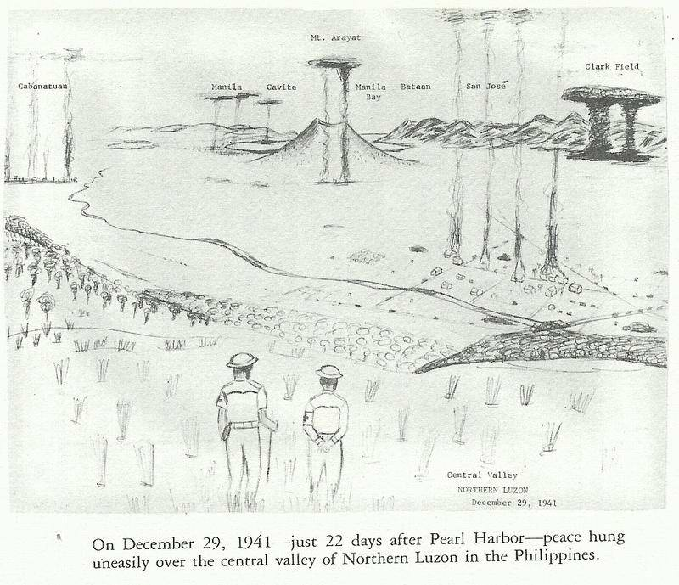

General Wainwright's withdrawing North Luzon Forces had blown many bridges on their way south to Bataan. It was very evident that the enemy occupied most of the central plain-and was apparently harassing the natives. Many of the Filipino homes were in flames.
Toward evening, we sent a disguised medic back down the trail to find a Filipino home and make some arrangements to get
food for the remnants of our detachment-five. We never saw the other medics again.
We could hear the big guns booming on Bataan and Corregidor, 125 miles to the south. We located a hunter's lean-to and camped there for several days. We grew accustomed to the many strange noises in the jungles: birds, monkeys and many other animals, but were having trouble with the ants, spiders and mosquitoes. Camping in the tropics was quite different from camping in the States. In the Philippines every square inch of soil has its menagerie of insects. One of the things I feared the most was being eaten to death if I should be unlucky enough to be wounded.
Each night I thanked God for sparing my life. Our American medic, Al Roholt, carried a pocket New Testament. Within several days each of us had read through it.
We quickly learned that we couldn't eke out an existence in the jungle. There was too much competition. The birds and animals were extremely mobile and agile, getting to any available food much quicker than we could.
The Japanese cavalry and infantry were making daily trips up and down the highway. They entered houses along the road and slapped the Filipinos, demanding, "Where are the Americans?" The natives remained loyal and gave them no information.
Peeking through the bushes at the Jap units going by, I began to wonder why and how studying medicine had gotten me into such a mess.
We had plenty of time to just sit and reflect: We knew the Japanese had designs on U.S., British, French, and Dutch possessions in Southeast Asia. We knew the War Plan Rainbow 5-assumed the Philippines were defensible. We knew the Philippines were not scheduled for any reinforcements, and that its early loss was expected both in the U.S. and in Japan.
It had become quite obvious that the Japs had made landings wherever they chose, and were proceeding to Bataan with very little resistance. We knew that Gen. MacArthur had from 12,000 to 15,000 American troops and about the same number of well-trained Philippine Scouts (P.S.), but the remaining 100,000 Philippine Army (P.A.) troops had less than three months training, and their weapons were for the most part obsolete (World War I vintage).
We had lost much of our aggressive power before the U.S. (Congress) declared war on Japan. We hoped that most of our
troops could get through to Bataan. We could hear the big guns rumbling on Bataan; we hoped they were ours, not the Japanese.
The Japanese cavalry continued to move up and down the highway every day-keeping it open for their purposes. Each squadron of cavalry had several Filipina girls following along on horseback. Natives told us, "Those young girls were seized from their homes along the highway by the Japanese." Then the Filipino families moved their homes back into the jungles from evacuation camps.
The Red Line Bus family sent a guide down from the mountains to lead us to their camp. As soon as it became dark, the five of us started to work our way north, up the rocky river bottom, I in my shoes wrapped in gunny sacks, the soles being completely worn out.
In several hours we were in their evacuation camp. They seemed happy to see us and we were delighted to see them. They lived in a large, open shed in a camp containing one-hundred Filipino families. They were quite well situated beside a small river; they had dug a well in the river bank for their drinking water. They had their own flock of chickens. We were lucky-we ate well for a few days. They had a small radio, capable of getting news from Corregidor and San Francisco. From it we learned that the Japs occupied Manila.
Gen. Wainwright's troops were pouring into Bataan from the north, and Gen. Parker's, from the south. They were trying to establish a defensive line across the base of the peninsula. The Japs were putting out much propaganda such as "Asia for Asiatics" (which really meant "Asia for the Japanese"); and "The Greater East Asia Co-Prosperity Sphere."
We began to hear new terminology from Bataan, such as SNAFU (Situation Normal, All Fouled Up!). There seemed to have been many snafus. Our pilots had received many planes from the States prior to the war that needed Prestone in order to fly. Nowhere in the Philippines could they find any Prestone. Some pilots had to fly planes that had Swedish instruments. Four out of five hand grenades were failing to explode. There was only one rammer rod for fifty-four tanks.
The evacuation camp teniente (town lieutenant) kept me busy every day, visiting the sick in camp. My medicines were rapidly being consumed.
I finally located an old, smooth tire; I cut the rubber in the
shape of the soles of my boots, and patiently sewed them to the uppers; my boots were now good for another hundred miles.
The news from Bataan was bleak: "Front line troops were having difficulty getting any food. The rations had been cut in half because of the thousands of refugee Filipinos fleeing to Bataan along with the troops. Many soldiers were becoming so weak they could hardly hold their rifles. Hospitals I and II were filled with sick and wounded.
On Jan. 26, 1942 a communiqué from San Francisco was received on the radio: "The first American convoy carrying U.S. troops has finally arrived safely in Ireland." We in the Philippines were being completely abandoned. However, it seemed that England would now be able to fight to the "last American!'"
Arrangements were being made by the teniente for a group of Filipinos to go over the mountain to the east of us, to hunt and get food for the camp. I was asked to go along. We started early the next morning. At each little village we would come to, the teniente called out in a loud voice: "Ahhhhhh-Pooooooo! Ahhhhhh-Poooooo!" letting the natives know we were friendly.
By evening we had reached the next valley, where I was informed it was the place where Pres. Theodore Roosevelt and Governor General Leonard Wood had hunted many years before.
I remembered that Gen. Wood had visited our high school, Dr. Nicholas Senn H.S., in Chicago in 1920 and talked to our ROTC classes. I was greatly impressed. Gen. Wood was a doctor (Harvard), who had won the Medal of Honor riding in Roosevelt's Rough Riders in Cuba. He then became Gov. Gen of Cuba at the turn of the century and helped Major Walter Reed conduct his great research, leading to the control of yellow fever. Later he became the only American medical officer to ever become the Chief of Staff of the U.S. Army. I'll never forget how he limped into the auditorium. Rumor had it that he had a wooden leg.
The Filipinos built a fire and soon had our evening meal ready.
As we ate, we could hear deer barking in the mountains, sounding like a dog barking. I had never before known that deer made any kind of a noise. As night approached and a full moon appeared over the mountains, each Filipino selected a suitable cobble stone for use as a pillow. I was satisfied with my small bundle of clothing.
Next morning we were up early, and in several hours had bagged a deer and two wild boars. In the afternoon we hiked
several miles to the southeast to a river near Carranglan, where the teniente threw in a stick or dynamite to stun the fish. Then we all jumped in to capture several of the stunned fish. Each time I came up from a surface dive, all of the Filipinos were laughing.
I asked the teniente, "What is so funny?" He replied, "It is your butt, sir! None of us had ever seen a white butt before, sir!" I was pleased to hear their laughter and was soon laughing myself. None of us had had much to laugh at during the last couple months.
The cargadors (baggage carriers) had quite a struggle carrying the game and fish on their backs over the mountain. I was amazed at their strength and endurance, hour after hour.
We could hear the rumbling of the big guns on Bataan like distant thunder. The evening radio reported a heavy artillery duel; also that MacArthur had received an ultimatum from Gen. Homma, "Gen. MacArthur, you are doomed! I order you to surrender!"
The next day we learned from Filipinos coming down from the north that "Guerrilla groups are forming in the Cagayan Valley!"
Again we thanked the Red Line Bus Co. family for their hospitality and courtesies. Traveling at night, because the Japanese occupied the roads during the day, we were able to reach a small detachment of soldiers guarding Balete Pass. We spent several hours, learning about the troops at Bambang, Bayombong, Bagabag, and Jones.
The following day we made the long, hot and dusty hike to Bambang, where we found a platoon of soldiers; they had destroyed several large bridges across the Magat River to keep the Japanese cavalry from making their daily excursions. The soldiers informed us that Major Warner was the C.O. of the Guerrillas. Warner and I had to make a survey of Camp Hay after the first bombing, looking for "duds" (bombs that didn't go off). We found one dud that had brass fins on it made out of an old T Ford radiator. We could still see the Ford imprint on it."
After a good night's rest in a real bed, and a native breakfast, we were off to Bagabag and Jones on the old dilapidated truck that must have had 300,000 miles on it. We were soon passing through rice and tobacco fields in the fertile Cagayan Valley.
Chapter III
MACARTHUR'S FIRST GUERRILLA REGIMENT

We arrived at Jones just before dark; it appeared to be a more prosperous barrio than we had seen. There were many nipa shacks, some on stilts and some on the ground.
As we drove into headquarters area, we were greeted by Major Everett Warner, the C.O., and Major Guillermo Nakar, the Executive Officer and the C.O. of Headquarters Battalion. They both seemed pleased to have an American medical officer in the regiment. I also met Captain Warren Minton, C.O. of the 3rd Battalion, which included one squadron of cavalry, and Captain Robert Arnold, in charge of communications. He had brought a two-way radio from the northwest corner of Luzon, where he was with the Air Warning Service. I was introduced to several other American and Filipino officers, and then taken to the officers' mess and fed. The regiment now numbered nearly 1500.
For quarters, I was assigned a small tobacco warehouse, where Major Nakar would be my roommate. He slept in a full-sized brass bed; I slept on bales of tobacco, Tobaccolera, the worlds finest. I didn't smoke, but knew that many soldiers on Bataan were dying for a smoke.
Major Nakar was a short, "smiling roly-poly Filipino officer, who looked about thirty-five, with a big black mustache, curved up at the ends, a twinkle in his black eyes-set deep in a small chubby face. He liked to lay, propped up in bed, and read books about great military leaders such as Napoleon, and the Filipino patriot and idol, Jose Rizal." With a chuckle, he liked to quote Confucius: "Make enemy think you are far away when you are near! Make enemy think you are near when you are far away!"
About Nakar, Capt. Arnold remarked, "He means to get ahead!" After knowing him for a few days, I began to get the feeling that he would someday be President of the Philippines. I asked Major Nakar: "How come this barrio seems to be named, 'Jones,' after an American? I don't know of any other named for an American."
He replied:
"Dr. Jones was a professor from a California university. He came to the Philippines many years ago to make some studies. He lived in this vicinity for a long time. When he finished his work, he announced his departure for the States. The local
Ilongots, an uncivilized tribe of headhunters living in this area, told Dr. Jones, 'We have come to like you and respect you. We do not want you to go, but to stay here with us!' Jones explained that he liked them and appreciated their hospitality, but he had finished his work and must return home.
"With chilling logic, the Ilongots cut off Jones' head so that his spirit might always remain, and named the barrio after him, Jones."
When I learned that "Christian heads" were at a premium, I always kept my .45 and my newly acquired M-l rifle handy.
Supply System: A supply system was organized. Owners of rice mills, farmers and politicians were cooperative-furnishing food, clothing, equipment and even one-hundred small Filipino ponies for our cavalry squadron. For these, they were willing to accept IOU notes-hopefully to be honored by the government after the war.
Communications: A small nipa shack housed our two-way radio set up by Captain Arnold. Contact was established with USAFFE HQ on Corregidor, and a regular time set for transmission. News could be obtained several times each day, making the shack a very popular place. A relay telephone system using existing lines along the highway reached all outposts.
Air Strip: Troops with the help of civilian labor constructed an air strip in the vicinity of Jones, adequate for light planes. It was concealed by placing several portable buildings on it. On two occasions a light plane from Bataan dropped boxes of medicine, ammunition and shoes. This bolstered our morale more than our warehouses. General MacArthur became intensely interested in his first Guerrilla Regiment, probably because things were not going well on Bataan.
Medical Service: As former C.O. of the station hospital at Camp John Hay, I became the Regimental Surgeon and organized a medical service with one dental and four medical officers, all from the Philippine Army, as my assistants. We had a dispensary at the Regimental HQ in Jones and two small hospitals in abandoned schools in neighboring barrios Minuri and Dibulwan hopefully out of bombing range.
In the absence of a regular source of medical supplies, our treatment was often quite primitive. We were able to get some medicines and surgical instruments from local hospitals, but only after the Japanese had raided them. Local physicians and civilians
gave freely of their time and care.
Since malaria was prevalent in the Cagayan Valley, our anti-malarial drugs were quickly consumed. Under the guidance of native officers, the bark of certain tall trees was gathered and boiled in water. The resulting extraction caused cessation of active malaria symptoms for a few days, and then had to be repeated. A similar potion was made from the bark of guava bushes, and was reputed to relieve diarrhea. We were fortunate that most Filipinos seemed to have considerable immunity against tropical diseases; our morbidity rates were low.
Our visits to the hospitals were frequently made on horseback.
As I rode along the trails, little Filipinos, noting my King George V beard, often amused me by doffing their big straw hats, bowing low and saying, "Buenos Dias, Padre!" For security reasons, and to keep rumors to a minimum, many of our trips were made after dark.
When patrols were going our on the prowl, medical aid men went along, carrying small amounts of medicines and bandages. Local physicians were used whenever possible. Civilians were very good to our sick and wounded, taking them into their homes and caring for them until they could travel, in spite of threats by the Japs.
Efforts were made to care for all sick and wounded civilians in our areas of operation. This paid dividends in many ways. It was the friendliness of the Filipinos that paved the way for MacArthur's eventual invasion of Luzon. Most of the time there was no question of loyalty among the Filipinos.
Diet and Sanitation: Our diet was good-obtained from the fertile farms and haciendas of the Cagayan Valley. When possible, water was obtained from the deep wells in each barrio. Most Filipinos were familiar with crude sand filter, made by digging shallow wells a few feet back on river banks.
Pit latrines were dug whenever troops remained in an area for more than a few hours. We had no venereal problems. The majority of Filipinos were good "family" people.
Tuguegarao Air Field Raid: Captain Minton selected some of his outstanding Scouts for his patrol. Under cover of darkness, Minton and his men surrounded the Japanese barracks at the Tuguegarao Air Field, killed some one-hundred Japanese soldiers as they emerged, and destroyed two planes on the ground.
MacArthur was delighted! He promptly decorated the patrol
and promoted Majors Warner and Nakar to Lt. Cols. and Minton to Major.
The following communiqué was quickly announced from Corregidor: "One of General MacArthur's guerrilla bands, operating in the Cagayan Valley in northern Luzon, scored a brilliant local success in a surprise raid on a hostile airdrome at Tuguegarao. The Japanese were taken completely by surprise and fled in confusion leaving 110 dead on the field. Approximately three hundred others were put to flight. Our losses were very light."
MacArthur said, "If Bataan should fall, I'd consider joining the guerrillas myself."
Patrols: Our patrols and outposts harassed the enemy until they withdrew from the Cagayan Valley late in March. One battalion pursued the Japs to Balete Pass, where they set up defense positions. Telephone and courier services were quickly established.
The patrols continued to make raids on enemy held barrios. Normally two soldiers (former townsmen when possible) entered the selected barrio as civilians with produce to sell or trade. After making the necessary observations as to the habits of the enemy, they would leave. The following dawn, they would cut the telephone lines at each end of town, and then attack the enemy barracks. Usually food, supplies and equipment could be obtained, in addition to disrupting Japanese activities. Any injured soldiers who' could not continue with the raiding party were cared for by a local civilian family.
Politicians: Riding our horses into town, Col. Nakar and I met frequently with provincial governors, mayors and engineers to discuss mutual problems. We helped them police their areas and they helped us obtain supplies. When a politician became jittery, thinking of possible punishments if he should be captured, we had to replace him with a stable official.
We were able to get permission from President Quezon on Corregidor to print "emergency money" to pay the regiment and to purchase the supplies. The actual printing of the money was done by the provincial treasurer.
In late February, 1942, President Roosevelt announced that there could be no attempt to relieve the Philippines. Actually no reinforcements had reached the Philippines since the first bombing.
Roosevelt directed MacArthur to transfer his headquarters from
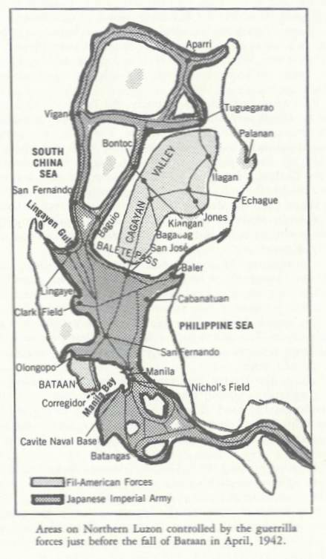
Corregidor to Australia. On March 11th, MacArthur and his family, and some of his staff departed on P.T. boats.
Spanish friends: On Sundays, when things became quiet, Guillermo Nakar and I liked to ride our horses to a Spanish hacienda across the Cagayan River to spend several hours "away" from the war. We crossed the river in long bancas (dugout canoes) and swam our horses behind us, at times fending off rather large crocodiles.
Since Spain was a neutral country, the Japanese did not bother the Spaniards very much, except indirectly. The Spaniards grew fine fruits, vegetables and tobacco. They ate and lived well; Guillermo and I enjoyed sharing a good meal with them.
On my last visit to the hacienda, I gave the Spaniards my movie camera, Hamilton watch, fountain pen, and a pearl ring I had bought for Judy, for "safekeeping" until the war was over.
About one year after the end of the war, I received them in poor condition (being buried in the moist ground) from a Spanish priest, who probably had had great difficulty in locating me; (he wanted money to help him build a new church).
14th Infantry, Philippine Army: On April 1, 1942, USAFFE HQ on Corregidor seemed to have learned that guerrilla type warfare was not in accord with the rules of land warfare. Our regiment received a new title-we were the" 14th Infantry of the Philippine Army." Our regiment now controlled the Cagayan Valley, from Tuguegarao in the north to Balete Pass in the south, and from Kiangan in the west to Palanan and Casiguran ports on the east coast.
Bataan: The Bataan situation was becoming desperate; rations had been cut a second time. Soldiers in foxholes were having trouble getting food. The 26th Cavalry was eating its horses. The 65th Pack Train was eating its mules. Other soldiers ate trapped dogs, monkeys, lizards; in fact most anything they could catch.
On Good Friday, 1942, General Homma opened up with his biggest offensive-all his artillery supported by heavy bombing.
The front line of General Lim's 41st Division was pulverized. Nearly 100,000 seasoned Jap troops were overrunning the cadaverous defenders of the "American Way of Life." A few terrified and bedraggled remnants of the native companies were managing to filter back.
General Edward (Ned) King's 11th Division was too exhausted
to plug holes in the 41st Division. The Japs were now penetrating in large numbers.
On April 8, Gen. King called all his officers together; he tried to spare his starved, diseased, wounded, and exhausted troops such things as marching to internment camps; he requested conditions of surrender:
1. A four-hour armistice.
2. Japanese forces to remain in present positions during armistice.
3. Consideration be given for sick and wounded soldiers and civilians.
4. That U.S. Army transportation be used to carry sick and wounded to any internment camp that the Japanese General may direct. General Homma's Chief of Staff shouted, "Yuo vill sullendah unconitionarry!"
Bataan Falls: On April 9, 1942, starvation, disease and the ubiquitous Japanese caused the collapse of Bataan. General King became the first U.S. general ever forced to surrender his command to an enemy. He referred to his "heroes of Bataan" as follows: "Courage is a quality God has seen fit to dispense with utmost care. He limits it to His special favorites. He knows they will reward Him well, using the power with dignity, strength and distinction. The men of Bataan and Corregidor were His chosen favorites. They walked through unbearable hell and labored on-under conditions that history had never recorded. When they were supposed to be dead, these men of honor rose again-to battle a cruel enemy with this intangible weapon."
"When history of the Second World War is fully written, Americans will thrill to the story of the 'Defenders of Bataan and Corregidor!'"
The fall of Bataan ended any possibility of getting supplies for the 14th Infantry; our patrols had only three rounds of ammunition per man. We became quite depressed over the surrender of Bataan; we knew many of our friends there must be dead, wounded or suffering from starvation and many diseases.
Shortly we received the following order from Corregidor: "CUT STRENGTH OF 14TH INFANTRY TO 600! WAINWRIGHT." This was a big blow to the whole regiment.
Thousands of Japs were massed at Balete Pass and moving north into the Cagayan Valley. Our patrols kept us posted. Col. Warner, becoming frustrated and trying to determine what
positive effort could be made toward winning the war by his remaining troops, noted that the 14th Infantry held two valuable ports at Casiguran and Palanan. He took Major Minton and some Scouts across the Sierra Madre mountains to the Pacific coast to explore possibilities. He considered finding or building a good pier for supplies to be brought in; he looked for suitable beaches for landing craft in the event of an invasion and as a last resort, boats that could carry personnel to China.
The Japanese troops were advancing on Echague, some fifteen miles from Jones. Guillermo was fearful lest the Japanese locate the regimental radio by triangulation of transmission waves. Guillermo and I, with several Scouts, got into two bancas and worked our way up the Cagayan River through a series of rapids to Pinippigan, where we spent the night. The following day, with the barrio teniente, we looked for places to hide the radio if it became necessary.
When we returned to Jones, we discharged nine hundred soldiers, to be sent home, to grease and hide their rifles, to hide their uniforms and equipment, and to become civilian farmers. They soon earned the reputation, "farmers daytime-soldiers nighttime."
Corregidor, the "Rock": With the fall of Bataan, the Japanese moved their heavy artillery right into the grounds of our Army hospitals on Bataan-to concentrate their massive barrages on Corregidor-without fear of retaliation from the big guns on Corregidor. The shelling and bombing became relentless for several weeks.
On May 5th, as the Japanese barges were approaching Corregidor, General Wainwright offered to surrender to General Homma, who replied, "Imperial Japanese Army and Navy are only prepared to accept surrender of all American and Filipino troops in whole Archipelago - Homma."
One of the last messages to come from Corregidor: "Major Eugene C. Jacobs, M.C., transferred to command of Col. John Horan in Mountain Province north of Baguio."
I reasoned, "Maybe his heart is giving him trouble and he feels the need of a doctor." My weight was down from 165 to 120 pounds. I had had amoebic dysentery for several months and had lost considerable strength. I didn't relish traveling some one hundred to 150 miles through areas held by the Japanese, to learn that Col. Horan had already surrendered to the Japanese.

(Later I learned that this is exactly what happened. He surrendered on May 14, 1942).
Corregidor Falls: With the silencing of the big guns and the radio on Corregidor on May 6th, we found ourselves unable to contact any ally. In a matter of hours, we picked up the voice of General Wainwright over the Japanese radio in Manila: "WE ARE 8,000 MILES FROM THE UNITED STATES. THERE HAS BEEN AND WILL BE NO REINFORCEMENTS. FURTHER RESISTANCE AND BLOODSHED ARE USELESS.
I ORDER ALL FIL-AMERICAN FORCES IN THE PHILIPPINES TO LAY DOWN ARMS AND TO SURRENDER! WAINWRIGHT."
We were quite sure that Wainwright was being pressured by the Japanese to make his broadcast. We questioned whether or not a captured general still had the authority to issue orders to his former "unsurrendered" command.
Transfer to Mountain Province: Trying to be a good soldier, I prepared to make my transfer to Col. Horan's Guerrilla Unit. I obtained a good guide and a strong horse. I told the officers and men of the 14th Infantry, "Good-bye and good luck." We started north.
After several days on the trail, the guide and I reached a small barrio east of Ilagan. Natives told us Ilagan was occupied by Japanese.
As I was bedding down in a small native shack, a Filipino quietly crept up to my bed, and said, "Sir! I am an emissary from General Aguinaldo in Palanan. Sir! General Aguinaldo wants to hide you from the Japanese for the duration of the war."
I was delighted; this seemed like the answer to a prayer. I had no idea where Aguinaldo had ever heard of me, or why he was interested in me. We did have one thing in common we were both doctors. I learned several things about Aguinaldo: he had been mayor of a small barrio. When the Americans took the Philippines from the Spanish in 1899, Aguinaldo appointed himself the President of the Philippines and led an insurgent army of 40,000 against the Americans and fought a long and bloody war.
Aguinaldo was finally captured in Palanan by Gen. Fred Funston; he was brought to Manila as a prisoner, where he swore an oath of allegiance to the United States and became a good friend. The Military Governor, Gen. Arthur MacArthur, the
father of Gen. Douglas MacArthur, treated Aguinaldo as an honored guest in the Malacanong Palace in Manila.
General Aguinaldo's emissary told me to meet him the following day at a Spanish hacienda, the Buen-venida, near the barrio of San Mariano, about thirty miles to the south. He would lead me over the Sierra Madre Mountains to Palanan and General Aguinaldo.
The next morning the guide and I started south-attempting to find the designated hacienda. After riding all day, we finally arrived at a hacienda, but not the Buen-venida. When I inquired as to the direction to Buen-venida, the Spanish owner asked me:
"Did you come to surrender?" I answered with a very positive, "No!" He said, "Col. Warner and Major Minton are here with their staff-from Palanan." I answered, "I would like to see them!"
As I greeted Col. Warner and Major Minton, in walked another American from a different direction. Lt. Col. Theodore Kalakuka, QMC, Gen Wainwright's G-4 from Manila, saying, "I've been sent here by General Wainwright." Ted had arrived in a Jap plane from Manila with a Japanese pass. He continued, "He has ordered all Fil-American troops to surrender. If any unit does not surrender, all of the captives on Corregidor will be severely punished (probably slaughtered!)" For my benefit, he continued, "There are thousands of Americans in internment camps that are extremely sick and desperately in need of medical care. Any American who does not surrender will be considered a deserter of the United States Army!" (Several weeks later, Ted died of cerebral malaria while looking for Americans who had not surrendered.)
Col. Warner pointed out to our officers that "the Japanese have a bounty on each of our heads. It is the beginning of the rainy season. There is a great scarcity of food. The Japanese have warned the Filipinos that anyone caught helping Americans would be executed. The Filipinos can no longer afford to be friendly to Americans."
Chapter IV
COL. WARNER SURRENDERS THE 14th INFANTRY
(June 20, 1942)

Col. Warner officially surrendered the 14th Inf. to the Japanese on June 20th. The following day our group walked down to the river and obtained a guide and several bancas. We spent the day coasting down the river to Ilagan. On the way down, I decided that no American would be killed by my .45; I dropped it in the river.
In Ilagan, we hiked several blocks to a Japanese barracks, knocked on the door and tried to explain to some ignorant soldiers that "we had come to surrender!" We were about as welcome as a vacuum cleaner salesman. With little planning we could have "wiped them out." We were finally directed to an empty house across the street to spend the night, sleeping on the floor.
The next day we hired a Filipino caratella (pony cart) and rode about fifty miles to Echague where we repeated the surrender process at a cavalry barracks. Six of us Americans soon found ourselves sleeping on the concrete floor of the guard house of the old Constabulary Barracks, west of Echague. Our hosts were a squadron of Japanese cavalry-probably the same squadron we used to watch going up and down the highway.
Echague was the town where Guillermo Nakar and I had frequent conferences with the Governor and provincial officials. We were only fifteen miles from the radio shack, where Nakar was persisting in his efforts to contact Gen. MacArthur.
I didn't get to Palanan to meet General Aguinaldo! I have often wondered how different my life might have been-sitting out the war with Aguinaldo.
Guests of a Japanese Cavalry Squadron: For one month, we six Americans were assigned to perform all of the unpleasant chores of the squadron, pumping water by hand, preparing vegetables, burying garbage, etc. We were pleased when we heard through the "bamboo telegraph" (rumors whispered to us by the natives selling us bananas and coconut cookies) that the government officials that we had appointed had been accepted by the Japanese. We knew that they would maintain a certain loyalty to the United States.
The Japs called us "captives," not P.O.W.s. Each morning and each evening, we had to stand formation with the squadron
facing east repeating an allegiance to the Emperor (we substituted our own words, which we deemed more appropriate).
Nakar Successful: About the 4th of July, Col. Nakar succeeded in contacting Australia. I quote from Gen. MacArthur's book, Reminiscences: "After the fall of Corregidor and the Southern Islands, organized resistance to the Japanese in the Philippines had supposedly come to an end. In reality, it never ended. Unfortunately for some time, I could learn nothing of these activities. A deep pall of silence settled over the whole archipelago.
"Two months after the fall of Manila Bay Defenses, a brief and pathetic message from a weak sending station on Luzon was brought to me. Short as it was, it lifted the curtain of silence and uncertainty, and disclosed the start of a human drama with few parallels in military history. The words of that message warmed my heart: 'YOUR RETURN IS THE NIGHTLY SUBJECT OF PRAYER IN EVERY FILIPINO HOME! - NAKAR.'
"I had acquired a force behind the Japanese lines that would have far-reaching effect on the war in the days to come.
"Unhappily, the sender of that first message, Lt. Col. Guillermo Nakar, a former battalion commander of the 14th Infantry of the Philippine Forces, was caught by the Japanese, tortured and beheaded. The word passed from island to island, and from barrio to barrio. From Aparri in the north to Zamboango in the south the fire of resistance to the invader spread. Whole divisions of Japanese troops that the Emperor badly needed elsewhere, deployed against phantom units."
Before Nakar's untimely capture, he had received the following message: "THE COURAGEOUS AND SPLENDID RESISTANCE MAINTAINED BY YOU AND YOUR COMMAND FILLS ME WITH PRIDE AND SATISFACTION - Stop. IT WILL BE MY PRIVILEGE TO SEE THAT YOU AND YOUR OFFICERS AND MEN ARE PROPERLY REWARDED AT THE APPROPRIATE TIME - Stop. MY AFFECTIONS AND BEST WISHES. MACARTHUR."
Within a few weeks we learned that an unfaithful Filipino had betrayed Col. Nakar. The Nipponese had captured him and the regimental radio in a mountain cave near Jones, and had taken him to the old Spanish Fort Santiago in Manila where they threw him in a dungeon to face starvation, thirst, water rats, the ingenious system of Japanese questioning and torture by the Kempie Tai Qapanese Secret Police), and finally beheading.
Col. Nakar's short war was far from fruitless. His tender years did not prevent him from becoming a "champion of liberty!" His message to MacArthur actually signaled the end of Allied defeats and withdrawals, and the beginning of an unbroken series of crushing defeats for the Japanese Empire. It kept "Freedom's Flame" burning brightly throughout the Philippines and gave the Filipinos the necessary strength and courage to resist-and finally to defeat the invaders. Col. Nakar's "Brief and pathetic message from the Cagayan Valley" gave MacArthur the reassurance he needed:

To plan his aggressive warfare;
To fulfill his pledge to the Filipino people: "I shall return!"
and
To know he had a friendly base from which to attack Japan.

MacArthur's First Guerrilla Regiment (later the 14th Inf.) had produced a much needed diversion for the hard-pressed forces on Bataan and Corregidor. Thirty months later, these same guerrillas of the 14th Inf. played an important part under the brilliant leadership of Col. Russell Volckmann in assisting MacArthur's invasion of Luzon at Lingayen Gulf on January 9th, 1945.
MacArthur stated, "The guerrillas had been busy ever since receiving my orders 'to open up!' They cut telephone wires and otherwise disrupted Japanese communications. They blew up bridges and mined roads; they blocked supplies to the front lines; they smashed patrols and burned ammunition dumps. Their shining bolos began to turn red. I estimated that Col. Volckmann’s northern Luzon guerrillas accomplished the purposes of practically a front line division."
(Still nine months later, these same guerrillas helped Col. Volckmann at Kiangan-both defeat and capture Japan's distinguished General Tomoyuki Yamashita, the "Tiger of Malaya." The Tiger was quite amazed and chagrined to find his veteran troops both surrounded and beaten by guerrillas in the northern Mountain Province.
On September 2, 1945, General Yamashita surrendered to Col. Volckmann at Kianhgan. The following day, Sept. 3rd, he surrendered to General Wainwright at the High Commissioner's mansion at Camp John Hay, ending World War II in the Philippine Islands. Yamashita was then taken to Bilibid Prison
in Manila to await war crime trials.
In December, 1941, some of the newly recruited Filipino soldiers '"broke and ran" for the mountains when the big guns were fired from the cruisers and destroyers in Lingayen Bay, but in 1945, these same Filipinos were ideally suited for guerrilla warfare; they thoroughly enjoyed twisting the "Tail of the Tiger." "This was their kind of war!" Actually Japan never conquered the Philippine Islands, nor did they ever gain the friendship of the Filipinos.
The Nipponese merely occupied some of the larger cities and controlled the main roads for three years, during which time they established much ill-will of the Filipinos, only serving to strengthen the resistance movements. Who could have ever dreamed that World War II in the Philippines would both begin and end at Camp John Hay, a Rest and Recreation Center?
Captives on the Move - July 20, 1942: Six of us the American captives, guests of the Japanese cavalry squadron stationed in Echague Constabulary Barracks in Isabella were placed aboard a charcoal burning truck, with a half dozen Jap guards, bound for an internment camp.
When we reached Bambang, our truck stopped to pick up a junior Japanese officer, who was being transferred to another area. The Nips wanted to give him a big send-off; they had gathered and instructed a group of Filipino children to express their great fondness for the officer by waving Japanese flags, by shouting: "Banzai, Banzai, Banzai!" and by presenting the officer with a small bouquet.
The performance was quite dull, until one of the children discovered the Americans in the back of the truck. The little faces brightened and broke into smiles; "V" signs began to appear, followed by a chorus of "Hello, Joe! Hello, Joe! Hello, Joe; Mabuhay, Joe!" The Japs were plenty irked and hurried the truck down the highway.
In the early afternoon we passed through the barrio where we had encountered the Japanese Chevy and tanks seven months before. Shortly we passed through San Jose and on to the central plains.
About one mile before reaching the internment camp at Cabanatuan, we suddenly became aware of a horrible, acrid stench, the smell of disease, dysentery and death.
Chapter V
JAPANESE PRISONER OF WAR CAMP NO1, CABANATUAN

Toward evening we arrived at the gate-made of slender poles and barbed wire-which I immediately recognized as one of the camps built prior to the war to house a division of the Philippine Army. It was located on several hundred acres of treeless wasteland (formerly rice paddies) near the foothills of the Sierra Madre Mountains. It consisted of some one hundred cantonment type barracks with walls of nipa and roofs of swali and cogan grass.
Within the barbed wire enclosure, many of the seven thousand half-naked, starved bodies, the "captives," slowly milled about camp. In the several guard towers along the fence, sentries closely scrutinized their movements. The arrival of our old truck and its handful of new captives were scarcely noted in camp.
I made my "duty calls" on Col. D. J. Rutherford, C.A.C.,
Camp Commander, on Lt. Col. Leo Pacquet, Group II Commander, and Col. Gillespie, Medical C. O. Group II Dispensary proved to be a small, twenty by twenty foot grass shack. In one corner was my two-by six foot bamboo slat bed for the next several months.
Although my weight was down from 165 to 120 pounds because of amoebic dysentery, I was still relatively active and in fair health. How lucky I had been to have missed the starvation, the many diseases, the battles and bombings on Bataan and Corregidor, and most of all, the "Death March," which had taken so many thousands of lives, "slaughtered by the Japs."
"Thank you God!" became my frequent and fervent prayer.
Shortages: The first shortage of which I became aware was water. The deep well in camp required diesel fuel or coconut oil to run the engine-to pump the water to a central water tower, from which it went to one outlet in each group and each mess hall, and several outlets in the hospital. Since fuel was always in short supply, there was usually a shortage of water. By standing in line for an hour, I obtained my first canteen of water (which could only be used for drinking). Baths were obtained by standing under the eaves on rainy days. Fortunately the rainy season was beginning.
Chow: The evening meal was my introduction to the diet. I had been warned that I would only need my canteen cup for
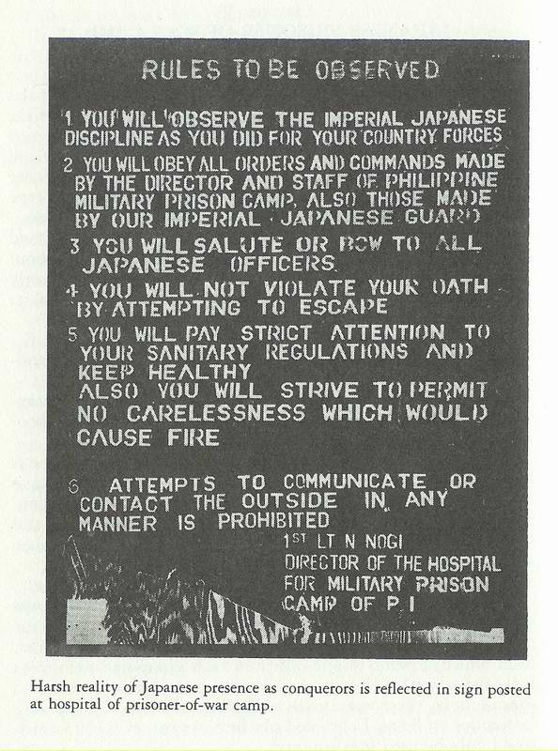

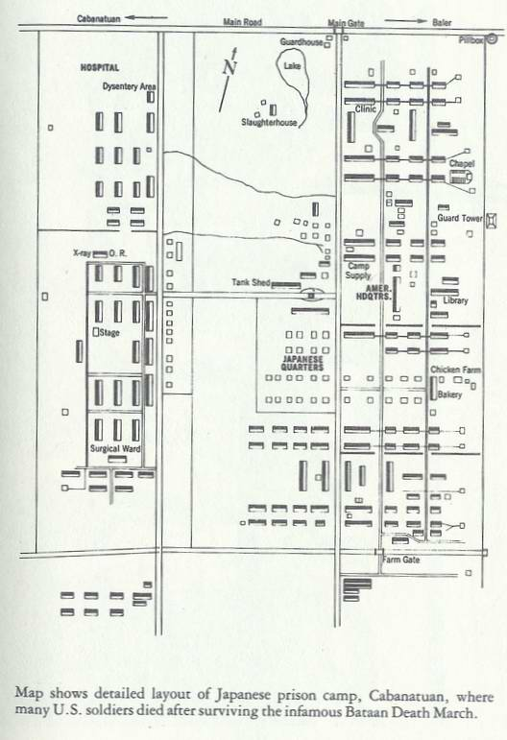

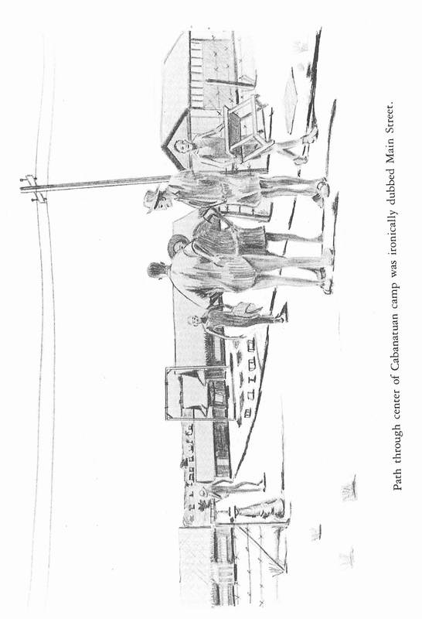
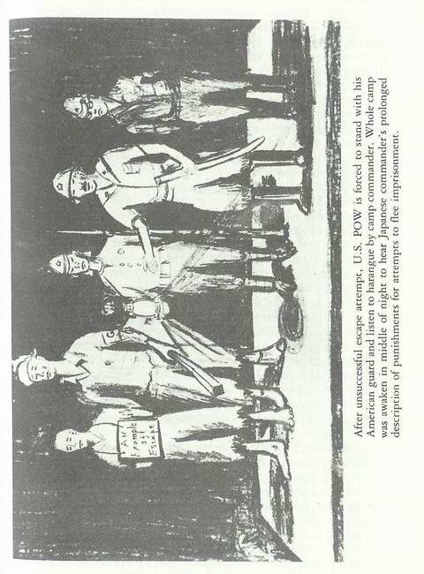
dinner. After waiting in a long line, I received one half cup of lugao (a thin watery rice soup) and some foul tasting greens, a very skimpy meal compared to those I enjoyed with the guerrillas chicken, eggs, pork, fruits, and vegetables.
As the days went by, the diet did not improve just lugao and greens day after day. On a rare occasion a small amount of mongo beans or corn might be added.
About once a month, a carabao (water buffalo) was killed and added to the soup for from 6,000 to 12,000 captives, after the Japs had removed all of the choice cuts. We believed ourselves lucky when we could find a shred or two of meat in the soup.
Our captors reasoned that slow starvation would make us too weak to resist authority or to attempt to escape. To further insure our servility, the Japanese divided us into groups of ten "blood brothers." If one attempted to escape, the other nine would be severely punished. Recaptured escapees were paraded around camp by American guards for twenty four hours and then used for bayonet practice by the trainees and Koreans.
First Night: During the first night in camp, I spent several hours walking under the stars, just thinking. Life had been much better with the guerrillas; I was free to go many places not occupied by the Japs. I ate much better.
But what was done was done! There was no question that the captives in Cabanatuan P.O.W. Camp needed all of the medical care I could give them. From that point of view, I reasoned that I was in the right place. .
I wondered if Judy could see the same stars that I could the hunter and his two dogs, and the Southern Cross. When we lived in Garden Court (near Nichol's Air Field), we used to delight in watching the moon and the stars shimmering in Manila Bay. It seemed a lifetime ago.
Apparitions: The next morning, some three hundred pathetic, skeletonized human beings, Americans, lined up in front of Group II Dispensary, all hoping for miracles. Several of the patients recognized me from Manila, where I had treated them at Sternberg Army Hospital, or the dispensaries of the 57th Infantry Regiment, or the 14th Engineer Regiment at Fort McKinley.
With their shaven heads and their considerable weight losses, I had great difficulty in recognizing them. These were the pitiful survivors from Bataan and Corregidor, the "Battling Bastards of
Bataan," and the remnants of the "Death March." One by one I listened to their stories and tried to help them.
Since there was very little medicine to give out, most of the therapy had to be improvised. Those with dysentery were told to take a teaspoon of charcoal from the mess hall stoves after each meal, and to sleep on the right side so not to irritate the sigmoid colon. They were to wash their hands after each trip to the latrine in spite of water shortages.
Malaria patients were given one quinine tablet after each chill hoping to alleviate symptoms. There was never enough to attempt a cure.
Both "wet" and "dry" beriberi cases were prevalent. There were no vitamins to treat them. We tried to make yeast cultures; the process was too slow, and we could never see that the cultures did any good. Hundreds of beriberi cases died each month.
Scurvy came on suddenly in large numbers of captives several times each year. When we could persuade the Japs to obtain a lime or two for each captive, the cures were remarkable.
Nightly Toll: Each day we transferred the most seriously ill patients to the hospital, where there were small amounts of extra food. In spite of the daily transfers, each night several captives died in the barracks. Many of the captives refused to go to the hospital seeing it as the last stop before death.
Mess Halls: There were eleven mess halls in camp-each with one or two large concrete stoves at one end. Large iron caldrons held the rice or soup to be cooked. During the rainy season, there were serious problems getting the wood to burn.
It often appeared that the mess crews were better fed than other captives. The daily diet consisted of two hundred to four hundred grams of a poor grade of rice, containing fine gravel and insects, about one hundred grams of weeds (from carabao wallows), and, on a rare occasion, ten grams of "one" of the following: sugar, coconut oil, beans, camote (sweet potato), corn, or meat. The diet was usually below eight-hundred calories daily, of which protein and fat were less than fifty calories.
Captives, who were able to earn a pittance by hard labor on labor details or on the farm, could supplement their diet with an occasional banana, egg, a few peanuts, or a few mongo beans.
A few captives raised small gardens growing vegetables for their own use. As they ripened, the produce had to be carefully watched to prevent theft. Some captives trapped stray dogs, some
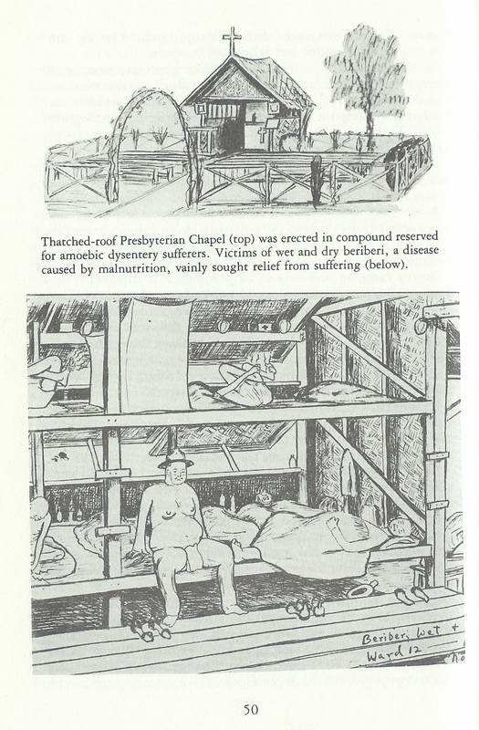
ate lizards, grasshoppers and even earthworms.
With food from every available source, the daily diet rarely reached one thousand calories. Fat and salt were almost never available.
Slow Starvation: Starvation, the scourge of the Orient for centuries, devastated the captives held by the Japanese; it was not a starvation bred of poverty, but starvation bred of brutality, sadism and neglect. Murder would have been more humane; execution more legal. A slow, tortured death, however, was more in keeping with the desire of the Japanese to make the "Defenders of Bataan and Corregidor pay dearly for having challenged 'Dai Nippon."
We were hearing so much about the "Death March" and "Camp O'Donnell," I have decided to include several paragraphs on each:
Bataan "Death March": The "Death March" began April 9th, when the Japanese General Homma demanded that General King surrender his 80,000 Fil-American forces on Bataan "Unconditionally."
Since Gen. Homma's prizes, Corregidor and the Philippine Islands, still lay before him, he had no time to worry about the captured Fil-American forces. His shock troops, tanks, trucks, cars, cavalry, artillery, and infantry occupied the only highway from Bataan to the central plain. They were getting into position (on the grounds of Hospitals I and II) to shell and bomb Corregidor into submission. "Why the dirty bastards! They're using us as shields to fire on Corregidor."
At the same time, Japanese guards between Marivales and Limay were rounding up the 80,000 hungry, sick, confused, and exhausted captives to march them north on the same highway in groups of one hundred in columns of four.
Guards were continually barking orders: "Get on the highway!
Hully! Hully! Hully! Kura! Stop! Get off the load! Speedo! Sona bitch! Kura! Get on the highway! Stop!" They used their weapons to enforce their directives.
The "March" began at Marivales, proceeded "on foot" for about sixty miles, then by box car for some twenty miles and finally another ten miles "by foot" to Camp O'Donnell. "It was hot, hot, hot and dusty! There was no food; there was no water!" Most captives did not have canteens. Those who attempted to fill their canteens in the ditches besides the road were frequently bayoneted; anyone who couldn't keep up was slapped, clubbed or
bayoneted in full view of the others.
Heard along the march: "During the day, we had to travel along the highway when it was not being used by heavy equipment going south." "At night, we were placed in barbed wire enclosures; sometimes there was water; more often there was none." "As the days passed, the stench of death became very pronounced; bodies were laying along the highway in all stages of decomposition swollen, bursting open, and covered by thousands of maggots."
The Korean guards were the most abusive. The Japs didn't trust them in battle, so used them as service troops; the Koreans were anxious to get blood on their bayonets; and then they thought they were veterans.
"If you fell, you were dead!"
"There were things you didn't want to see! There was the captive that the Jap trucks and tanks had rolled over until he was just a flat 'silhouette' in the pavement."
"The heat was terrible!"
"The Jap kept poking me with his bayonet; fear gave me the strength to go on."
"To have a close friend a buddy to help you might be the difference between survival and death."
"As the days passed, the compounds holding captives at night became filthy; sick and dying almost filled the areas. The dead were not being buried. The terrible odor was sickening."
"Sometimes when the compounds were crowded, they marched us all night.”
“I had 10,000 teeny blisters on the bottom of my feet."
"The compound was full of people a lot of dust, dirt and filth; I just fell into the dirt and slept."
"People were going crazy they were 'nuts!' sometimes talking to themselves, sometimes screaming!"
"We all had dysentery, and there was no water. Usually there was no food."
"We finally reached the train a few box cars with doors closed in the hot sun they were stifling hot like a furnace."
"We were jammed one hundred to a car standing room only. Men fainted, but there was no place to fall down."
"They didn't open the door until we reached the destination.
The living and the dead just fell out."
"Sit down and be counted!"
"When we had reached Capas, it was pandemonium, Japs and captives all milling around. They tried to count us as we rested."
"Then we were told to line up-in columns of twos. We started the march on a dirt road some six miles to Camp O'Donnell."
"Some captives had marched all the way from Bataan close to one hundred miles."
"It wasn't the march that killed us; it was the continual delays along the march the standing in place for two or three hours at a time without food or water."
"If you stepped out of line, you were apt to have a bayonet in your gut."
The exact number of dead from the "Death March" was probably known only to God. The best estimates were anywhere from 12,000 to 17,000.
Deaths at Cabanatuan: During the first eight months of camp, deaths totaled 2,400. Some thirty to fifty skeletons, covered by leathery skin, were buried in common graves each day. The Japs issued documents certifying that each death was caused by malaria, beriberi, pellagra, diphtheria, in fact, anything but the real cause starvation and malnutrition.
After the war, when the Graves Registration searched the Cabanatuan cemeteries, they found and disinterred 2,637 bodies.
Sanitation: From the beginning of camp, sanitation was a serious problem. Flies, including the blue and green bottle types, were present everywhere. Maggots thrived in the latrines, weakened the walls, resulting in cave-ins, and sometimes engulfing the visitor. Daily rains further weakened the walls.
After several months some engineer officers, under the leadership of Major Fred Saint of Elmhurst, Illinois, organized a sanitary detail, and succeeded in building deep septic tank type latrines that would not cave in. They applied lime daily to control flies and maggots. Gradually they dug ditches along all walks and around all buildings in order to promote draining and to prevent quagmires.
Labor Details: The camp had not been in operation many days before the Japanese requested that the American headquarters furnish labor details of various sizes and types to work both inside and outside the camp. Although an occasional detail would be commanded by a very cruel Jap guard and unbelievable brutality followed, the men on some details had reasonable guards, received extra food and remained relatively healthy.
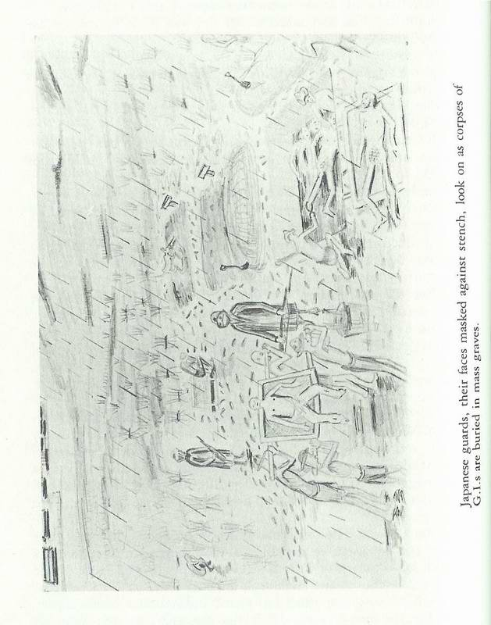
Wood Detail: On good days, a firewood detail went to the
forests to get wood for the mess hall stoves.
Rice Detail: One to three times each week, a rice detail composed of from five to ten carabao carts, an American driver for each cart, and several Jap guards, drove to market in the town of Cabanatuan to pick up one hundred pound bags of rice for the mess halls.
Outside Details: Details were taken to many places in the Philippines to build and repair roads, bridges and airfields and to load and unload ships in the port area of Manila. Several details of Americans were taken to Bataan to make a Japanese movie, entitled Down with the Stars and Stripes! Periodically, a detail was taken to Japan.
The Farm: After several months of starvation, some hungry captives suggested to the Japanese that a farm could supply extra food for the captives and might reduce the high morbidity and mortality rates.
The farm was started with a few farmers and expanded very rapidly. Groups of one hundred men each were marched out of camp every morning barefooted to spend the day on the farm.
The farmers worked under many difficulties; the sun became very hot. Farmers were not allowed to squat down or to bend the knees. They had to work bent over from the waist. They received only a fifteen minute yasume (rest period) in the morning and another in the afternoon. There was much language confusion; much misunderstanding followed by frequent slapping, kicking or beating.
Nearly every day the Japanese insisted upon larger and larger details insisted that more and more patients be returned to duty from the hospital in order to work on the farm. The workers received a small amount of extra food.
Much to my surprise, many sick patients, that we thought were too sick for duty, were becoming rather husky farmers.
More to my surprise, the Jap guards soon found they could make extra money by taking farm products to the market in Cabanatuan city, where they were sold to the civilians.
Camp Hospital: The hospital was first opened in June, 1942, by Col. James Gillespie with the mess halls under Major Jim Rinaman. There were sixty six officers and 183 enlisted men. By July 1st there were 2,300 patients and by August, 2,500.
There were thirty wards (made to hold forty soldiers), often
holding up to one hundred patients. There were upper and lower decks made of bamboo slats. Each patient was allotted a two-by-six foot space. Seriously ill were kept on the lower decks.
By Dec. 1st, I had been appointed chief of the medical service; I tried to see every patient each day. Since medicines were very scarce, there was actually very little I could do, except give some hope of a better tomorrow.
Dire Economy: In the early days of the hospital, the Japanese issued a few cartons of condensed milk that they had captured on Bataan for the benefit of the seriously ill. Unfortunately, most of the recipients of the extra milk proceeded to die in spite of the extra nourishment taking the milk with them. We quickly learned a harsh but valuable lesson: "Do not give extra nourishment to dying patients!"
From then on, the extra food went only to patients who possessed the possibility of recovering plus the will to live.
Malaria: Fully 50% of the 2,400 patients had malaria. For many months all we could do was to give one quinine tablet after each malaria chill, hoping to make them more comfortable. But after the Japs conquered the Dutch East Indies, we received 30,000 three grain tablets of quinine. This allowed us to control most cases of malaria and to cure some.
Occasionally we saw a few cases of cerebral malaria; most of these died in spite of quinine therapy.
Multiple Diseases: Most patients had more than one disease, usually multiple vitamin diseases. Many had lost from one third to one-half of their body weight. Most everyone had either wet or dry beriberi, or a few both.
Beriberi: Wet beriberi cases were bloated with edema usually beginning in the feet and gradually progressing upward to the head. A patient with edema of the feet and legs, after lying in bed all night, frequently found that the edema had spread to his chest and face in the morning.
After being up for several hours, the edema slowly returned to his legs and feet. When the edema became extensive, the patient became nearly helpless unable to get about.
Tropical ulcers often developed in swollen legs, and continued to weep as long as the edema existed. If the edema had been caused by salt intake, it could be, controlled by eliminating salt, but for the most part salt was not a factor, because we rarely had any salt in our diet.
Patients with dry beriberi were usually very thin. Their chief complaint was lightning-like pains (neuralgia) in their legs and feet. The only relief came from soaking their legs in buckets of cold water. Many sat up all night trying to obtain some comfort.
On a rare occasion a dry beriberi patient would develop edema in his feet and legs; strange as it may seem, the edema seemed to relieve the pains of the dry beriberi.
Forty years later, some of the survivors still have leg pains in spite of heavy vitamin therapy indicating permanent nerve damage.
Beriberi Heart Disease: Beriberi heart disease was seen frequently, and often resulted in sudden death. Like the legs and abdomen, the heart became enlarged with edema; the beat became irregular. As some patients lay down, their heart would stop beating, especially if lying on the left side.
If you could get to them in time to sit them up, or to massage their heart, it was sometimes possible to get the heart started again.
Sudden death at night was a rather frequent occurrence. Many American trained cardiologists still consider beriberi heart disease as a reversible condition, but some ex-P.O.W.s still have the same irregularities.
Pellagra: Pellagra was common, manifest by conjunctivitis, glossitis, amblyopia, angular stomatitis, geographic tongues (often with deep grooves and severe sensitivity), and scrotal dermatitis of varying degrees including sloughing. There was increased pigmentation of the skin sometimes patchy.
Xerophthalmia: Xerophthalmia and optic atrophy were seen occasionally and often left permanent damage to vision, and sometimes complete blindness.
Diphtheria: We had an epidemic of diphtheria some two hundred cases of which 125 died before the Japs obtained a limited amount of antitoxin. Most survivors had permanent residuals.
Infectious Hepatitis: We had several epidemics of infectious hepatitis, which seemed to be self-limited. At times it was difficult to differentiate it from malaria with jaundice following Atabrine therapy.
In 1943, I had infectious hepatitis for about ten days and turned a bright yellow accompanied by severe nausea and vomiting. Every time someone would mention "food," I would run to
the window and retch. It seemed this happened about every five minutes during the day, as prisoners rarely talked about anything else. The individual would apologize for mentioning food, but it would be only a short time before it was the subject again.
Scurvy: There were several widespread epidemics of scurvy; we could stop these quickly if and when we could persuade the Japs to get a lime or two for each captive.
Diabetes Mellitus: When I entered camp, I was worried about diabetes mellitus, because there was no insulin or other medicine available to treat it. Ironically, starvation solved the problem.
The blood sugar never got up high enough to produce any symptoms.
Red Cross Packages: Just before Christmas in 1942, 1943 and
1944, the laps issued one or two Red Cross food packages, each of which contained seven pounds of food. After the package in 1942, the camp mortality fell miraculously from forty deaths daily to one or two a month. December 15, 1942, was the first day in camp in which there was not a single death.
Refeeding Gynecomastia: Three times during our thirty to thirty-six months of incarceration at Cabanatuan and in Bilibid, following the receipt of one, two or three Red Cross packages, making our diet adequate for from one to six weeks, up to six hundred "refeeding" type of breast swellings (gynecomastia) of various sizes appeared.
After the food in the packages was consumed by the captives, and the diet returned to the starvation-type, the captives with the swollen breasts noticed that the breasts were slowly and gradually returning to normal size.
Again after liberation, when the diet returned to normal and remained adequate, many hundreds of refeeding gynecomastia were seen, and lasted from one to eight months, before disappearing. At times the enlarged breasts were rather tender and even painful.
Dysentery Section of Hospital: Fenced off from the hospital was a quarantined area containing about ten wards-called the Dysentery Section-under the supervision of a separate staff of medical officers and corpsmen.
There was a tremendous sanitary problem. Many of the patients were too weak to leave their wards. Some "passed out" on their way to and from the latrine. There was essentially no medicine for these debilitated patients-unless they were lucky enough to
have a friend in Manila and knew how to contact him via the Underground.
Zero Ward: In the Dysentery Section, there was a building that was missed when the wards were numbered. Later, it was called "Zero Ward" and served as a place to put the seriously ill, essentially dying patients. It was an empty building with wooden floors, and usually contained about thirty extremely ill patients naked lying on the floor, frequently in their own vomitus and dysenteric stool.
Their chances of survival were just about zero. Flies walked casually over their leathery skin; rarely did a patient arouse himself sufficiently to threaten a fly. Most of the patients did not want to be disturbed, typically responding "Please leave me alone; I have suffered enough! Just go away!"
Exhausted and sick corpsmen moved slowly among the dying, trying to keep them clean, and giving them food or medicine, when available.
Operating Room: In the early days of the hospital, the Japanese permitted several medical officers to return to Bataan to retrieve an operating table, minimal surgical equipment and a field X-ray unit from the abandoned U.s. Army hospital.
Captives who had needed operations prior to the obtaining of the surgical equipment were operated in Cabanatuan city by Japanese doctors with 100% mortality.
Our American surgeons said, "We can do better than that!" The American surgeons had no mortality.
A Camera: Ingenious Americans built a camera: they used X-ray film, took pictures around the camp and developed the film in X-ray solutions. They, of course, had to hide the camera and pictures when Japs were in the area.
A Radio: After hearing no news during the early months of the camp some other clever Americans decided to build a radio.
Several of the captives operated the electric generating and pumping station. In the evening, when they suspected' the Japanese were listening to their radios, they would run the voltage up high and blowout the Jap radio sets. The following morning, the Japs would bring their sets to the Americans and say: "You fix!"
After a quick examination, the Americans would exclaim, "We must get some new parts in Manila!" In Manila, they would get extra parts and eventually built a radio-in the bottom of a

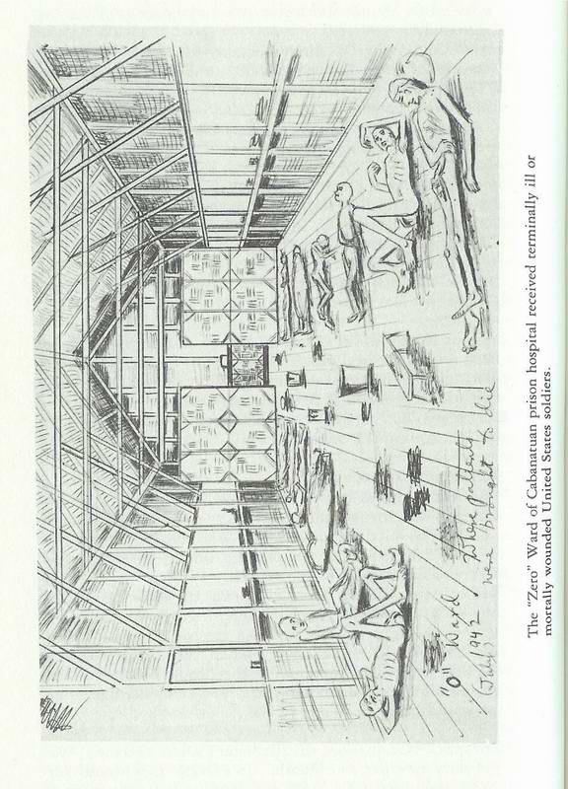
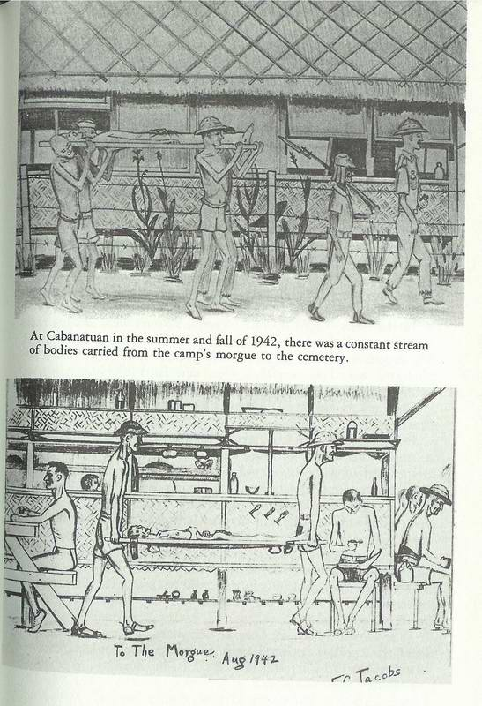
canteen; in the upper half was water that they could pour out, if the Japs became suspicious. Gradually, the captives became very knowledgeable concerning war activities; Jap guards contacted the Americans for the latest news.
Scuttlebutt (Rumors): The word "scuttlebutt" was an old Navy term probably antedating the father of the U.S. Navy and his first ship, the U.S.S. Alfred in 1775. The butt was a bucket or cask often placed near the ship's ladder, where sailors congregated for a drink of fresh water, and to exchange rumors.
When the sailors joined the soldiers and airmen on Bataan, scuttlebutt soon followed, and usually referred to: Long convoys filled with food, vast supplies and equipment and loaded with troops-replacements-that President Roosevelt kept assuring us were "On the way." The convoys always proved to be phantom, or arrived safely in Ireland, Australia or Africa, never in the Philippines.
In the Cabanatuan P.O.W. Camp, rumors were always rampant, especially in the evening when daily activities were finished. The scuttlebutt often referred to big Allied victories, prisoner exchanges, ships loaded with food, a new Ford for every prisoner, promotions, decorations, etc., etc.
They all proved to be figments of the imagination-just pure scuttlebutt.
Prisoner-of-War Status: About October of 1942, the Japanese removed our status of "captive" (criminal awaiting trial) and designated us as "prisoners-of-war!" We hoped that this meant that things would get better.
We began receiving pay-the same as the Japanese officers and soldiers of the same rank. I quickly learned that after receiving my thirty yen at the pay window, I had to move to the next window and deposit twenty yen into Japanese Postal Savings.
When I graduated from Prison Camp (Class of August, 1945), I had more than 30,000 yen in Postal Savings. They have never offered me any money, or a Toyota; in fact, they haven't even answered my mail.
Post Cards: When we became prisoners-of-war, each prisoner received a yellow, printed form post card. He could fill in the blank places, sign it, and it would be sent home.
"Major Eugene C. Jacobs
I am interned at Philippine Military Camp No.1.
My health is fair
I am Uninjured
Please take care of Insurance

Love, Eugene C. Jacobs, 1897"
We were allowed to send one post card every six months during thirty-eight months. The last card was a fifty-word card.
Mail: About the same number of times shipments of letters and packages came into camp from the States. Censoring was extensive. I got one letter that was completely cut out, except, "Dear Gene, -------------------------------------------------------------------------------------------------------------------------------------------------------------------------------------------------------------------------
Love, Mother

Of course, these letters and packages were a Godsend. We passed the letters around to all of our friends, hoping there might be something of interest to them. We ate the cheese and malted milk in the packages-even when they had maggots in them. It was a great boost to our morale to know that someone loved us and was praying for our safe return.
Commissary: We were permitted to have a commissary; my ten yen each month bought a can of salmon or condensed milk, several bananas, a cup of mongo beans or peanuts. Once I was able to buy a live chicken and have a Thanksgiving dinner. The commissary was operated by Lt. Col. Harold K. Johnson (later to become the Chief of Staff of the U.S. Army), Capt. Amos and Capt. Norton. Gradually inflation became so bad that the Japanese pay become almost worthless.
Chapel Service: We were permitted to go to church on Sundays.
The sermons had to be censored on Saturdays; there was often a Jap attending service-to keep the preachers honest. Lt. Col. Alfred Oliver, U. S. Army, was chief of chaplains in the Philippines by reason of seniority.
Two protestant chaplains built their own chapels with scrap lumber and prison labor. Capt. Frank Tiffany was a Presbyterian; I became an elder in his chapel. Capt. Robert Taylor was a Baptist. I became a deacon in his chapel. Other chaplains used mess halls, libraries and even barracks to hold their services.
Catholic chaplains were: Majors Stanley Reilly and Albert Braun, Captains Richard Carberry, John McDonnell, Stober, Albert Talbot, Tom Scenina, and Dugan, and Lieutenants McManus, James O'Brien, Mithias Zerfas, John Wilson, Duffy, William Cummings, and John Curran.
Protestant chaplains included: Majors John Borneman and Ralph Brown, Captains Sam Donald, Leslie Zimmerman, Morris Day, Arthur Cleveland, and Lieutenants Quinn, Herbert Trump and Ed Nagle (a missionary from Baguio).
Chaplains of unknown denomination: William Dawson, Joseph Vanderheiden.
Jewish cantor: Aaron Kliatchko.
Christmas Midnight Mass and Easter Mass were very colorful events attended by all healthy prisoners. On May 30th of each year (Decoration Day), the Japanese allowed one thousand prisoners to visit the cemetery. Chaplain Oliver led the services; Major Iwanaka Oapanese Camp Commander) presented a large wreath.
Chaplains took turns accompanying the Burial Detail from the morgue to the cemetery nearly every day-giving graveside services. Chaplains' visits to the wards of the hospital were much appreciated by the patients-sick, depressed and underground dying.
Underground: After being in camp for several months, I discovered that some of the captives were leaving notes (addressed to friends in Manila) on their beds. In some mysterious way, they were picked up and delivered in Manila. In a couple weeks there would be an answer, also left on the bed of the sender.
Sometimes there would be money, medicine and even food.
Looked like a good idea! I didn't inquire about the mechanics of the Underground. In fact I didn't want to know. I had had amoebic dysentery with bleeding for four months-with a loss of fifty pounds weight. Here was a chance to get some medicine.
I had a Spanish friend in Manila, the president of an insurance company. When he had been in Baguio with his family prior to the war, he brought his eight-year-old son to me because of a chronic stomach ailment. I made the diagnosis of "peptic ulcer" and treated him with good results. The family was quite pleased.
So I wrote Jose Olbes a note explaining my predicament.
Sure enough, in two weeks, on my bed was a note, carbazone (medicine) and twenty pesos. In another two weeks I was feeling better and gaining strength. I never inquired further about the Underground, figuring that someday someone would get caught, and the penalty would be severe.
During the two years that the Underground operated, it undoubtedly saved the lives of hundreds of prisoners. After the war was over, I learned the mechanics of the operation:
In the early days of the war, a 31st Infantry Sergeant John Phillips married a Claire (?) on Bataan. Sgt. John survived Bataan and the "Death March," but died on July 27, 1942 in the Japanese P.O.W. Camp No.1 at Cabanatuan.
A few weeks later his wife, Claire, received a note from Chaplain Frank Tiffany in Cabanatuan, verifying that Sgt. John Phillips had died of malaria, dysentery and starvation. Frank ended his note with, "I beg you do not forget the ones that are left; they are dying by the hundreds! God Bless You!" Everlasting (code name). To fill her emptiness, Claire vowed revenge. Claire returned to Manila; she obtained false Italian identification papers from the Japanese, stating that she was born in Manila of Italian parents.
Claire opened a nightclub, The Club Tsubaki (Camelia) and sang her heart out every night to high-ranking Japanese officers, all the while raising money to send to the sick and dying at Cabanatuan.
When the Japanese officers became "high and loquacious," she pumped them for information concerning the movements of Japanese ships and troops, and forwarded this information to guerilla leaders.
Claire assumed the code name of "High Pockets," because she kept her valuables in her bra. Once every two weeks, High Pockets "baked cookies!" (That is, collected notes, money and medicines from prominent citizens in Manila: Juan Elizaldi, Judge Riveria, Lopes, Dr. and Mrs. Romeo Atienza, Father Lopez, Judge Roxas, and many others.)
A Filipina mestiza, Evangeline Neibert (code name, "Sassy Suzie"), carried "the cookies" by train from Manila to the town of Cabanatuan, where she delivered them to the market.
Naomi Flores (code name, "Looter"), a brave Filipina, who had also lost a husband in prison camp, obtained a Japanese license as a vegetable peddler and worked in the Cabanatuan market. Naomi hid "the cookies" in the bottom of rice sacks to be taken to camp.
Once or twice a week, the "Rice Detail" from Camp #1, went to the market in Cabanatuan to get some hundred pound sacks of rice for the mess halls.
In the mess halls, the notes were removed from the sacks of
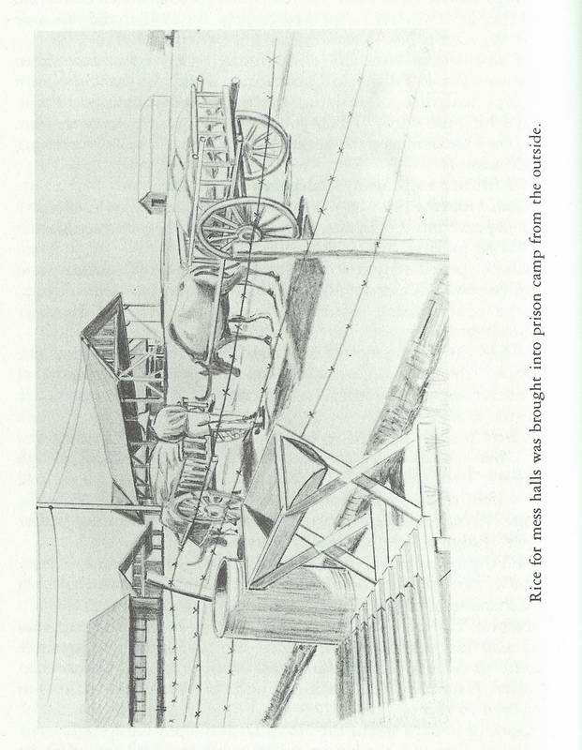
rice, and delivered to one of the following:
Captain (Chaplain) Frank Tiffany-"Everlasting"
Lt. Col. Jack Schwartz, Hosp. C.O.-"Liver"
Charles De Maio (U.S. Navy)-"WOP"
Lt. Col. Mack (Inspector General)-"DITTO"
Captain (Chaplain) Robert Taylor-"Chap BOB"
Captain (Chaplain) John Wilson-"Left Field"

Helpers delivered "the cookies" to the beds of the senders of notes, and picked up notes for future delivery in Manila.
High Pockets also baked "cookies" and collected intelligence for the guerrilla leader-Major John Boone (code name, "Compadre") for delivery to MacArthur.
The Underground continued for about two years. The Japanese became suspicious when the prisoners were spending more money in the commissary than they were being paid by the Japanese.
May 3, 1944: Six carabao drivers were arrested on their return trip from the market, and taken to jail in Cabanatuan city: Fred Threatt, Sgt. S.H. Bish, St. Sgt. Virgil Burns, Pvt. Reed Philipps, Tysinger and Rose.
The Japs seized the rice sacks with the notes, money and medicines in them.
May 10, 1944: Capt. Pat Bynes, Lee Baldwin, Capt. Jack LeMire, Lt. Bob Shirk, Sgt. Alexander, Walter Jasten, Bellew, and Cherokensky were picked up by the Japanese Military Police-along with all their belongings. That afternoon Gov. P.D. Rogers and Lt. Col. Mack were nabbed.
May 11, 1944: Sixteen Americans and eight Filipinos were taken away in a truck. All had their hands tied behind them.
May 12: Jack Shirk and Chaplain Tiffany were taken to Cabanatuan.
May 16: Five carabao drivers were returned to camp. Several prisoners were placed in "Sweat Boxes" in the middle of the field-on one meal per day: Lt. Col. (Chaplain) Alfred Oliver, Lt. Col. Jack Schwartz, Capt. (Chaplain) Bob Taylor, Col. Mack Rogers, Threatt, and Rex Aton.
Almost three months later, on August 5th, the Japanese doctor (Isha) came to me and said, "Come with me!" We walked out in the field to the sweat boxes, specially to one containing Chaplain Oliver; it was about three by three by five feet, too small to sit up-too short to lie down without curling up. Isha seemed to speak English quite well. I was surprised when
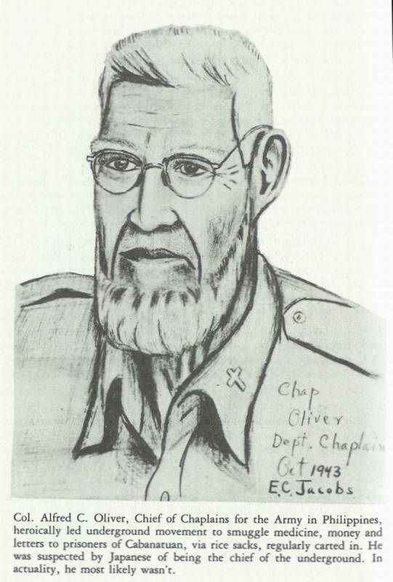
he seemed to be rather friendly and told me: "I like American music, especially 'Old Black Joe,' and 'Way Down upon the Suwannee River,'" adding, "you must not speak to Col. Oliver. You examine him, and then tell me the diagnosis and prognosis."
I found the chaplain semiconscious with large bruises on the back of his neck. I told Isha, "He has a fractured neck. He will die if we leave him here; he must be taken to the hospital." Isha said "OK! You take him to hospital!"
Chaplain Oliver had married Judy and me at the Walter Reed Hospital Chapel about six years before. We both had great affection for him and his wife. It was very distressing to see him in this condition. He was a big man, in spite of many months of starvation; I had an awful time carrying him back to the hospital. (In spite of his broken neck-caused by being hit with the butt of a Japanese rifle while being interrogated regarding the Underground, he survived to return to the United States and to be honored by the Supreme Council of Scottish Rite Masons with the esteemed 33rd Degree.) I don't believe that Chaplain Oliver ever had an active part in the Underground, but he was suspect because he was senior chaplain in the Philippines.
August 30, 1944: Again, the Japanese Isha came to get me: "Come with me! We go to examine Chaplain Taylor, but you must not speak to him! You tell me diagnosis and prognosis!"
Being a deacon in his church, I had great respect for him. He was very weak and obviously quite sick.
"Doctor Isha, I do not know his diagnosis, but I do know if we leave him here, he will die! He must be taken to the hospital." Isha replied, "OK!"
The next day Bob conveniently coughed up a twenty-inch worm, which I could show to Isha. He seemed satisfied. I could breathe easier. (Bob survived, in spite of wounds received on a "Hell Ship" to take Judy a note that I wrote in Japan when I thought I was dying. He later returned to active duty with the Air Force and eventually became a major general and Chief of Chaplains.) He also was made a 33rd Degree Mason.
A third time the Japanese Isha came to get me to go out to the "sweat boxes"-this time to examine Lt. Col. Jack Schwartz, Medical Corps and Commander of the camp hospital. "You must not talk to Col. Schwartz! You make diagnosis! Then you tell me!" This time I didn't have to talk to Jack; he was talking to me in medical language. He had assumed the typical position of
"acute appendicitis." I examined Jack and reported to the Isha: "Col. Schwartz has an acute appendicitis! He will die if we don't operate!" Again Isha said "OK! You take him to hospital! You take out appendix and show me!"
We took Jack to the hospital and got the operating room ready. Col. Bill North removed an appendix, which was quite normal. I couldn't show it to the Isha! Fortunately for me, after viewing Jack's recent incision, he seemed satisfied. (Col. Schwartz survived to return to the States, to go back to active duty and eventually become a major general, and to command Letterman General Hospital in San Francisco.)
Claire Phillips: While the investigation of the underground was proceeding in the Cabanatuan POW Camp, Claire Phillips (High Pockets) was picked up by the Military Police in Manila.
She was taken to the old Spanish Fort Santiago, thrown into a dungeon and then cruelly interrogated by the Kempei Tai (Secret Police) to make her talk. She was given the water treatment (a hose was put down her throat, the water turned on-until she was suitably distended, and then the interrogators jumped on her abdomen until she talked.)
Claire would have probably been executed, but was spared death by the sudden dropping of the atom bombs, followed by the quick conclusion of the war.
Cabanatuan Cats (Orchestra): Everything in camp was not always dire; we had a few lighter moments. Several captives had been successful in bringing their own musical instruments into camp. In the fall of 1942, Capt. Lee Stevens, Army Transportation Corps, was able to obtain a small piano from his home in Manila.
Soon after, Father Bruddenbrook, a Belgian priest, acquired a miniature piano and several instruments.
P.F.C. (private first class) Johnny Kratz, a clerk on Corregidor, organized an orchestra, the Cabanatuan Cats. The Japanese enjoyed music and permitted the orchestra to practice several hours each week and to give a concert on Wednesday evenings. The orchestra and singers did much to raise the morale of the camp.
Some of the musicians were from big-name bands. Eddie Booth and Pappy Harris played pianos; Marshall on the saxophone and clarinet; Lt. Claire Kuncl (57th Infantry) was tricky on the trombone; Lt. Larry Parcher and Pvt. Salas played trumpets; Chester McClure and Sgt. Melvin Reinhart played guitars; Red Kadolph beat the drums; and Captain Joe Salee sang a beautiful

tenor. Butch Manke, Hank Ruhl, Chuck Kaelin and Louie Baller were vocal soloists; and Sgt. Becher, Al Roholt, Hank Ruhl and Harry Mock formed a barbershop quartet called the Four Bees.
When the Cats played "Rhapsody in Blue," you could close your eyes and imagine Paul Whiteman's complete ensemble performing on the stage-they were that good. For a few brief moments, the horrors of reality vanished.
Because of the large number of prisoners from Texas and New Mexico, "San Antonio Rose," "The Eyes of Texas," and "The Yellow Rose of Texas" always received great applause.
Nearly every ambulatory prisoner placed his blanket out in front of the stage in the afternoon to reserve a seat for the eight o'clock performance. As soon as the music began, many Jap guards gathered around to listen.
Favorite songs were: "Stardust," "Tennessee Waltz," "A Pretty Girl Is Like a Melody," "Mood Indigo," "Deep Purple," "Sleepy Lagoon," "Sentimental Journey," "Fascination," "Tenderly," "Sweet and Lovely," "In My Solitude," and many others. A native song, "Planting Rice," was popular. And once in a while, they even got away with "GOD BLESS AMERICA!" of course without words.
In October of 1944, the orchestra was ordered to Japan on a prison ship; the ship was unmarked, and after a few days out, was sunk by an American submarine. All members of the orchestra were lost!
Stage Shows: The first few months of camp, we had so many captives transferred to Group IV (the cemetery), that the future seemed very bleak. To raise the camp morale, Lt. Col. O.O. (Zero) Wilson began a variety program in Group I; Lt. Bill Burrell started a medicine show in Group II and Captain Bleich initiated shows in Group III.
In October, 1942, Col. Zero combined the shows into a central casting office, and every Saturday night put on a super colossal by the Cabanatuan Mighty Art Players.
Some of the actors were: Al Manning, Robin Swann, a Britisher, Don Childers, Ben Mossel, Bill Nealson, Robert Brownlee (a Negro and camp favorite), Bill Burrell, Eddie McIntyre (female impersonator), and many others.
Some of the fifty-four productions were: Casey Jones, The Drunkard, Gone with the Wind, Journey's End, Uncle Tom's Cabin, etc.
Glee Club: Several times, Sgt. Clarence Sayre's Glee Club put
on entertainment in the three groups and in the hospital: "The Halleluiah Chorus" was among all time favorites.
News Reels: On a rare occasion, when the Japs had a big victory to gloat over, they would show the camp a news reel. The photography was horrible. They had not yet achieved the American know-how in making cameras, film, radios, televisions, automobiles, computers, etc.
Library: Some two hundred books were collected from the barracks in Group II. Records were kept on the back of labels off condensed milk cans. Other groups started collecting books and the number reached nine hundred including magazines.
In November, 1942, a camp library was started by Lt. Col. Babcock, assisted by Capt. Brunette and Lts. Trifilo and Edwards. Prisoner details were sometimes able to obtain books or magazines on their journeys.
Classes: Captives were forbidden to gather in groups without special permission. Classes were formed in many subjects: Japanese, German, Spanish, Russian, and Tagalog (native Philippine language). There were classes in astrology, banking, photography, history, cheese and wine making, menus, diets, etc. One prisoner, almost blind, wrote a cookbook.
Games: Many games were played during off-duty hours: cribbage, acey-ducey (U.S. Navy), chess, checkers, bridge, poker, and the like. At times baseball and volleyball were attempted, but beriberi definitely limited any enthusiasm and the games died out.
Soochow, a Chinese bulldog and Marine mascot, gave much pleasure to many prisoners-he thought he was an officer.
Masons: In August, 1943, two Masons, Chap. John Borneman and Major Howard Cavender (former manager of the Manila Hotel), were instrumental in getting money, medicine and food from Masons in Manila through the underground and donating it to prisoners.
In a camp where competition for survival was becoming a serious problem, where officer was stealing from officer, it was a real joy to see the brotherly love of Masons for their fellow men. I decided that someday I would be a Mason.
The Morgue: It was only a short distance from Zero Ward to the morgue, where bodies were accumulated, awaiting the daily trip to the cemetery.
The Cemetery (Group IV): Once each day, thirty to fifty
captives formed lines at the morgue to carry the naked bodies on window shutters to the cemetery, about one-half mile from camp. Following a brief religious ceremony, the skeletonized bodies were lowered into common graves. On rainy days the graves filled with water; it became necessary to hold the bodies down the poles, while dirt was shoveled on to them. Sometimes the rain would uncover an arm or leg; then animals ate away the flesh.

BOOT HILL *

No monuments nor flowers there amid the fields of cane,
No birds their song to fill the air, No trees to shield the rain.

We've watched these things through tear-dimmed eyes,
We've felt a sense of shame,
But now we see as time goes by,
We are really not to blame.

No, it's surely not the best,
No glory does it claim,
It's just the place where we laid them to rest,
Our friends who lost the game.

Chapter VI
JAPANESE ATROCITIES

The Japanese were a proud people, regarding themselves as descendants of the gods, a superior race, destined to bring light into a darkened world. Should any wicked nation dare to impede or to obstruct their Emperor in carrying out his celestial undertakings, Japan would fight-by the command of the Japanese gods to reunite all nations under the rule of the Japanese Emperor.
The Imperial Rescript of the Emperor to his military powers included the following statement: "Should any emergency arise, "Boot hills were at Camps O'Donnell & Cabanatuan, written by Ed "Tommie" Thomas while in the hospital at Cabanatuan with diphtheria. The burial details went by the barracks each morning as he watched, wondering if he would be on one of those litters the next morning.
offer yourself courageously to the state, and thus regard to maintain the prosperity of our Imperial Throne, Coeval with Heaven and Earth."
As late as 1877, the ancient custom of making trophies of the heads of the enemy soldiers was still in effect in Japan.
Japan violated the Geneva Convention in 1931 when she invaded Manchuria, and again in 1937 when she invaded China both without a declaration of war. The world shouldn't have been surprised when the Japanese bombers made their sudden attack on Pearl Harbor without a declaration of War, further violating the Articles of Code 1929. Actually, the Japanese had never approved the Geneva Convention, either in theory or in practice, especially concerning P.O. W. s.
To the Japanese, surrender was a violation of military morality. In any defeat, a loyal Japanese soldier would commit hari kiri.
Discipline in the Imperial Army was enforced by frequent slapping, beating and kicking of junior officers and enlisted men for rather minor offenses. For serious crimes, discipline was more complex. The victim could be turned over to a Judo expert for suitable punishment. He could be given the water treatment. He could be tied to a fence post, and slapped beaten or kicked by each passing soldier. He could be used for bayonet practice by recruits. Severe crimes called for an officer to unsheathe his samurai sword and behead the criminal. The head was displayed to others, tied to a bamboo pole, so the observer would learn that crime does not pay. Enlisted men with little or no rank, had no one to slap, beat or kick, so a captured enemy filled an important gap in their system. In the minds of the Japanese, they were. Not barbarians or savages, but merely loyal and patriotic personnel administering a just punishment to those who dared to defy authority, the Emperor or the Gods.
Atrocities were committed on many work details, including the farm. Some were for the punishment of rather minor rules and others were for the amusement of the guards, who enjoyed watching the Americans performing super Herculean tasks.
Once a month, I had to carry hundred pound sacks of rice from the gate to mess halls. This could have been easily accomplished by carts, but the Japanese thought that the Americans should "pay the price!" As a result I developed three hernias, which became a considerable handicap in completing my tour
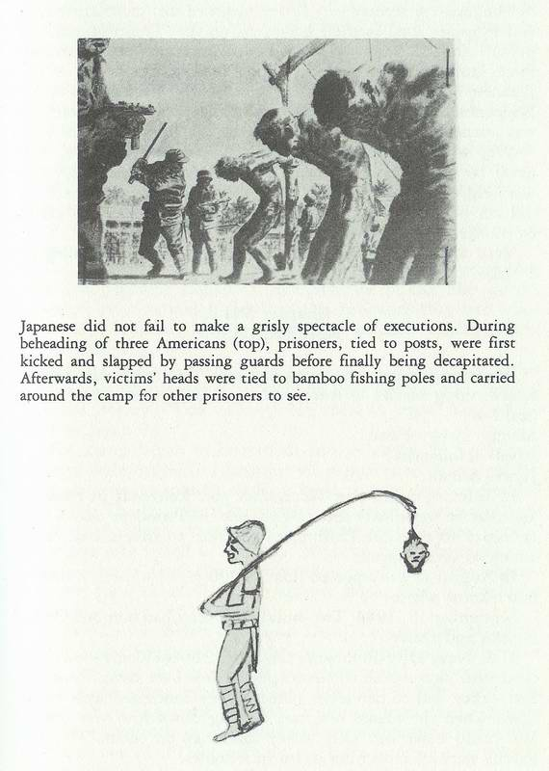
with "the Sons of Heaven."
The Japanese seemed very little concerned that more Americans and Filipinos died as their prisoners, on the "Death March," in prison camps, on labor details, hell ships, and working in coal mines and munitions factories, than died at the hands of the Japanese on the battlefields. Those of us, who were guests of the Nipponese Emperor, have little doubt that some of the treachery was learned from the German Kulture.
We, who were captives and prisoners of the Japanese, will never be able to forgive them, but knowing their background did help to explain some of their vicious actions. However, it did not make their barbarous, brutal, cruel savagery any easier to endure.
Very few ex-P.O.W.s will ever drive Toyotas, Datsuns or Mazdas.

Chapter VII AMERICANS!

We kept getting reports on our little radio that MacArthur was winning battles in many places, some of which we'd never heard of:
March, 1944 – Palau;
April – Hollandia;
June – Saipan.
In July, we heard that MacArthur met Roosevelt in Hawaii, and that he was finally able to convince the President that it was necessary to take the Philippines in order to have a base from which to attack Japan.
In August it was reported that 30,000 Japs had been killed don't know where. .
September 15, 1944: Two-hundred aircraft had bombed Cebu, Negros and Panay.
U.S. Navy Dive-Bombers! On Sept. 21-suddenly-out of a clear blue sky-some thousand planes flew over camp from the east-they had to be carrier planes. They continued west to an hour. Then the planes returned coming down low over camp.
We could make out U.S. Navy markings on them. The Jap guards were all crouching down in foxholes.
"Don't lose your head now! Don't show any emotion! The Nips are all trigger-happy, just waiting for an incident to happen
before shooting up the camp."
A big Jap bomber tried to sneak off the local airfield that we had built with prisoner labor. It was flying low-barely over the treetops. A Navy dive bomber saw it, dropped down right over it and strafed it with incendiaries. In seconds there was a big explosion and tremendous orange flames as the bomber plowed into the ground. This was followed by billows of black smoke lasting several hours.
It was a great show! It was tough trying to repress our elation. There was no food served that day - a typical Japanese reaction.
We all believed that freedom must be close that the Americans would be making landings soon. That night morale was high; the camp literally buzzed with rumors. A few Navy planes appeared almost daily.
October, 1944: MacArthur invaded Leyte producing 100,000 Japanese casualties. The attitude of the Nip guards changed very markedly; they lost the arrogance they had when they were winning the battles; some became sadistic; some became friendly.
A big Jap "shakedown." Every prisoner had to display all his possessions. Japs picked up all mosquito netting and tropical helmets, saying, "You vill not need these in Japan! You vill be sent to Japan!"
The camp began to buzz with rumors again. U.S. Medical officers were ordered to examine all prisoners to determine the ones well enough to make a trip to Japan and the ones too disabled to travel. The Japanese did not want any amoebic dysentery cases in Japan. Suddenly, there was a new commodity "warm stools." Prisoners, who feared a "hell ship" cruise to Japan, bartered for a "hot specimen" from a known amoebic to present to the laboratory for examination hoping against hope, that it would be "positive."
Japan Detail: Before our Japan Detail departed for Manila, I asked Major Stephen Sitter, the camp psychiatrist, "Why is it that very few of the 12,000 prisoners spending time in the Cabanatuan camp ever made any attempt to take their own lives when they were starving, suffering from many diseases and were frequently in unpleasant and uncomfortable situations?"
He answered, "They were all too busy figuring out ways to survive; they didn't have time to think about suicide."
Between October 21 and 27, about 1600 prisoners, the Japan
Detail, were loaded on trucks to be delivered to the old Spanish prison in Manila-Bilibid. Before leaving, several of us prisoners buried diaries, notes, sketches, etc., near the buildings in which we lived, hoping to retrieve them after the war. My 110 sketches were placed in a Mason jar and buried near Bldg. #12. On our way to Manila, our truck had to stop frequently under big trees-to hide from the numerous U.S. planes passing overhead.
Cabanatuan Rescue: After the exodus of the Japan Detail (the so-called healthy prisoners) in late October, there were only 511 unhealthy prisoners remaining in camp.
Things were rather quiet until about 2000 hours on January 30, 1945, when sudden gunfire from outside the camp wiped out all of the Japanese guards in the towers. It was MacArthur's 6th Ranger Battalion under the command of Lt. Col. Henry Mucci - aided by guerrillas - walking into camp. They quickly obtained carabao carts and sleds for the bedridden prisoners.
That evening 511 internees were moved many miles down the road to the west in the moonlight with hardly a shot fired. Early the next morning they arrived at a transportation center, where prisoners were placed aboard trucks and ambulances and taken to Lingayen Gulf; then they were transferred to planes and flown to Manila. After suffering from more than three years of intentional neglect by the Japanese Imperial Army, they were finally "free men."
No prisoners were lost in the operation; there were two casualties among the Rangers: Capt. James Fischer, the doctor, was killed by mortar fire near the main gate of camp. Cpl. Sweezy died from wounds.

Chapter VIII
"OLD" BILIBID PRISON

Our trucks entered the main gate of Bilibid, where we dismounted and walked to a large stone building in the back of the old prison. I was assigned an area two by six feet in the middle of the hall on the second floor. My bed was a blanket on the concrete floor. The windows were all boarded-up.
We were greeted by other prisoners: "American planes have been making daily bombing raids on the port area only a few blocks away and on the ships in the harbor - Manila Bay." We thought, "That's good! Maybe they won't be able to get
us out."
"MacArthur must be getting close! When the air-raid alarms sounded, the guards have been chasing all of the prisoners inside the buildings."
"We were able to find peepholes where we could watch the U.S. planes dive down through heavy flak of anti-aircraft guns, to drop their bombs on important targets."
It was not long until we had a front seat to a bombing raid.
We watched black smoke billowing up from burning oil tanks really a great show! It was also quickly evident that slow starvation was the daily pattern at Bilibid. The high walls made it impossible to get any extra food. My weight was now 110 pounds.
In November, I developed dengue, a mosquito-born disease called "break-bone fever." It was properly named-felt .like every bone in my body was breaking. For ten days I was in the prison hospital, overlooking the main gate and Rizal Ave. I didn't care much whether I lived or died - one chill after another. No appetite! I couldn't eat the thin lugao they brought me. Lost weight and strength. I was in bad shape to start a trip through MacArthur's blockade.
About December 1st, I was pronounced well! I dragged myself back to the big stone building and my area on the concrete floor. My bones were getting very close to the concrete.
Shortly, a typhoon arrived; the winds blew, the skies darkened and heavy rains beat down-generally very unpleasant. No planes arrived to make their daily attacks.
In a few days, we began to hear ships' whistles and bells again. That meant ships were moving in and out of Manila Bay, unmolested by bad weather and U.S. planes. This was a bad omen! The Japs would probably get us aboard a ship and on our way through MacArthur's blockade.
Again, the Japanese ordered our medical officers to examine all prisoners in Bilibid, to determine those healthy enough to complete the trip to Japan, and those sick enough to remain behind the stone walls-to be recaptured by MacArthur's troops in a few weeks. My better sense told me it would be smarter to be sick and be rescued, but my conscience kept telling me I should go along.
Liberation of Bilibid Prison: MacArthur's invading forces landed on the beaches of Lingayen Gulf on January 9th, 1945, with the aid of Col. Russell Volkmann's Northern Luzon guerrillas
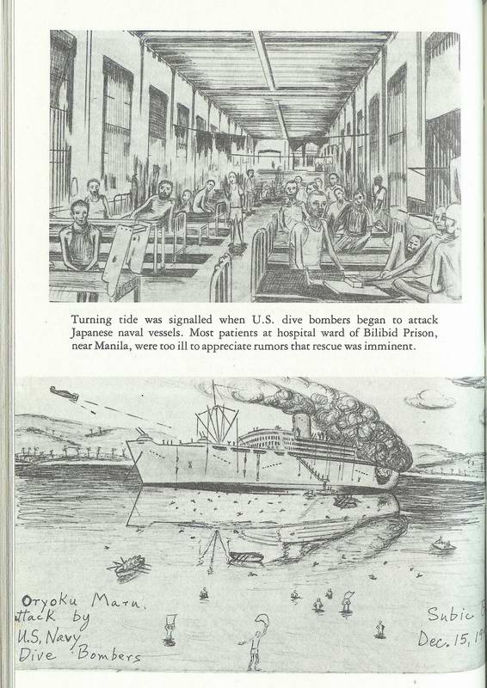
Headquarters were established in Dagupan.
On February 4th, a flying column of the 1st Cav. Div. Under Brig. Gen. William Chase entered Manila and relieved the prisoners from Bilibid. As a soldier broke down a boarded-up window in the stone wall near where Ted Winship was busy quanning (cooking), Ted asked, "Who are you?"
The soldier answered, "I'm Sgt. Jones! We've come to liberate you!"
Ted countered with: "Where the hell have you been for three years?"

Chapter IX JAPAN DETAIL - ORIENTAL TOUR STRICTLY THIRD-CLASS!

In the fall of 1944, when MacArthur's forces were threatening to retake the Philippines, the Japanese began to evacuate all healthy prisoners of war to Japan, so that none could be liberated to assist the invading army. The death of a prisoner by any means was considered preferable to capture by the invading troops Japanese thinking).
"Hell Ships": The "hell ship" journey began at old Bilibid Prison.
December 13, 1944: Long before dawn, we were awakened by the ringing of a large bell at the prison guardhouse. The day we had been dreading for many months, had arrived; 1619 of us would depart from our uncomfortable quarters and start a long journey to Japan. Thoughts of riding on a prison ship filled us with apprehension; several prison ships had already been sunk and many of our friends had been lost.
We lifted our emaciated bodies from the concrete floor, showered and shaved in the dark; we didn't know when we might experience such luxury again. We put our few worldly but worthless possessions into our packs. Breakfast was the usual half-cup of lugao.
As the first light of day peeked over the high stone wall, we were lined up with our baggage; we stood for hours as Col. Beecher, USMC, our commanding officer, and a Japanese guard wandered through our ranks-trying to get a head count. The guards, a rather ignorant group, were completely puzzled by such a large number - 1619. Finally about 0800 hours, everything
seemed to be ready. Shouting and waving disabled prisoners filled the windows and doors as our long line moved slowly through the gate and dawn Rizal Avenue. When the line was about was quickly reversed and hurried back into the prison: "Kura! Hully, Hully! Speeda! Speeda!"
We couldn't see any planes, but were kept in line far hours. Sweat rolled freely dawn our faces and backs. Guards went among us, picking up mosquito nets and tropical helmets: "Don't need in Japan!"
At 1100 hours, the long line moved slowly out the gate. Rizal Avenue was crowded with saber, gaping Filipinas not the, happy-go-lucky ones we had known before the war. Occasionally when hidden from guards, they would give us a "V" sign. We dared not acknowledge it.
We could see "pity" on their faces as we passed dawn the streets, by the Metropolitan Theater and over the Passig Bridge. The natives’ looked haggard and ragged. Most of them were on foot rather than riding the usual caratellas or caramettas (pony carts). Many stores were closed, boarded-up. Many homes showed signs of looting. Metal had been removed from every available place-iron bars from windows, manhole covers from streets taken to Japan far making armaments.
We went the long way through Luneta Park; we saw artillery and anti-aircraft positions there and in the streets. It appeared that the Nips would put up a good fight to retain the Philippines.
There were many ships in the bay-destroyers and cruisers as well as transports. Same had been sunk; many were nearly submerged or listing badly; yet others appeared to be unharmed.
Tugs and tenders moved briskly about the bay; derricks strained aver damaged vessels. All in all, there was entirely too much activity far a supposedly blockaded port!
There were many Japanese civilians, mostly women and children, milling about Pier Seven. They were short and stocky, dark and expressionless. Most of them were carrying cloth or straw bundles-their possessions. They were being evacuated to Japan to avoid the battle far the Philippines that everyone knew was coming.
As we arrived on the pier, we were divided into groups of one hundred and ordered to "Sit dawn and stay in place!" The floor was filthy, but the rest was welcome.
Oryoko Maru: By squirming around, I could read the name of
the ship, Oryoku Maru, on the bow painted over with gray as was the whole ship. There was nothing to mark it as a ship carrying prisoners. Winches were working rapidly, raising American-made appliances and cars to the deck.
I discovered a water faucet nearby and eased over to it to fill my canteen, only to be driven away by a jabbering guard. I was not enthused about making a trip through MacArthur's blockade with an empty canteen. However, I did get a good look at the ship. It was a large, modern passenger liner with several big anti-aircraft guns on the deck. The ship was not to be sunk without a good fight.
Pier Seven showed much evidence of heavy bombing, but was still definitely usable. Just before dark, prisoners began to climb the ladders to the deck. The aft hold was loaded first 719 prisoners. Next, the forward hold with 718 prisoners.
Just as we, the remaining 182 prisoners were ordered into the second hold (behind the forward hold), we were joined by seven additional prisoners who had come from Fort McKinley, a few miles east of Manila. Many others were on the way to join us, when their lead streetcar conveniently left the tracks.
Our group, now 189, was composed mostly of medics and civilians. The ship's cabins, dining rooms and parlors were crowded with several thousand women, children and elderly Japanese civilians. We dropped our packs into the hold and quickly descended the long ladder into darkness hurried by the grunting guards and their "vitamin sticks."
There was not enough room for everyone to sit down. Our group of medics crowded together in the center of the hold. The floor was filthy, covered with horse manure. The stench burned our eyes; our roof was the darkening sky. We were glad for its protection. The ship was soon under way, moving smoothly and rapidly.
We were divided into groups of twenty. A representative of each group was sent above to get small amounts of fish, rice and water. Our latrine was a five-gallon can in the center of the hold; it was soon filled.
Sleeping was difficult; we were awakened each time a neighbor would move, because of cramps, numbed extremities or the urge to urinate.
December 14, 1945: Thursday - We were awakened at the first sign of daylight. Three of us who had shared an interest in

a can of Spam saved for several weeks from a Red Cross package-debated whether or not to eat it. We decided to save it for a suitable emergency.
Our group representative went above to the kitchen for a bucket of rice; he brought back bad news from the other holds which were more crowded: "Some thirty prisoners had died from suffocation during the night. Several, suffering from extreme thirst, had become crazed, slashing and biting throats, arms and legs to 'suck' the blood. Some men actually had to fight off their neighbors with a shoe or a club to keep from getting murdered. Several frenzied prisoners tried to climb the ladders and were immediately shot by the guards. Perhaps this was a blessed relief from their tormentors."
Our representative also told us, "We are in a convoy of some seven ships, a cruiser, destroyers and transports, loaded with troops (probably sick and wounded). We were moving north along the Zambales coast at about twenty knots."
About 0900 hours I heard planes; many of them; soon there were loud blasts from the anti-aircraft guns on the deck above. The planes began to dive. Faster and faster they whined. Then tremendous explosions! They were attacking the other ships; they could knock us off at their leisure.
Then bullets and shrapnel slashed and rattled through our hold- as several food carriers were coming down the ladder with buckets of rice.
One of these was my good friend, Chaplain Ed Nagel, a former missionary in Baguio, shot through the thigh. With blood streaming down his leg, he continued down the ladder carrying a bucket of rice.
"U.S. Navy planes!" he shouted.
There was no doubt now; our ship was the target, and we were sitting on the bull's eye.
Motors continued to accelerate-then terrific concussions; the ship quivered and was actually bouncing in the water. The air was full of bomb dust and chips of rust; it was becoming difficult to breathe. We tried to move toward the side of the hold and huddled close together. My heart was pounding like a trip hammer in my parched throat; my ears were ringing and my eyes were popping. I completely forgot how hungry I was. Each prisoner was conversing with his God. I had quick visions of my family they'll never know what happened to me. There'll be
no survivors to tell them. Will it ever stop?"
Many men were bleeding badly! There was much confusion, much moving around. Everyone was trying to get in a safer place, to get bandages, to apply pressure to wounds it was hopeless; everything was covered with dirt and dust.
The planes were diving again, spraying their deadly missiles. (I have neither the will nor the talent to describe the gory details.) "Would this be the explosion that would blot out our existence?" Then it was over! Complete silence!
Stunned, we moved into the center of the hold to get better air to breathe and to thank God for surviving. We bandaged the wounded and moved them into positions of relative safety.
But our quiet didn't last long! More planes! More anti-aircraft blasts! More explosions! More concussions! More dust and dirt!
As a doctor, I had seen many people die during the previous sixteen years. I knew that nature was usually kind to dying persons, supplying stupor and coma to ease any pain. But I wasn't ready to die-I wasn't even forty, when life is supposed to begin. We had buckets of rice, covered with dirt and rust chips, but no one could eat.
Fifteen more times that day planes returned to attack our ship. Five times the gun crews on the deck were annihilated and replaced with fresh crews. There had been no lack of bravery on the deck. Officers continued to wave their sabers at the pilots. During the last bombing, fragments of rock flew into the hold; our ship had been beached on the Zambales coast to prevent its sinking.
As the sun went down, we could feel the ship backing off the shore. By watching the shadows rotate around the mast, we could tell that we were headed to the west, out to sea. We wondered if the ship was fit for further voyage.
Our food carriers, returning from the kitchen above, reported,
"All the other ships in the convoy are gone-probably sunk."
As we moved out to sea, we heard muffled explosions - depth charges to keep submarines away.
After several hours the engines stopped and we drifted gently for some time, and then the anchors were dropped. We could hear small boats coming alongside. Wounded passengers were being taken off in the darkness. A Japanese officer took several American doctors up on deck to help the wounded. On returning, they reported, "The decks, cabins and dining rooms are littered with
dead and dying. We had only candle light no medicines, no bandages. Actually there was nothing we could do."
That night held all of the horrors of the previous night: groaning, cursing, praying, screaming, and shouting of the wounded and crazed: "Don't touch me! Oh! God, NO! Keep away from me! Don't kill me! Give us air! Let us out! We need water!" and on through the night. The unloading continued through the night. No one slept.
Dec. 15, 1944: The bright sunrise rekindled our apprehensions-" Are we being left on board the ship to be bombed out of our miseries?"
We didn't have to wait long planes again closer and closer.
They were diving! This time there were no gun crews on deck!
"Now they can come in close for the kill!"
Deadly showers of bullets ricocheted through the hold. Tremendous explosions shook the ship. Planked flooring off the hold fell into the bilge, dropping many prisoners into the bottom of the ship; some were hopelessly pinned down.
I prayed to God and asked for mercy, but felt that I had a poor connection! Maybe He wasn't listening! He probably .had more important things to do! My feelings were of complete submission-"What will be, will be!"
Our doctors were frustrated! Wounds were covered with dirt blood bubbling through the filth. No water available! We tore up clothing for bandages, and hoped a miracle might help.
Large fires were burning in the stern of the ship where a bomb had made a direct hit. We couldn't understand why Admiral Halsey's pilots had not been informed that American prisoners were aboard the Oryoku Maru.
It was disturbing to be bombed by our own Navy aviators "our friends." Yet, I couldn't bear them any ill will. They obviously didn't know!
Mr. Wata, the diminutive and deformed Japanese interpreter, appeared at the top of the hold, and shouted down, "Abandon ship! Remove all clothing! Wounded must come up first! All of you leave ship!"
As the first fifty wounded reached the deck, back came the planes strafing and bombing. Many of those reaching the deck were killed or further wounded. In a few minutes we got a second opportunity to go up the ladder. Knowing I would have to swim,
I removed my shoes and outer clothing; I discarded them with my medical bag and "our" precious can of Spam. The rungs of the ladder were very sharp and painful to my bare feet. By the time I had reached the deck I was exhausted.
I was suddenly aware that three planes overhead were diving! I believed I must get away from the ship and fast. I ran across the deck toward the nearest shore and jumped off-just like in, the movies. Some five decks below, I hit the water and descended about twenty feet; it was a desperate struggle through oceans of green water to reach the surface and God's good fresh air.
The planes were pulling out of their dives-they had dropped nothing. They had spotted the waving prisoners in the water, circled around, dipped their wings, and disappeared. I saw a piece of bamboo floating in the water, pushing it; I slowly paddled toward shore, about one-half mile away. Lt. Toshino and Mr. Wata, still on the ship, were shooting prisoners possibly the "coup de grace" rather freely.
As we neared shore we were rounded up in a group in waist-deep water; there we remained all day-shivering from cold and fright.
We were in Subic Bay, a large and beautiful harbor, and the site of a large U.S. Naval base (Olangapo). We were surrounded with the jungles and mountains of Bataan. Cy Delong and I decided we would climb up on the sea wall and rest. As we were sitting there watching the group in the water nearby, a Jap guard came out of the woods behind us, his bayonet dripping with blood; he raised his rifle and put a shot straight through Cy's heart, his chest spouting blood.
I wasted no time in jumping into the water and losing myself in the group.
Twice during the afternoon, Navy planes returned and bombed the ship with incendiaries-producing intense fires and many explosions.
Tennis Court: Toward evening, we were ordered to come ashore, each four prisoners to carry a wounded man. Dripping wet, we were herded through the forest for about one - half mile to a large tennis court on the naval base.
A count showed 1,340 survivors. We had lost 286 men. Again, there was not enough room on the court for everyone to sit down. As the sun went down it became very chilly. There was nothing to eat all day.
Even though it was a great relief to be off the ill-fated Oryoku Maru, nobody slept. The concrete surfaces became harder and harder as the hours wore on. The mosquitoes became very enthusiastic about our bare arms and legs.
Dee. 16, 1944: The warmth of the sun felt good. We improvised a hospital at one end of the court. We tore up clothing for bandages and broke up pieces of wood for splints. Many prisoners had serious burns: faces were swollen and blistered, eyes were closed by edema, and lips were puffed and cracked. Men who had swallowed oil were retching and vomiting. Some had inhaled fumes and were coughing uncontrollably. Fortunately the open air therapy was good for burns. Many survivors were covered with oil; a very real problem.
My friend Ed, the chaplain, in spite of his painful wound, quickly sized up the situation. He obtained a bar of soap, a safety razor and some cloth and water. Ed spent the day washing faces and shaving beards, trying to bring comfort to his patients.
The pleasant sun of the morning turned into a blistering heat in the afternoon; there was no shade. Again, no food!
The Japs were jittery themselves; they were thoroughly unhappy over the frequent bombings of the ship. We got blamed for the bombings, so no food!
The night was cold with occasional rain. Croupy coughs developed in all sections of the court. I felt I was growing thinner by the hour; my bony prominences were making an effort to poke through my skin.
Prisoners were extremely restless and angry; they kept up a constant chatter all night. The guards became very annoyed and threatened to shoot into the court. "Be quiet! Ve vill shoot in the dalk!"
Dee. 17, 1944: One sack of raw rice for 1340 prisoners-averaged out to four teaspoons per person. The night was very cold. I couldn't get my mind off the clothing, medical bag and Spam that I had abandoned on the ship. Three patients died during the night. The count was now 1,337.
Dee. 18th: Everyone had eye irritation; one sack of raw rice. A truck load of worn-out Japanese summer underwear arrived. As usual there was not enough to go around. Two died. The count was now 1,335.
Dec. 19th: The Oryoku Maru rolled on its side and sunk out of sight, ending the periodic explosions. One sack of rice, many croupy coughs. Bitter cold night-prisoners can't sleep. Much chattering; guards furious kept threatening to shoot. Two died. The count was now 1,333.
Dec. 20th: A Marine officer's arm was becoming gangrenous; Lt. Col. Jack Schwartz amputated the arm with only a jack knife and no anesthetic. The marine lived only a few hours before giving his last sigh of relief. One sack of rice. Three deaths. The count, 1,330.
Thirty trucks arrived; 681 prisoners were put on the trucks bound for the jail in San Fernando, Pampanga. Now there was more room to lie down. No sleeping; many hacking coughs.
Dec. 21st: The thirty trucks came back; our remaining group 648 - were put aboard for the trip to San Fernando. I got a good look at the Olongapo Naval Base as we passed through; it h d been completely destroyed. One death today. The count - 1,329.
A very hot and dusty trip. We were afraid the U.S. planes might discover the large clouds of dust raised by our convoy. We arrived at an empty theater, which offered cover and some protection from cold and mosquitoes.
Dec. 22, 1944: Received five sacks of cooked rice two cups each a real treat.
"They are probably fattening us up for who knows what!"
Toward evening, Mr. Wata, the Jap interpreter, entered the theater and inquired, "Who is too sick or too disabled to continue journey to Japan?"
He asked our medics to select fifteen disabled. We thought we were doing the fifteen disabled a favor, and actually envied them. They would be going back to Bilibid in Manila.
Wata took the prisoners away in a truck supposedly to Bilibid.
We learned that the Japs took the prisoners to the local cemetery, forced them to dig their own graves, and then bayoneted them, so they fell in the graves. A most miserable night.
Dec. 24th: Sunday - About 0900 hours, we were marched down the street barefooted and in rags to the railroad station. The Nips enjoyed prodding and goading us especially in front of the Filipinos to show the superiority of the yellow race. We arrived at a very badly damaged station. There were ten
small freight cars with an engine at each end standing on a siding; 131 prisoners were crowded into and on top of each car. There was barely room to stand in the cars; it was stifling; it was difficult to breathe the hot air; in fact there wasn't enough air to breathe.
It took nearly eighteen hours to go the one hundred miles north to the end of the line at San Fernando, La Union. On the way, I passed out. When I came to, I found myself lying on the floor with prisoners sitting on me. Fortunately I had found a crack in the floor through which I could breathe.
Dee. 25, 1944: Monday - We arrived at the station about 0300 hours after much thirst, hunger and misery. There were several dead on the floor of each car. We spent the remainder of the night on the gravel terrace about the station. Most prisoners had dysentery, so the area was soon filthy.
As the sun rose, we were lined up and marched through the streets. Japanese soldiers, hanging out many windows and doors, were laughing and joking as they spotted us odd characters passing by. We were taken to a school yard. The school house became our hospital. Every survivor was extremely weak. We were given a half cup of cooked rice for our Christmas dinner.
About 2000 hours, as we were settling down for the night, we were routed out for tenko (counting) - 1,308.
We then marched several miles to the beach. No one volunteered to help us medics carry the sick and wounded. We dug holes in the sand for windbreaks, and huddled together for warmth. It was too cold to sleep!
Dee. 26, 1944: About 0500 hours, we were divided into groups of one hundred, and each prisoner issued a rice ball. As usual, there wasn't enough to go around.
Our groups were taken one at a time out into Lingayen Gulf to bathe. It was very pleasant while it lasted. The beach soon became very hot. We received three teaspoons of water to drink. Two died. The count - 1,306.
Dee. 27, 1944: In a series of short marches, we crossed a small peninsula to a pier. Six large transports were anchored in the gulf. There were fourteen sunken vessels visible above water.
Landing barges were bringing about fifty Japanese soldiers at a time to the beach with many boxes of ammunition. The barges then came over to our pier to take on some fifty prisoners.
High waves made it very difficult to get on the barge; I had
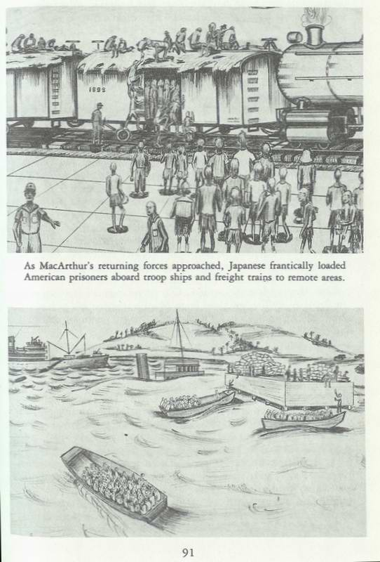
to jump down about ten feet onto the bouncing front deck. I was surprised that my "toothpick" legs didn't buckle under the jolt. We started out to a transport with a No.2 on the stack, the Brazil Maru. An air raid alarm sounded!
In the confusion our landing craft was directed to an empty transport marked No.1, the Enoura Maru. We were soon up the long ladder, and put in the forward hold; then we were divided into groups of twenty.
This time there was plenty of room and an abundance of fresh air, but it was very cold.
On the level above us were hundreds of sick and wounded Japanese soldiers returning to Japan. They were dressed in army caps, long white gowns, g-strings, and field shoes. No food; no water! But the Jap soldiers were eating their regular meals three times daily. Steel decks very hard! Unable to sleep.
Dee. 28, 1944: Thursday-Under way at dawn! Again, no food; no water; Jap patients getting three regular meals on time. A few prisoners were trying to trade jewelry for food. Most of us had nothing to trade. Manure and flies were very bad.
When I attempted to stand, I blacked out. One died; we wrapped him in a straw mat, had a brief religious ceremony, and then slid him over the side. The count, (?) 1,305.
Col. Harold Johnson, our C.O., prohibited all trading with the Japs! A civilian gambler from Manila ignored his orders and obtained rice and candy for his friends. Angry prisoners scattered the rice and candy into the darkness.
December 29, 1944: Raining. Prisoners fought each other, trying to get their cups and mess gear under the drippings from the hatch covers to catch a few drops. Two spoons of rice.
1800 hours - Blasts of large guns on the deck. We crawled off the wooden planks on to the steel deck. Depth charges were exploding on each side of the ship for a thirty minute period. Then there was enthusiastic clapping by the Japs on the upper deck. It was announced: "Japanese Impeliar Navy has sunk Amelican submaline!" Banzai/ Banzai/ Banzai/
At 2000 we dropped anchor. There was a full moon. Pens, rings and mess gear were being traded for cigarettes or water. It was a very cold night.
Hips and spines were becoming extremely sore-attempting to poke through the skin.
December 30: The sea was very rough. Our empty ship,
floating high, pitched and pounded. Half cup of rice; several spoons of water.
2000 hours - shelling and depth charges for half hour. During the night a Japanese soldier fell from the upper deck into our hold killed by the fall. This added much to the usual confusion. Intermittent depth charges all night as our ship dashed and pounded across the open sea toward Formosa.
Dee. 31, 1944: Sunday-No food; half cup of water! Col. Johnson told Mr. Wata: "If we don't get food, we will all die!"
Mr. Wata responded: "Evelbody must die! This is no time for sympathy!"
The sea was very rough and very cold! During the night we entered a land-locked harbor-Takao in Formosa. It was New Year's Eve! The old bewhiskered rabbi and farmer, Aaron Kliatchko died. The count, (?) 1,304
Jan. 1, 1945: We dared to think that things might get better in "forty-five." We began to hear, "Still alive in 'forty-five!'" Issued five moldy "hardtack" type biscuits.
The prisoners were now like animals in a cage begging for food and cigarettes. The Japs couldn't understand how the Americans could expend so much energy jumping for cigarettes, when they were supposedly very weak. Three-quarters of a cup of water (a real treat). Bitter cold. We were extremely hungry, thirsty and cold. Our bodies were very sore and we were unable to sleep.
Old John "The Thief," died. The count, (?) 1,303.
Jan. 2, 1945: The harbor was surrounded by high, snow covered mountains; we were in southern Formosa. The Japanese patients were taken out of the holds; their areas were fumigated by American soldiers-hoping to get something to eat in return for their work.
Col. Johnson again requested food. Mr. Wata answered: "United States submalines sink arr Japanese food ships! Vely solly!"
Many prisoners continued to scramble around the hold grabbing for cigarettes thrown down from the deck above; they were more addicted to tobacco than food. Their prancing around made it more difficult for us to convince the Japanese that we were hungry and thirsty.
Received two-thirds cup of rice and one teaspoon of dried fish. No water! A bitter cold night! Much coughing! Some prisoners were acting crazy; doing weird and unpredictable things. An officer was assigned to guard the stairway so none of these crazy
persons would try to escape and cause an incident.
Jan. 3rd, 1945: 0800-There was an air-raid alarm! It was followed by rapid firing from the deck for about two hours; much running about on the deck above. Several planes flew low over the harbor probably observing. No food; no water!
When I tried to stand, I blacked out! Many prisoners were coughing, and suffering from cramps and dysentery. It was a very cold night. The Japs worked all night loading the ship.
Jan. 5: In the evening, as we were trying to get to sleep, several of us were showered with 11 liquid, which tasted like battery acid. "What were the Japs up to now?" The liquid proved to be the contents of a latrine bucket; the prisoner, carrying the bucket to the deck, was so weak, he spilled it. When we asked the guards for some sea water to clean ourselves off, they just laughed.
I volunteered to take guard duty at the stairway so I wouldn't freeze to death.
Jan. 6th: It was bitter cold! We were still barefooted and wearing the summer clothing received at the Olongapo Naval Base in the Philippines. The guards were shivering in spite of heavy overcoats. No food; no water!
We were taken up on deck, then down a long ladder to scows and moved out into the harbor. Some prisoners were grabbing dirty and rotten vegetables floating in the filthy water. Some even filled their canteens with sea water.
In a few minutes, our scow pulled up to transport No.2, the Brazil Maru. We were soon up the ladder and put in the second hold with the other prisoners - all 1,273 of us. We were told that there had been thirty deaths on the Brazil Maru. We were divided into groups of twenty. Again it was very crowded; much confusion, much cursing.
Half cup of rice; a quarter cup of thin cabbage soup. A miserable night.
Jan. 7, 1945: We started a hospital on the upper deck and moved some fifty dysentery cases into it. The Japs gave us some dysentery medicine-looked like pellets of gunpowder. Flies were very bad. Four died! Tenko (?) 1,262.
Jan. 8th: Hatch covers were moved above us admitting dazzling light and extreme cold. All prisoners were moved off from the lower deck; about 473 into the forward hold, and about 789 on to the upper deck of our hold; again it was very crowded.
Thirty-seven English and Dutch prisoners were taken off the ship-to be transferred to a P.O.W. camp in Formosa.
Winches lowered many sacks of sugar into the lower hold. Mr. Wata warned us, "If you touch any sugal, you vill be hollibly shot!"
Jan. 9th, 1945: At daybreak, we heard many planes followed by anti-aircraft fire in the distance. Very soon, planes were overhead! There was panic in our hold. Men were trying to get off the wooden planks on to the steel decks. A young captain stood up and shouted, "Everybody stay put! You are as safe in one place as another!"
A direct hit produced a blinding and deafening explosion nearby; a tremendous orange flash followed by pandemonium.
Hatch covers above came crashing down into the bilge, dropping many prisoners thirty to forty feet below. There were screams, cries, groans, and oaths! The air was filled with dust and dirt. Wounded were soon being dragged into our improvised hospital; many with fractures, shrapnel wounds, all covered with dirt.
Just as we were getting the wounded cases moved into the hospital and the dysentery cases out, back came the planes. When it was over we had lost several of our doctors. Col. Riney Craig, Major Mack Williams and I were the only doctors still active. We removed the clothing from thirty dead to give to those still living. No food! No water! Open hatches aggravated the bitter cold night.
Jan. 10, 1945: We worked on the wounded all morning. In the afternoon my attention was called to a shrapnel-made gash in the forward bulkhead of our hold. I looked through into the forward hold and witnessed the most horrible sight of my life.
There were three hundred mangled Americans piled some three deep the result of a direct bomb hit. At the sides of the hold, a few wounded were sitting and standing dazed and motionless. The Japs had no compassion at all they would not let us enter the forward hold to help in any way.
Jan. 11, 1945: Finally, two days after the bombing, several masked and white robed Jap soldiers gallantly descended the ladders into our hold, and painted mercurochrome on minor wounds. They would not look at the serious wounds.
The Japs wound not enter the forward hold. Only God knew what suffering was going on there. Jap laborers pounded wooden
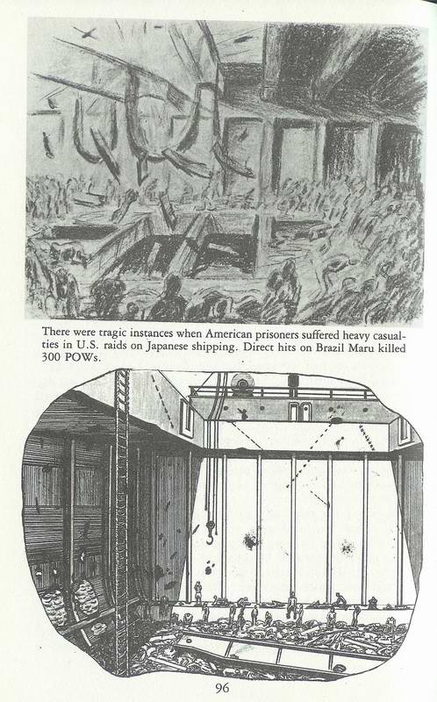
wedges into the holes in the sides of the ship. Water in the forward hole was up to the flooring.
The night was bitter cold; my feet had lost all feeling. There were endless groans and screams from the wounded and crazed.
Jan. 12, 1945: Forty-five bodies in our hold were tied to lines to be lifted to the deck. I can never forget the grotesque positions some of the bodies assumed as they were raised. Then the winches lifted 150 bodies out of the forward hold and placed them on a scow beside the ship.
One cup of rice! No water! Not even rice for the survivors in the forward hold.
Jan. 13, 1945: 150 more bodies winched out of the forward hold. We heard that the dead were taken to a Chinese cemetery near the beach and cremated.
In the afternoon, our sick and wounded were raised on ropes. The rest of us climbed the long ladders and sat on the deck waiting our turn to get on a small platform to be lifted; twenty at a time; then dropped at a dizzy speed to a small scow.
There were many dead on the scow; among them, my old guerrilla chieftain, Col. Everett Warner, of Pikesville, Md., who had died just as he predicted, "Like a rat in a hole!" It made me ill to look at my good friend his face was covered with large blood blisters but I wanted that one last look. I had always had much respect for this dedicated soldier, a Freedom Fighter!
Enoura Maru: We were quickly taken over to the ship we had been on earlier No. 1, the Enoura Maru and were soon pulling each other up the long ladder. We were all placed in the same hold just aft the superstructure.
Ed Nagel, John Shock, Cary Smith, and Wade Cothran were crowded into a very dirty bay with me; it was filled with coal dust. We huddled next to the coal containers to preserve any warmth in our bodies. One-quarter cup of rice; no water!
Thirty bodies were quickly piled up by the stairs after being stripped of their clothing to be used by the living. The count, (?) 924.
Jan. 14, 1945: Sunday - At dawn, we moved out of the harbor in a convoy of six or seven ships. Everyone had dysentery. The latrines were two boxes hung over the side of the ship. Only two persons were allowed on the deck at a time. Many were too weak to climb the stairs. The floor soon became filthy, making walking in bare feet very unpleasant.
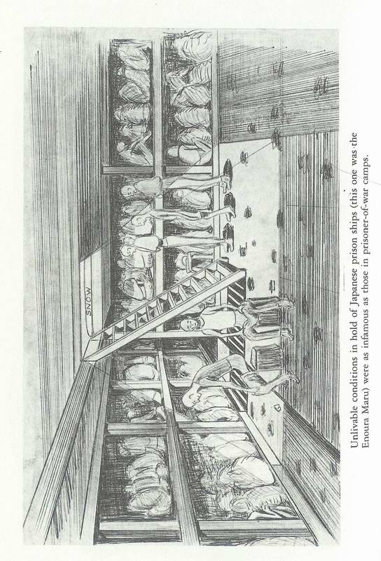
Our ship zigzagged generally north at a speed of about eight knots. One-quarter cup of rice; no water! Another thirty prisoners died. Toward evening, medics carried the bodies to the deck; after a short service by the strongest chaplain, the bodies were slid into the sea. The count, (?) 894.
Jan. 15, 1945: The night had been extremely cold; I had lost all feeling in my feet. I had no desire to freeze to death; in fact I had volunteered for the Philippines because I enjoyed warm weather. We were all becoming extremely dehydrated; urination became very painful. One cup of rice; no water (4th day). The count, (?) 864.
Jan. 16, 1945: Several inches of snow on the deck. Some men were .going down into the hold to get sugar. It was very difficult to swallow the sugar without water.
Cursing and stealing were now a way of life. Anchored all night. The count, (?) 834.
Jan. 17, 1945: I was bitter cold; we were hibernating-huddled close together-not moving any more than necessary; we were saving our energy. One-quarter cup of rice; no water (6th day): Usual deaths. The count, (?) 804.
We were very discouraged; we believed the end could not be far away. Anchored all night!
Jan. 18, 1945: Very cold! The sea has turned muddy (? Yellow Sea). We were passing many barren, mountainous islands to the starboard with an occasional lighthouse. One-quarter cup of rice; twelve teaspoons of water. Anchored at night. Thirty-two died. The count, (?) 772.
Jan. 19, 1945: We were underway at dawn-for three hours then stopped! We were alongside a large transport badly humped up amidships. It had been torpedoed! Many Jap soldiers were standing on the deck in their overcoats, shivering.
We spent most of the day waiting while seamen attempted to get a cable aboard the stricken vessel. Finally underway making only three knots. One-half cup of rice; twelve spoons of water. Many have died. The count, (?) 740. Anchored at night. Very cold! Brrrr!
Jan. 20, 1945: Moving north all day very slowly. Major Kirchner, an Army medic, died in the next bay (he had had a leg broken during the bombing of January 9th). Thirty died. The count, (?) 710.
January 21, 1945: Sea has turned green. Zigzagged generally
north. The cable to the crippled vessel snapped; we drifted for hours while seamen spliced it. One cup of rice; several spoons of water. Usual dead. The count, (?) 680.
Jan. 22, 1945: Monday - Moved north for ten hours towing our albatross. Major Wade Cothran died in his sleep-next to me. I was able to get his sweater, a big help in keeping the cold out. Usual deaths. The count, (?) 650.
Jan. 23, 1945: Extremely cold; had been snowing all night. Col. Shock, Dental Officer, died in our bay. He had been very bitter. He thought the doctors had not given him the proper care. He could not have been more right! Other friends dying: Cmdr. Josses, USN medic, Maj. Horace Greely, Capt Kornblum, Army dentist. The count, (?) 620.
Jan. 24, 1945: Snowing and bitter cold. The ship was making very poor time; life was slowly ebbing away.
Jan. 25, 1945: Extremely cold! Col. Fred Saint of the Army Engineer Corps died. He had been wounded in the Jan. 9th bombing. One-quarter cup of rice; six spoons of water.
Jan. 26, 1945: Coooold! Many have died! There were only three chaplains alive of twenty-three starting the trip. The medical service had completely evaporated. Major "Mac" Williams was the only medic still on his feet.
We passed another convoy going south. One-quarter cup of rice; no water! The count, (?) 555.
Jan. 27th: Anchored all day! Any chance of survival is slowly slipping away. I was so weak, it was impossible to move around. Snow covered islands around us were beautiful. One-quarter cup of rice; six spoons of water. The count, (537).
Jan. 28th: We were underway at dawn; many depth charges had been dropped during the night. One-quarter cup of rice; no water! The count, (?) 517.

Chapter X
JAPAN!

Jan. 29, 1945: Anchored at dawn in the harbor of Moji on the most southerly island of Japan, Kyushu. One-quarter cup of rice twice during day; six teaspoons of water. The count, (?) 497.
1129 had died since we departed from Manila on December 13th, 1944, an average of twenty-four deaths each day; 463 had
died since we left Takao Harbor on Formosa on Jan. 14, 1945, an average of thirty deaths each day.
Jan. 30, 1945: We were issued cotton army clothing and tennis shoes. A senior Japanese officer boarded the ship after observing the debilitated prisoners; lingering close to death; he slapped Lt. Toshino and Mr. Wata.
The surviving derelicts teetering between life and death, attempted to climb the ladder to the snow covered deck of the Enoura Maru.
As we debarked in six inches of snow and 20°F., masked Japanese soldiers in white gowns sprayed us with a carbolic acid solution, adding to our misery.
Eventually, those prisoners who could still stand up were divided into 3 groups:

Group I: 100 prisoners to Camp 3 (Tobato).
Group II: 192 prisoners to Camp 1 (Kashi).
Group III: 95 prisoners to Camp 17 (Omuta).
Group IV (the hospital group): 110 prisoners - unable to walk, sat or lay in the snow all day. I tried to get a drink of water, but found the faucets frozen. In desperation, I ate snow.

About 2100, five small charcoal-burning ambulances arrived. Twenty two Americans were crowded into each ambulance.

Japanese Prisoner of War Hospital - Moji
We turned into a gateway and were promptly challenged by a Jap sentry. After several minutes of excited guttural grunts and groans, we moved into the compound and were unloaded. Our new home was a low and flimsy frame building without heat. Inside, we were assigned straw mats on the floor, and were quickly under six cotton blankets and still cold. Each received a small binto box containing rice and salty fish. I tried to sleep, but couldn't. All of the events of the last seven weeks were vividly going through my mind.
Feb. 2, 45: My friend, Chaplain Ed Nagel, the missionary from Baguio, died. He had gradually grown weaker following his wound in the thigh on Dee. 14th, 1944 until he passed away in his sleep. I had just lost my good "Buddy" he had been an excellent friend; I would miss Ed.
Feb. 3, 45: Many patients were dying; the Japs told us they had ordered Red Cross packages, but they never arrived.
Joe Ganahl, the Northern Luzon Force, told me, "I feel as weak as a kitten!" and proceeded to lay down and die.
The food set-up was going from bad to worse. Half-cup of soup twice daily. Wt. 80 lbs.
Feb. 13, 45: Severe pains in my legs and feet. Could be beriberi, vascular disease or frost bite, or all three. Believed gangrene was setting in.
Feb. 16,45: Awakened, no feeling in my feet at all. Believed the end must be near. Wrote Judy a final note, telling her I loved her and didn't want to leave her. I gave the note to Chaplain Taylor to be delivered after the war.
The following days were very painful.
Mar. 1, 45: Loaded into charcoal-burning ambulances and taken to the railroad station. Spent the day riding on coaches, arriving at our destination about dark.

Fukuoka Camp #22

Walked up a steep hill for half a mile, hanging heavily on an agreeable Jap guard. Greeted by jolly Australian prisoners; their language was very "bloody," but they were good guys, serving us hot soup and Red Cross coffee, saved from their own rations. They got us blankets and hot water bottles.
Mar. 2, 45: The Aussies took us down to the Jap pool (a 15' x 15' vat), and gave a hot bath-and washed our lousy clothes.
Mar. 15, 45: Now only 34 of our original hospital group alive. Air raids becoming very frequent, especially at night; there were sirens in many directions. We could hear high-flying planes; in the distance we could hear heavy bombing. Food was becoming very scarce. The 'In Charge' came by and told me: "You have given up; you are yellow; get up and walk around!"
It made me mad probably just what I needed.
April 1, 45: I seemed a little stronger; could take several steps, but each step caused much "bloody" pain. The American patients
are all confined to bed. wt. 90 lbs.
Aussies give us our weekly baths, the highlight of each week.
My skin was rough and scaly - pellagra; my feet were numb and swollen - beriberi. I had lost much of my body hair. My beard, normally heavy, was thin and silky - probably due to changes in the sex hormones.
April 10, 45: Air raids frequent and heavy; cities being badly crippled. Everybody was jittery. The skimpy meals; very irregular.
April 12, 45: With help of Dudley Wilkinson of Australia, I was learning to walk, much like a baby. It caused much pain in every muscle moved. Ten steps and I was exhausted.
Apr. 25, 45: The 24 remaining patients and several guards were loaded on a truck. We passed through beautiful mountain country; people were working their small farms. Arrived at the Port of Fukuoka about noon. Other groups of Americans were coming in; I could see Major John Raulston and Lt. George Chamberlain.
About dark each group was marched to a pier; waiting a couple hours we boarded a rather streamlined 2 stack cruiser. I was carried one deck below and laid on a mat. The warmth of the cabin was very welcome. Major "Mac" Williams gave me an injection. Later, he told me he thought I was dying.
Major Tom Smothers, on the litter next to me, died. He was the father of Tommy and Dick Smothers, the comedians.
Apr. 26, 45: Arrived in Pusan, Korea in the afternoon. Carried about a mile to a theater, where we spent the night. Tenko 334.
Apr. 27, 45: About 0800, our group was marched (I was carried by a British prisoner) to the rail station. We were soon aboard a second class coach.
Was given a binto box: rice and very salty fish, causing great thirst. Chinese men were sleeping all over the coach: floor, seats and even luggage racks. Korea was mountainous and beautiful; many trees and plants were in bloom.
Passed the Yalu River - very muddy as it flowed into the Yellow Sea.
Apr. 29, 45: Arrived in Mukden, Manchuria (over a million population). (The Manchu’s once conquered and ruled the vast Chinese Empire, having overthrown the Ming Dynasty and set up the Ch'ing Dynasty, from which the name China evolved. During this period, the Great Wall was built).
Chapter XI
Camp Hoten, Mukden, Manchuria

I was carried to the prison hospital. This was the Emperor of Japan's birthday. We each received a cookie. At one end of the ward was a large cylindrical Russian stove; we received one scuttle of coal per day; when it was gone, we froze.
Mukden was extremely cold; had only two seasons: winter and the Fourth of July. Piled the blankets over my head and shivered.
Another problem; the air was very dry; our noses became irritated and uncomfortable. Old timers threw pails of water on the floors, putting moisture back into the air.
From the second floor, we could see over the high stone wall; we were in a factory area. The healthy prisoners had to work in the neighboring factories, making munitions, tools and rope. When they would return each night, we got the latest rumors from the Chinese workers: "Mussolini had been hung!"
In Mukden we felt isolated from the rest of the world and even the war; it wasn't all bad!
Capt. Herbst of Canton, Ohio, our medic, and the Japanese doctor, Juro Oki of Tokyo, got me small amounts of dysentery medicine.
The first weeks in the hospital were spent hibernating, trying to gain strength. I was extremely fortunate to have a good friend, Major (Honest John) Raulston, from Richard City, Tennessee, who helped me in many ways, while I was incapacitated. .
May 7, 45: My weight was up to 100 lbs. Discharged from the hospital.
Major Stanley Hankins was American C.O. of the Camp, and Col. Matsuda, the Japanese C.O. He ran one of the better camps.
May 10, 45: My fortieth birthday; I was ready for "Life to Begin!" Wt. 103 lbs.
May 17, 45: Rumors that Germany had surrendered on May 7th; May 8th called V.E. Day.
May 20, 45: The generals and colonels formerly stationed in the Philippines, arrived in camp from Sian, Manchuria. The generals included Wainwright, King, Moore, Parker, Sharp and Jones as well as Sir Arthur Percival from Singapore. The colonels were Selleck, Horan, Balsa, Brauner, Aldridge, Cooper and Gillespie. All were optimistic, believing they were on their way home.
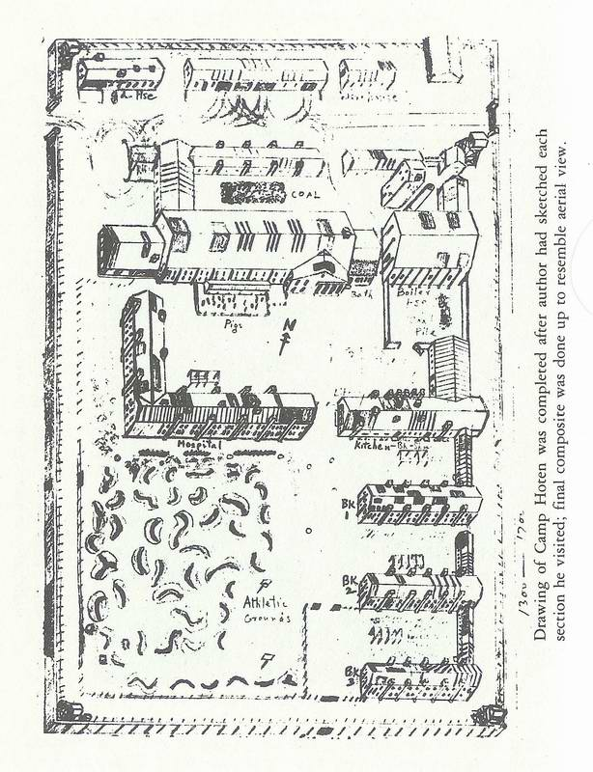
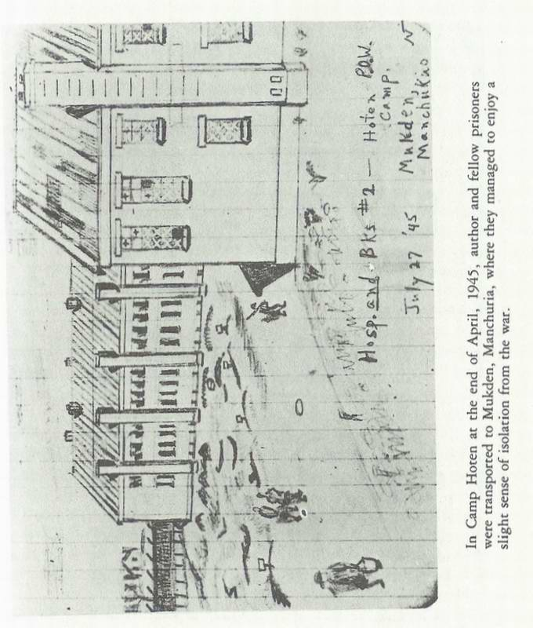
The following paragraphs were from Col. James Gillespie's Report of World War II in the Far East:
"As we marched into the Camp, many prisoners stood about with some curiosity watching our arrival.
"I happened to glance up at someone standing near the hospital. He was literally skin and bones - extremely emaciated, with a pale face that I knew I had seen before; his lower limbs were greatly swollen; as I passed within three feet of him, his identity flashed into my mind. It was Major Eugene Jacobs; he had served with me at the Sternberg Army Hospital in Manila.
"In a few days I was to hear from Jacobs, one of 300 survivors of the Oryoku Maru, the most horrible story of suffering by prisoners during World War II, in which 50% of the medical personnel serving in Sternberg Hospital, and General Hospital No.2 on Bataan, were wiped out from bombings and privations."
Col. Gillespie became the new hospital commander.
May 25, 45: Able to shuffle outside the building and sit in the sunshine, visiting with Army friends - made sketches of several. By moving to different of the camp, I made an accurate map of the camp, as seen from the air.
Jun. 1, 45: Had interesting visits with British, Australian and Dutch prisoners; made sketches of several. Enjoyed trading U.S. Army buttons for their Regimental buttons. Still very weak; called the "Walking ghost!" Wt. 106 lbs.
Jun. 15, 45: Rumors that MacArthur had taken Okinawa with big loss of life.
Jul. 1, 45: Spent much time sitting alone in the yard, soaking up the sun and thinking of Judy-making plans for the "Peace" that seemed to be coming.
Aug. 9, 45: Rumors of a conference in Berlin: that an ultimatum given to Japan. Air raid alarm during night; no bombing near by.
Aug. 10, 45: Rumors the U.S. had dropped an Adam bomb on Hiroshima on August 6th with much devastation. Rumors Russia had declared war on Japan on August 8th; Russians were anxious to share the Spoils of War. Planes overhead very active; no bombs.
Aug. 12, 45: Japanese soldiers all wearing battle dress and carrying packs on their backs. Camouflaged trucks and tanks on the streets.
Aug. 13, 45: Rumors that a second Adam bomb was dropped on Nagasaki, and that Russia was invading Manchuria.
Aug. 16,45: Rumors that Japan had surrendered on the 14th.
Cooks are baking extra corn buns.
Rumors that prisoners would be marched to Outer Mongolia (Gobi Desert) to prevent recapture. "Big Deal!"
A big bomber (B-29) flew over camp dropping parachutes just outside camp. Six paratroopers (O.S.S.) led by an Army Medic, Major LaMar, came into camp carrying parachutes, radios, first aid boxes, etc. They went directly to the hospital, where they were secluded. Everyone concluded the war must be over. It hadn't ended as we had expected. Mukden was quiet; no shooting.
Much excitement in camp; prisoners staying up after curfew, playing poker and smoking away from ashtrays (a No No). The guards finally admitted: "Waul is oval!" and later, "Ve aul tomadachi (friends) now!"
Aug. 17, 45: About 0800, General Parker announced, "I am now in command; an Armistice will be signed soon!"
Aug. 18, 45: Col. Gillespie called me to the hospital. He said, "Gene, you are the sickest doctor in camp. I am assigning you to go out on the first plane with 31 of the sickest patients.
I hope that some of you will survive to visit with your families. We will give you what little medicine we have."
I packed my few worthless possessions in a duffle bag, and then obtained a small notebook and got the names and addresses of two hundred prisoners' families, to be notified, when I reached the States.
About 1700, a U.S. bomber (B-24, Liberator) came low over camp, dipping its large wings and dropping thousands of leaflets. It was accompanied by many very fast Russian fighters (MIGs).
About 1800, Russian troops arrived in the Prison compound. A 31 year old general stood on a box, saying "Three weeks ago in Berlin, I saw General Eisenhower and told him I would liberate the American prisoners in Manchuria. You are now liberated!" Much cheering!

Chapter XII JAPAN SURRENDERS

About 1900, Col. Masuda and the Jap guard marched on to the field and officially laid their arms on the ground. Selected American prisoners picked up the weapons, and marched the Japs
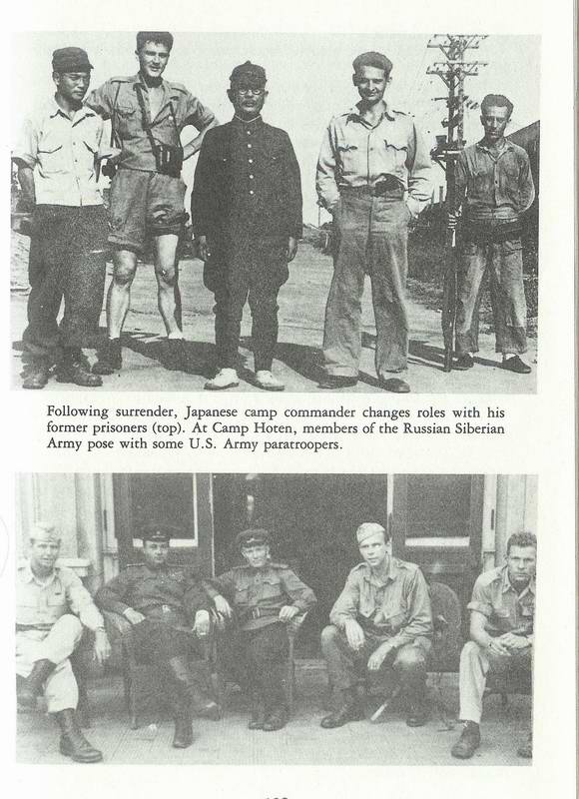
to the Guardhouse.
Now getting all we wanted to eat; some ate too much and got sick. Told to be ready to leave tomorrow on a B-24.
Aug. 22, 45: Flight cancelled! A drunk Russian guard had bayoneted the tires of the U.S. plane.
Much shooting outside the walls. The bodies of two Chinamen in black shrouds were swinging gently in the breeze from tall factory chimneys. It was OK for the Russians to loot, rape and plunder, but not for the Chinese.

Chapter XIII
START HOME

Aug. 24, 45: About 0800 we leave Camp Hoten Main Gate in a truck and two cars, a doctor and his 31 patients.
Saw many Russian soldiers and tanks passing through Mukden.
About 1000 we took off in two B-24s (Liberators); ours was named the" Homesick Angel." We sat in the bomb bays, eating C rations and K rations, the greatest invention of the war.
Passed over the Great Wall of China.

Sian, China

About 1600, landed at Sian - considered the cradle of Chinese civilization and the first capital of China.
The U.S. Flag flying over the base was a beautiful sight. Had a fine American dinner and in the evening were shown a movie, "If I were in Love!" Could hear shooting; the front line was near by.
Aug. 25, 45: a great breakfast with real coffee.
At 1000 boarded a C-17 plane and flew some 1000 miles over beautiful mountainous country.

Kunming, China

Toward dark arrived at Kunming, the capital of Yunan Province and the northern terminus of the Burtq a Road, some 6000 feet above sea level.
Transferred to the 172nd General Hospital for a medical survey. Good meals! Plenty of food! Soft sheets on the beds! Magazines to read!
Went through many examinations. Had gained 11bs. in 10 days. Wt. 138 lbs.
Aug. 29, 45: Met Col. George Armstrong, the C.O. of the 172nd. I had known George when we were captains at Walter Reed Army Hospital in the early thirties. We had a very pleasant visit. (I felt very shabby in the presence of George's "spit and polish." He later became the Surgeon General of the Army).
Aug. 30, 45: Discharged from the Hospital. Wrote to Judy, telling her I would soon be coming home.
Sep. 2, 45: Sunday-V.J. Day. Big Chinese parades; many dragons occupying the streets; much noise, like the banging of pots and pans.
It was very difficult for our ambulances to get through the streets to the Kunming airport.
Sept. 3, 45: We boarded a big Douglas C-54. About 2100 in a rain storm, we took off into the Wild Black Yonder. When it would lightning, we could see mountains on every side, the Himalaya Range. We circled up and up, to get out of the cup.
Sept. 4, 45: The Philippines! Near daybreak we came down low so we could see the badly damaged barracks of Topside of Corregidor, and soon landed at Nichol's Field-near my Garden Court home of 1940-41. (Parangue).
We were driven to 29th Reple Depot (a tent city in Los Banos. There were letters from Judy, mother and sister Ruth, the first in many months-all thrilled that I was coming home. It was good to learn that things were normal back home.

Generals Liberated from Mukden.

While we were waiting transportation home, the generals were flown from Mukden to Yokohama, Japan-to be greeted by General MacArthur.
On September 2, 1945, on the deck of the U.S. Battleship Missouri in Tokyo Bay, Generals Jonathan Wainwright and Sir Arthur Percival stood behind General MacArthur as he accepted the Surrender of the Japanese Empire. The following day, General Wainwright was flown to Baguio on Northern Luzon, to accept the surrender of the Philippines from Japanese General Tomoyuki Yamashita in the High Commissioner's Mansion at Camp John Hay, ending World War II.
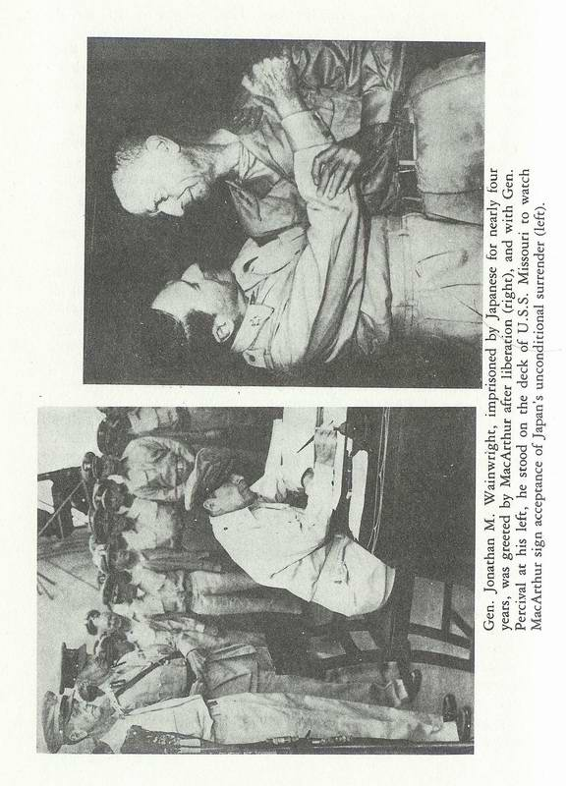
Sept. 5, 45 - Wednesday: Many papers filled out. In the afternoon I was taken for a ride through Manila. Many of the buildings along Taft and Dewey Blvds. were in shambles. There were some two hundred damaged ships in the harbor, many assuming bizarre positions.
Sept. 6, 45 - Thursday: Mother's birthday and I had no way to communicate with her. Edna Miller, a former school teacher at Brent School in Baguio, near Camp John Hay, called. She and her boy friend, Col. Jim Darrah, took me for a ride and dinner. Manila was a wreck!
Sept. 7, 45: I was able to make arrangements to obtain a small Army plane to fly back to Cabanatuan to look for the sketches I had buried there.
Sept. 8, 45: Lt. George Armstrong, from Utah, picked me up at 0800 and flew me in a Piper Cub to Cabanatuan, landing on an airport we POWs had built by hand - rock by rock (See poem, "The Pilot," by Gen. Brougher).
All of the prison camp buildings made of wood and swali were gone. I found where building #12 had been and dug in the area I had buried the drawings, but found nothing. The U.S. Army Engineers at the airport furnished a bulldozer, and still we found nothing. Arrived back at Reple Depot 29 about 1700 hours to find more letters from Judy, Mother and Ruth. It was fun to get reacquainted with activities in the States.
Sept. 9 - Sunday: Lt. Col. Ryle Radke, a classmate at Army Medical School, '36, came to the Reple Depot to take me to Manila, where we had a pleasant day discussing war experiences. Back in Camp at 2300, where I found orders promoting me to Lt. Col. as of August 20, 1945.
Sept. 10, 45: Alerted at 0800. At 1130 hrs we left for Nichols Field, and at 1445 we took off in a B-24 (Liberator) with bucket seats. Had a very smooth flight through heavy rains; could see two complete rainbows, one inside the other, as we looked down toward the earth. At 2230 we sat down on Guam; enjoyed a fine steak dinner.
Sept. 11, 45: Arrived on Kwajalein, a large atoll in the Marshall Group. Time was changed from 1000 hrs to noon. A Capt. Andrews, U.S.A. Air Corps from Danville, Virginia, took us to dinner at the Officers' Club and then for a ride around the island which was one half by two miles. Nearly every barracks
had its washing machine on the beach, powered by its own windmill, and closely observed by goony birds. Departed at 1530.
Sept. 11, '45: Arrived at Hickham Field in Hawaii about 0350; time changed to 0650. Just had time for a shower and a good American breakfast. Departed at 0930.

Chapter XIV
THE GOOD OLD U.S.A.

Arrived at Hamilton Field, North of San Francisco, at 2130; time changed to midnight. Had a fine steak dinner and off to bed.
Sept. 12, '45: After breakfast we were transferred to the Letterman General Hospital at the Presidio in San Francisco for a P.O.W. Survey. About 1500, I was hurriedly routed out of my room and driven back to Hamilton Field. Judy was arriving from Washington, D.C. on the first Constellation ever to make a non-stop flight to the Pacific Coast; it took eleven hours and one box lunch.
At 1600, the big plane, carrying my precious cargo, gently sat down on the runway. In a few minutes, I had my lovely wife, Judy, in my arms-a moment that I prayed would never end.
Vivian Raulston, John's wife, had come from Washington with Judy. I was able to tell her that John wanted her to bake him some brownies. John came home about three weeks later by ship.
The Army took us to the Saint Francis Hotel, where they had made reservations. The room, 1123, was beautiful, considering the price - $6.50. Mr. London, the manager, brought fresh flowers frequently.
Each day I had to return to Letterman Hospital for my survey. Wt. 140 lbs.
Judy came to the hospital each afternoon to take me to dinner. We tried a different restaurant every evening: Lamps of China; Sam's Fish House; Julian's Steak House; the Manger Upstairs; the Blue Fox; and Alfred & Segunda.
Many wives were coming to see me to get any possible information about their husbands, sons and brothers. A few I knew: Illa Gillespie, Tempie Williams, Jean Manning, and Crystal White. '
Sept. 13, '45: I spent the day in a telephone booth at the
Hospital sending some two hundred messages to families of prisoners, courtesy of the American Red Cross and the American Telephone Co.
About a dozen generals arrived at the hospital from Manchuria; immediately they wanted to know how I got Judy to the West Coast, when they couldn't even get commercial travel. I had to let them guess.
Actually, Vivian's sister, Vera, was the girl friend of Col. Dudley Fay, the Chief of Army Air Transportation, and he had a son who had been a prisoner of the Germans. He was sympathetic and repeatedly told Vivian and Judy, "When your husbands, John and Gene, are liberated, I'm going to see that you girls get a ride to the West Coast." So Vivian and Judy arrived at Hamilton Field on time, but actually without any official orders. Of course, I couldn't tell the generals that; they would have court-martialed me.
Sept. 15, 45: "Pappy Boynton" and his men arrived at the St. Francis. I thanked God for that fearless aviator who had been awarded the Medal of Honor.
We were now getting daily calls from Colonels Dudley Fay and Larry Smith in Washington, wanting to make arrangements to fly us to Walter Reed Army Hospital. Our answers were always "NO!" Now we were in no hurry! "We'll come by slow train with stops in Lincoln, Nebraska, and River Forest, Illinois, to see our families."
Sept. 17, 45: We started east in our bedroom aboard the Union Pacific, through the gorgeous Rocky Mountains. When the train stopped at stations, I was amazed to see husky young women, balancing themselves along the tops of freight cars, brake persons, no less. It had taken many dedicated people, doing many strange and often hazardous jobs, to bring the war to an end. I felt grateful to each and every one of them.
We spent a couple of happy days with Judy's family in Lincoln and two more in River Forest, before proceeding on to Washington, where I became a patient on Wards 1 and 4 at Walter Reed General Hospital.
Judy lived in an efficiency apartment at 906 at 2000 Connecticut Ave., near Holton Arms School, where she taught during the war.
About the second week we were in Washington, one of Judy's teacher friends, Peggy Snow, arranged for us to get invitations
to her father's cocktail party for the top brass in Washington. General Snow, the Chief of Engineers in the Army, sat me in the center of the party, where I was a curiosity and subject to much questioning. Many important persons came to look me over and ask, "Are you having any difficulty adjusting?" My answer was always the same, "If somebody gave you a Lincoln car, would you have trouble adjusting?"
General Leslie Groves, the "Father of the Atomic Bomb," asked me, "What did you think of the, Atomic bombs we dropped on Japan?" I answered, "General, by dropping the bombs, you saved thousands of American lives that would have been lost if the U.S. had been forced to invade Japan. Also, you saved thousands of P.O.W.s lives; we could not have endured many more months of captivity. Actually I'm sorry you didn't drop more bombs on Japan!"
"Colonel, we only had two bombs and we dropped them both!"
"Thank you, sir! You saved my life! I am very grateful to you and the brave crews that dropped the bombs!" The general look relieved.
"Colonel, I'm happy you are back; this country owes you and your friends a great debt. You gave us what we needed most, TIME."
Washington was overrun with military personnel. To me the amazing thing was the youth of the officers; generals in their forties and thirties; colonels in their thirties and twenties. I wasn't jealous! I thanked God for each of them. They had done a bang-up job.
Two months passed at Walter Reed. I wasn't dying as predicted in Manchuria. In fact I was getting better, gaining strength and weight each week. I was able to walk several city blocks at a time.

Chapter XV BORROWED TIME

Mar. 17, 46: The Chief of Medicine, Col. Charles Mueller, decided that I was ready to try active duty; he found a job for me on the Medical Service. How great it was to be a halfway normal person again!
I moved in with Judy in her cozy little efficiency apartment; it was actually all that we needed; it had a nice view of Rock Creek Park and the Shoreham Hotel.
Visiting patients in the many scattered wards at WRGH was difficult; I often felt that the patient I was treating was healthier than I was, but I thanked my lucky stars just to be alive and perking. I really had all in this world that I had ever hoped to have.
The Surgeon General, Gen. Raymond Bliss, assigned me to a "Refresher Course" in Internal Medicine at George Washington University Hospital.
Lt. Col. Charles Gingles and I were to share cars to travel across town. One day while riding to work with him, I thought he would drop his teeth, when I told him that "Judy is pregnant." He couldn't believe it.
Apr. 8, 47: Dr. Preston Haynes delivered a beautiful baby boy for Judy at Columbia Hospital, and would take no pay; he was "my kind of doctor." We named our healthy son: Eugene Coryell Jacobs, II and called him "Little Bit!"
Fall of 1947: Little Bit was baptized at the Chapel of Walter Reed Medical Center by Chaplain (Col.) Alfred Oliver, who had married Judy and me there ten years previously. Little Bit was frightened by the large collar the chaplain wore for his broken neck. (The Japs hit him with the butt of a rifle in the back of his neck, trying to get him to tell who was operating "the underground mail" in Cabanatuan P.O.W. Camp)
Summer of 1953: While enjoying a very pleasant tour of duty as Area Command Surgeon in Salzburg, Austria, we took a two-week vacation to visit beautiful Copenhagen, Denmark.
While visiting the Royal Copenhagen China Shop about ten one morning, the clerks drew down all the shades in the store windows.
A clerk sidled up to us and whispered, "The King and Queen are in the store, shopping for wedding presents." Gene II, aged six, and having no inhibitions, pointed his finger directly at the fine looking gentleman, dressed in a perfectly proper business suit, and asked in a booming voice, "Is that the king?" There was a long startled silence!
Jul. 1956: Our little family was returning from a very pleasant three-year tour in Austria and Germany on the U.S.S. United States, enjoying first class accommodations, when nine-year-old Gene II came up missing. We searched the ship from bridge to the engine room where we found Gene consulting with the chief engineer as to "whether or not the United States could make forty-five knots."
Apr. 1957: The State of Virginia was celebrating the 350th Anniversary of the landing of Captain John Smith at Jamestown. Governor Winthrop Rockefeller was to host Queen Elizabeth and Prince Philip. The U.S. Army at Fort Monroe (Continental Army Command) was assigned to care for all the details.
Being Post Surgeon and Hospital Commander at Fort Monroe, I was to be the Queen's personal physician for twenty-four hours. I was to be in an ambulance at the end of the runway when the Royal party landed at Patrick Henry Field in Williamsburg.
I asked Gene II if he would like to ride in the ambulance with me. "Sure!" he said.
Plane time was getting close, and no Gene. He was located in the tower, helping to direct the royal plane to a safe landing. He wanted me to come up in the tower to meet his new friends, but I had to remain in calling distance of the queen.
1960-65: Secretary of the Army's Office: As President of the Army's Disability Review Board became a pioneer in determining that tobacco "IS HAZARDOUS TO THE HEALTH." Had difficulty in convincing the Surgeon General of the U.S. Public Health Service (a smoker).
May 31, '65: Gene II graduated from Valley Forge Military Academy in Wayne, Pennsylvania. It also happened that I had reached the age of sixty and this was my last day in the Army.
Gen. Milton Baker, the Academy Superintendent, invited me to review the graduating parade in his box.
I was retired as physically fit since I hadn't missed a day due to illness since returning to duty in March of 1946.
Jun. 30, '70: Finished my very pleasant five-year contract at the Student Health Service of the University of Maryland in College Park. We retired to Florida.
This found Lt. Eugene C. Jacobs II on duty with the Armor Corps of the U.S. Army at Fort Ord, California, where he met and married Mary Frances Kanne, a dietician.
Christmas, 1982: Judy and I drove to St. Louis to spend a white Christmas with Capt. Gene II and Mary and their two beautiful children, Alexander Coryell Jacobs (four) and Lindsay Jaudon Jacobs (two).
One night Gene II asked me to attend a lodge meeting with him. Imagine my surprise and thrill to help raise my own son to be a Master Mason. Also while in St. Louis, Gene II borrowed a uniform for me to wear (first time in sixteen years) to swear
Mary into the Army as a Captain in the Women's Medical Specialist Corps as a dietician.
Aug. 9, 84; Major Gene II and Captain Mary from Headquarters in St. Louis arrived at the summer home of Colonel Jacobs on Coryell Island (Cedarville) in Northern Michigan to present Colonel Jacobs with his fourth Bronze Star Medal - promised to the members of MacArthur's First Guerrilla Regiment by General MacArthur in June, 1942. See photo!

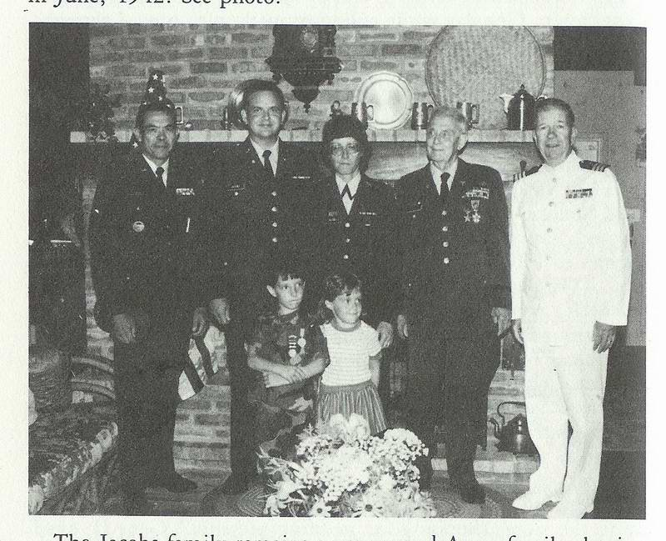
The Jacobs family remains a very proud Army family, having had a representative in every war since the American Revolution. Even little Alex is a proud G.I. Joe with a complete field uniform.
(Lindsay is a Smurf.) The Jacobs family thinks we have a great country that is worth fighting for, a great U.S. Army that can fight with the best when they have proper intelligence and equipment. May our Army always be strong, and our country, free! "'Peace is our profession."
What greater satisfaction is there for grandparents than to see their children and grandchildren turning out right? Thank you, Lord, for all of our blessings!
THE PILOT*
by Gen. William Brougher
in the Long Dark Road

"What did you do in the war, Grand Dad?"
His little grand son said.
A pilot bold was I, my lad,"
The old man hung his head,
A pilot for a plane, my lad,"
(The old P. W. lied)
"Was yours a P-thirty-eight, Granddad?"
He hears the old man sob:
"The lowest plane of all, my lad,
A tough 'P.W.' job."
"And did you shoot some Nips, Grand Dad?
And chase them from the air?"
"My specialty was 'transport,' lad;
I'd pile it here and pile it there."
"Had you a. brave co-pilot, too?"
He hears the bright boy ask.
"A chaplain, named Ed Nagel,
He helped me swing the task."
"It's grand you were a pilot, Grand Dad!"
The old man starts to whittle:
"Well, not so grand, perhaps, my lad
But the extra rice helped a little."

POSTSCRIPTS

Dr. Jacobs - Colonel Jacobs - Professor Jacobs - has given far beyond what most are ever asked to give... to his country and to the sick. Yet, he can look back over his life with equanimity... he is glad to be alive, and very glad to be living in this quiet, lovely city.

Sam Rohlfing, Editor

"In building an airport for the Japanese, we carried stones and dirt in a straw basket, and piled it here and piled it there, as directed, for which we received a small amount of extra rice. We called ourselves "pilots!"
Letter from Dr. John Beall

Dr. John A. Beall Jr.
120 Brandywine Trail
Carrollton, Georgia 30117

April 23, 1983

Dear Gene:
Thank you very much for sending me the two articles "From Guerilla to POW in the Philippines" and "Diary of a Hell-Ship Journey." They were terrific and say a lot of things that need to be said, less the US forgets the horrors of the way the Japanese treated our prisoners. As you know I fought the war in the European Theater and we had an easy time of it, compared to your experiences. I don't know whether I would have had the fortitude to hang in there and continue to help the others, treat their ills and wounds the way you did. Ruth tells me you are writing a book on the subject and I look forward to reading it.
Time goes by so fast and it is hard to realize that none of the top command of the Army and only a handful of others in the service saw service in World War II. We have a yearly course on the" History of World War II" as West Georgia College and the ignorance of students on the sacrifices so many made is astounding! We need to keep reminding them, that the quality of life they know was paid for dearly by soldiers like you who gave so much for their country.
I was particularly interested in this subject since right after VE Day I commanded 14 POW camps for General Patton in Bavaria. When he gave me the job I complained that I knew nothing about treatment of paws and he replied, "You should treat them the way you would like to be treated if you were a POW." That became our philosophy and we worked our tails off day and night to treat them fairly, keep them warm and well fed and provide necessary medical treatment. I can truthfully say we had very few instances of complaint nor have any surfaced since the war.

Sincerely

"Tige" Beall
APPENDIX: LESSONS LEARNED ON LUZON
"In war there is no substitute for Victory!"
Douglas MacArthur

We were amazed to discover how well-informed the Japanese pilots and invading forces were, as to our beaches, bays, terrain, and especially our military bases. Their geodetic maps were more accurate than ours.
We were amazed to find Japanese fishermen's nets-in the shapes of arrows-pointing directly to our naval bases at Olongapo and Cavite, to Clark and Nichols Airfields, and to Fort McKinley.
We were amazed as to the accuracy of Japanese intelligence, learned through houseboys, maids, store owners, fishermen, salesmen, etc. - ALL Spies!
We learned it was senseless to fight a war that you are unable to win, unless the delaying action could permit an Allied victory elsewhere.
We learned it was hopeless to fight a well-armed major power with equipment and weapons left over from the last war.
We learned it was best to be mobile when fighting an immovable force; you might live to fight another day.
We learned that guerrillas in the proper environment and in cooperation with friendly natives can harass an enemy for many months and gain much valuable time and information.
We learned that a fledgling Fil-American force on Bataan and Corregidor could sustain the most crushing campaigns of the mightiest army in the Far East for months, before being starved into submission.
Perhaps, if there had been more Bataans, the course of World War II might have been altered.

Eugene C. Jacobs

Three Great Things Necessary for Survival
In a Prisoner-of-War Camp.

FAITH IN THE GOOD LORD!
A WILL TO LIVE!
A GOOD SENSE OF HUMOR!
Two doctors helped me achieve these: "Grandma" Jim Bruce-for good advice. Major Edwin Kagy, who after working all day on the Seriously Ill wards, came back at night to sing popular songs with his terrific tenor voice.

Louis J. Voras "Medic."
Field Hospital # 2 on Bataan,
later Hospital at Cabanatuan.

"My men and I were the victims of short sightedness at home, of blind trust in the respectability of scheming aggressors. The price of our unpreparedness for World War II was staggering to the imagination.
"The price of unpreparedness for a World War III would be death to millions of us, and the disappearance from the earth of its greatest nation."
General Jonathan M. Wainwright, 1946

ACKNOWLEDGMENTS

I owe a great deal to my family. For nearly four years, they didn't know my whereabouts, nor whether I was alive or dead. I regret each and every heartache I caused them, and I appreciate all of their prayers.
I am especially indebted to my precious Judy for being the perfect wife during the most trying times, and for being very understanding during the forty years I have been assembling material for Blood Brothers.
I feel very kindly toward Colonel "Honest John" Raulston for his generous help when I was totally incapacitated in Camp Hoten, Manchuria.
I thank General "BOB" Taylor for his spiritual guidance and friendship while "the going was rough."
I thank General Harold K. (Johnny) Johnson, the Army Chief of Staff, for 25 years of inspiration and friendship as one of the Army's outstanding officers. Johnny, I appreciate your offer to write the "Preface for Blood Brothers," and the chapter on "Lessons Learned on Luzon;" you would have done it much better than I, but your long hospitalization and transfer to "Boot Hill" interfered. I'll miss your cheerful counsel. Johnny.
I thank General Aubrey Newman, war and Olympic hero, who thought I ran a "Happy" Hospital, and who insisted that I continue working on Blood Brothers, when it would have been much easier to quit.
I thank Stan and Peg Sommers, authors of the "Japanese Story," and their friendship to me and some thousands of Ex P.O.W.s.
I thank my Masonic Brethren, who believe in these United States and its Constitution, which has made it great.
I thank Sandra Rohlfing, Assistant Editor of the Vero Beach Press Journal, for her many hours of editing Blood Brothers and for her good advice.
I thank Don Knox, author of "The Death March" for friendly advice. He used my sketches.
I thank Peter Collins, Art Editor of Time-Life Series on World War II, for his visit to Vero Beach, and for the time he spent going over the material for Blood Brothers. He used my photographs.
I thank all those good people who have made my life worth living since "The War."
I thank the "Good Lord" for forty wonderful years of "Borrowed Time." It's fun to still be alive in eighty-five!

THE LEGACY OF WORLD WAR II TO OUR CHILDREN

In his book, "The Second World War," Sir Winston Churchill called World War II, "The Unnecessary War," stating that "Hitler could have been stopped in 1935, in 1936 and even in 1939, if two Western democracies had not been too timorous (afraid) and too stupid to react."
At that time, the political leaders of the Western democracies were:

Franklin Roosevelt
Joseph Stalin
Winston Churchill
Charles De Gaulle
The awesome results of that fear and stupidity were:
22 million persons - killed
34 million persons - wounded
142 thousands Americans - captured
$240 billion in property – damaged at a cost exceeding $1 trillion,
"ALL UNNECESSARILY!"
The legacy of World War II (by fear and stupidity) left to our children was a National debt exceeding $250 billion, a debt that may not be paid during this century.
Thank God we have a president and administration that understands the Russians. They will soon learn to understand the Japanese. No one will ever understand the Middle East.
INDEX

A Aguinaldo, Gen. Emilio, 37-39
Aldridge, Col., 104
Allen, Dr, Beulah, 13-18
Allen, Lt. Col. Henderson, 13
Aparri, 16-18, 40
Armstrong, Gen. George, 110-113
Arnold, Cape Robert, 29-30
Atom Bomb, 107-116
Atrocities, Japanese, 47, 73-76
Australia, 34
B Babcock, Col., 72
Baguio, Summer Capital, 10-19
Bahrenberg, Maj. James, 7
Balsam, Col., 104
Balete Pass, 22, 32-35, 118
Bambang, 28-42
Bataan, 7-28, 34-43, 119, 122
Bauer, Louie, 71
Beall, Gen. John, 3, 120-121
Becher, Wes, Sgt., 71
Beebe, Gen., 104
Beecher, Col., 49, 81-90
Bell, Don, Radio KZRH, 10
Beriberi, 49, 56-60
Berry, Maj. Wilbur, 7
Bertz, Maj. Wesley, 7
Bilibid Prison, 6, 41, 69-89
Bliss, Gen. Raymond, 117
Borneman, Maj. John, 63-64, 72
Boone, Maj. John, 67
Boothe, Eddie, 70-71
Boynton, Col. "Pappy", 115
Bluemel, Gen. Clifford, 104
Bradley, Capt. Ruby, ANC, 12-22
Brazil Maru, 42-96
Brownlee, Bill, 74
Britain, 14-15
Brown, Maj. Ralph, 72
Brougher, Gen. Wm., 104-119
Buddy System, 94, 102
Burma Road, 110
Burrell, Bill, 71
C Cabanatuan Cats (Band), 70-71
Cabanatuan City, 23, 60-67
Cabanatuan Camp (POW), 6, 42-78, 113
Cagayan Valley, 28-39, 41
Camp O'Donnell, 51-53
Cargadors, 28
Carberry, Chap. Richard, 63
Casiguran, 34-36
Cavender, Maj. Howard, 72
Cavalry, 26th, 29, 118
Cavite, 13, 23, 116, 123
Cebu, 76
Cemetery (Group IV), 53-73
Chamberlain, Lt. George, 103
Chambers, Lt. Beatrice 12-22
Chapels, 50-63
Chase, Gen. Wm., 81-82
Childers, Cape Don, 71-72
Chloa, 4, 14, 19-20, 36, 74, 103-110
Churchill, Sir Winston, 14, 124
Clark Field, 12-23, 116-117, 122
Cleveland, Cape Arthur, 64
Cooper, Col. Wibb, 16, 104
Costello, John, 18
Cothran, Maj. Wade. 97-100
Craig, Lt. Col. Riney, 25-43, 95
Corregidor, 22-26, 30-41, 51,122
D
Dagupan,. 19, 82
Day, Capt. Morris, 64
"Day of Infamy," 18
Dawson, Rev. Wm., 64
DEATH MARCH 41-53, 76
Deficiencies, 39, 115
DeMaio, Charles (WOP), 67
Dibulwan, 30
Donald, Maj. Sam, 63
Drake, Gen. CC, 104
Duffy, Chap., 63
Dugan, Chap., 63
Dunkirk, 14
Dutch East Indies, 56-58
E
Echague, 29-36, 38-39, 42
Eisenhower, Gen. Dwight, 108
Elizabeth, Queen, 118
Elizaldi, Juan, 65
Ellis, Lt. Jack, 117
Enoura Maru, 97 -10 1

F FARM, THE, 55
Fay, Col. Dudley, 115
Fisher, Capt. James, 78
Flores, Naiomi (Looter), 65
Ft. McKinley, 13-16,
Ft. Santiago, 40
Ft. Stotsenberg, 16
France, 14
Fukuoka, 102-103
Funk, Gen., 104
Funston, Gen. Frederick, 37
G Ganahl, Maj. Josepf, 19-20, 94, 102
Geneva Convention, 74
Germany, 10
Gerow, Gen., 17
Gillespie, Col., 3-99, 102-108
Gingles, Col. Charles, 117
Gloria, Senor (Tiente), 26-38
Groups I, II, III, IV, 40-72
Groves, Gen. Leslie, 114-116
H Halsey, Adm. Wm., 86-88
Hankins, Maj. Stanley, 104
Hart, Adm. Thomas, 19
Hawaii, 3-68, 74
Hay, Camp John, 3-10, 21, 116-118
Hay, John, Sec of State, 11
HELL SHIPS, 3, 69-107
Herbst, Maj. Mark, 104
Hirohito, Emperor, 73, 104
Hiroshima, 107
Hitler, Adolph, 14-17
Homma, Gen. Masahuru, 12-19,
28-35, 51
Horan, Lt. Col. John, 3-20, 31-37,104
Hoten, Camp, 105-114, 123
Hull, Sec of State, 10
I
Ilagan, 37
Ilongots, 30-31
Imperial Rescript, 66
Italy, 17
Iwanaka, Maj. (Camp C.O.), 64
J Jacobs, Alexander C., 118-119
Jacobs II, Maj. Eugene, 67, 118-119
Jacobs, Judy, 2, 26-61, 102-107,118-119
Jacobs, Lindsay, 118-119
Jacobs, Capt. Mary, 118-119
Japan, 3-124
Joint Army-Navy Board, 11
Jones, Dr., 23-30
Jones, Gen. Albert, 104
Jones, Isabella 28-36
Johnson, Gen. Harold, 3, 53-63, 84-94, 121-124
Jorgenson Family, 20-24
K
Kadolph, Red, 70-71
Kaelin, Chuck, 70-71
Kagy, Maj. Edwin, 123
Kalakuka, Ltc Theodore, 38
Kempie Tai (Secret Police), 40-70
Kiangan, 34-35, 41
King, Gen. Edward (Ned), 34-35, 41, 51, 104
Kliatchko, Aaron, 64, 93
Korea, 103
Kratz, Johnny, 70-71
Kuncl, Lt. Claire, 70-71
L Lamar, Maj. (O.C.S.), 108
Lee, Clark (Assoc. Press), 20-21
Lend-Lease, 18
Lentz, Maj. Emmert, 7
Lewis, Maj. Robert, 7
Leyte, 77
Liles, Capt., 118
Lim, Gen., 34
Lingayen Gulf, 3-18, 34-41, 79
Lough, Gen. M.S., 104
Lugao, 40-70
Lusod Sawmill, 21
Luzon, 13-24, 31-41, 116
M
MacArthur, Gen. Arthur, 37-38
MacArthur, Gen. Douglas 3-124
MacArthur's 1st Guerrilla Regt. 3, 5, 27-41
Mack, Lt. Co!. (Ditto), 67
Malacafiong Palace, 15-38
Manchuria, 7, 14, 100
Manke (soloist), 71
Marshall, Gen. George, 17, 108
Marshall (saxophone), 70-71
Masons, 72, 118
Matsuda, Col. Camp C.O., 108
McBride, Gen., 104
McClure, Chester, 70-71
McDonald, Maj., 71
McIntyre, Eddie, 71
Miller, Edna, 113
Minton, Maj. Warren, 29-38
Missouri (Battleship), III
Mock, Harry, 71
Moore, Gen. George, 104
Mucci, Capt. Harry, 78
Mueller, Col. Charles, 116
Mukden, Manchuria, 6, 103-110
Mussolini, 7, 104
N Nagasaki, 107
Nagel, Lt. Ed, 64-88, 102-120
Nakar, Lt. Col. Guillermo, 29-40
Nealson, Bill, 71
Neibert, Evangeline (Sassy Suzie), 65
Noble, Maj. Arthur, 114
Nogi, Lt. N. (Isha), 40, 65-72
North, Lt. Wm., 7-70
O O'Brien, Lt. James, 63
O'Donnell, Camp, 51-53,73
Oki, Juro (Isha), 104
Olangapo, Naval Base, 87-94
Oliver, Lt. Col. Alfred, 63-124
Orange Plan (W.P.O. III), 9, 20-24
Oryoko Maru, 3, 83-107
P Pacific Fleet, 3-4, 9
Palanan, 34-39
Panama Canal, 17
Panay, U.S.S., 17
Paranaque, 10
Parcher, Lt. Harry, 70
Parker, Gen. George, 104-108
Pearl Harbor, 3-10, 18, 94
Percival, Sir. Gen. A.E., 100-112
Peterson, Maj. Arthur, 72
Philip, Prince, 113
Philippine Army, 3-19
Philippine Defense Plan, 3-15
Philippine Islands, 3-124
Philippine Scours, 3-69, 115
Phillips, Claire (High Pockets), 65-70
Phillips, Sgt. John, 65
Pier Seven 7, 10, 65-70, 82-83
Port Area, 7, 70-71
Pusan, 103
Q Quezon, Pres. Manuel, 15, 28, 32
R Radke, Lt. Col. Ryle, 113
Rainbow War Plan (WPO V), 11-29 35, 37, 41, 104, 112, 123
Red Cross, 58, 84-86, 102, 115 Red Line Bus Co., 17-27
Reed, Maj. Walter, 27
Reilly, Maj. Stanley 63
Reinhart, Sgt. .Melvin, 63
Rinaman, Maj. James, 55
Rizal Ave., 83
Rockefeller, Gov W., 115
Rogers, Gov. P.D., 67
Roosevelt, Pres. Franklin, 17-18
Roosevelt, Pres. Theodore, 11, 27, 71
Ruel Hank (soloist), 70-71
Russia, 107
S Saint, Lt. Col. Fred, 53, 91, 100
Saipan, 76
Salas, Pvt. (trumpet), 70
Salee, Capt. Joe (soloist), 70
San Fernando, LaUnion, 14, 90
San Fernando, Pampanga, 79, 91
San Francisco, 26-27, 98, 114
San Jose, 22-23
Schwartz, Lt. Cot Jack, 70, 89-90
Scuttlebutt, 62
Seals, Gen., 104
Sharp, Gen, 104
Shirogo (worker), 94-96
Sitter, Maj. Steve, 7, 77
Sketches, 6, 78
Smothers, Maj. Tom, 103
Speth, Maj. Emil, 16
Stafford, Dr. Eugene, 15
Stevens, Capt. Lee, 70
Strand, Maj. Clarence, 7
Swann, Lt. Robin (Br.), 71
Suchow (4th Marine mascot), 72
T Taylor, Capt. Robert, 63-67, 102, 123
Tiffany, Capt. Frank (Everlasting), 63-67
Tojo, Hideki, 10
"Tokyo Rose", 18
Toshino, Lt., 101
Tuguegarao, 11, 12, 34
U Underground, 60-67, 70, 117
USAFFE, 11-20, 29-34
V Vigan, 16-19, 117
Volckmann, Col. Russell, 41, 79
W Wainwright, Gen. Jonathan, 19, 23,
Warner, Lt. Col. Everett, 11-32, 89-98
Wata, Mr. (Jap Interpreter), 86
Weaver, Gen. James, 104
White, Maj. Clarence, 7
Williams, Maj. Mac, 95-103
Wilson, Col. Ovid 0, 71, 92
Wood, Gen. Leonard, 27
Y Yellow Sea, 99
Z Zambales Coast, 84-86
Zerfas, Lt. Mathias, 63
Zero Ward; 59-60, 73
Zimmerman, Capt. Leslie, 64

End of Project Gutenberg's Blood Brothers, by Colonel Eugene C. Jacobs

*** END OF THIS PROJECT GUTENBERG EBOOK BLOOD BROTHERS ***

***** This file should be named 8423-doc.doc or 8423-doc.zip *****
This and all associated files of various formats will be found in:
http://www.gutenberg.org/8/4/2/8423/

Updated editions will replace the previous one--the old editions
will be renamed.

Creating the works from public domain print editions means that no
one owns a United States copyright in these works, so the Foundation
(and you!) can copy and distribute it in the United States without
permission and without paying copyright royalties. Special rules,
set forth in the General Terms of Use part of this license, apply to
copying and distributing Project Gutenberg-tm electronic works to
protect the PROJECT GUTENBERG-tm concept and trademark. Project
Gutenberg is a registered trademark, and may not be used if you
charge for the eBooks, unless you receive specific permission. If you
do not charge anything for copies of this eBook, complying with the
rules is very easy. You may use this eBook for nearly any purpose
such as creation of derivative works, reports, performances and
research. They may be modified and printed and given away--you may do
practically ANYTHING with public domain eBooks. Redistribution is
subject to the trademark license, especially commercial
redistribution.

*** START: FULL LICENSE ***

THE FULL PROJECT GUTENBERG LICENSE
PLEASE READ THIS BEFORE YOU DISTRIBUTE OR USE THIS WORK

To protect the Project Gutenberg-tm mission of promoting the free
distribution of electronic works, by using or distributing this work
(or any other work associated in any way with the phrase "Project
Gutenberg"), you agree to comply with all the terms of the Full Project
Gutenberg-tm License available with this file or online at
www.gutenberg.org/license.

Section 1. General Terms of Use and Redistributing Project Gutenberg-tm
electronic works

1.A. By reading or using any part of this Project Gutenberg-tm
electronic work, you indicate that you have read, understand, agree to
and accept all the terms of this license and intellectual property
(trademark/copyright) agreement. If you do not agree to abide by all
the terms of this agreement, you must cease using and return or destroy
all copies of Project Gutenberg-tm electronic works in your possession.
If you paid a fee for obtaining a copy of or access to a Project
Gutenberg-tm electronic work and you do not agree to be bound by the
terms of this agreement, you may obtain a refund from the person or
entity to whom you paid the fee as set forth in paragraph 1.E.8.

1.B. "Project Gutenberg" is a registered trademark. It may only be
used on or associated in any way with an electronic work by people who
agree to be bound by the terms of this agreement. There are a few
things that you can do with most Project Gutenberg-tm electronic works
even without complying with the full terms of this agreement. See
paragraph 1.C below. There are a lot of things you can do with Project
Gutenberg-tm electronic works if you follow the terms of this agreement
and help preserve free future access to Project Gutenberg-tm electronic
works. See paragraph 1.E below.

1.C. The Project Gutenberg Literary Archive Foundation ("the Foundation"
or PGLAF), owns a compilation copyright in the collection of Project
Gutenberg-tm electronic works. Nearly all the individual works in the
collection are in the public domain in the United States. If an
individual work is in the public domain in the United States and you are
located in the United States, we do not claim a right to prevent you from
copying, distributing, performing, displaying or creating derivative
works based on the work as long as all references to Project Gutenberg
are removed. Of course, we hope that you will support the Project
Gutenberg-tm mission of promoting free access to electronic works by
freely sharing Project Gutenberg-tm works in compliance with the terms of
this agreement for keeping the Project Gutenberg-tm name associated with
the work. You can easily comply with the terms of this agreement by
keeping this work in the same format with its attached full Project
Gutenberg-tm License when you share it without charge with others.

This particular work is one of the few copyrighted individual works
included with the permission of the copyright holder. Information on
the copyright owner for this particular work and the terms of use
imposed by the copyright holder on this work are set forth at the
beginning of this work.

1.D. The copyright laws of the place where you are located also govern
what you can do with this work. Copyright laws in most countries are in
a constant state of change. If you are outside the United States, check
the laws of your country in addition to the terms of this agreement
before downloading, copying, displaying, performing, distributing or
creating derivative works based on this work or any other Project
Gutenberg-tm work. The Foundation makes no representations concerning
the copyright status of any work in any country outside the United
States.

1.E. Unless you have removed all references to Project Gutenberg:

1.E.1. The following sentence, with active links to, or other immediate
access to, the full Project Gutenberg-tm License must appear prominently
whenever any copy of a Project Gutenberg-tm work (any work on which the
phrase "Project Gutenberg" appears, or with which the phrase "Project
Gutenberg" is associated) is accessed, displayed, performed, viewed,
copied or distributed:

This eBook is for the use of anyone anywhere at no cost and with
almost no restrictions whatsoever. You may copy it, give it away or
re-use it under the terms of the Project Gutenberg License included
with this eBook or online at www.gutenberg.org

1.E.2. If an individual Project Gutenberg-tm electronic work is derived
from the public domain (does not contain a notice indicating that it is
posted with permission of the copyright holder), the work can be copied
and distributed to anyone in the United States without paying any fees
or charges. If you are redistributing or providing access to a work
with the phrase "Project Gutenberg" associated with or appearing on the
work, you must comply either with the requirements of paragraphs 1.E.1
through 1.E.7 or obtain permission for the use of the work and the
Project Gutenberg-tm trademark as set forth in paragraphs 1.E.8 or
1.E.9.

1.E.3. If an individual Project Gutenberg-tm electronic work is posted
with the permission of the copyright holder, your use and distribution
must comply with both paragraphs 1.E.1 through 1.E.7 and any additional
terms imposed by the copyright holder. Additional terms will be linked
to the Project Gutenberg-tm License for all works posted with the
permission of the copyright holder found at the beginning of this work.

1.E.4. Do not unlink or detach or remove the full Project Gutenberg-tm
License terms from this work, or any files containing a part of this
work or any other work associated with Project Gutenberg-tm.

1.E.5. Do not copy, display, perform, distribute or redistribute this
electronic work, or any part of this electronic work, without
prominently displaying the sentence set forth in paragraph 1.E.1 with
active links or immediate access to the full terms of the Project
Gutenberg-tm License.

1.E.6. You may convert to and distribute this work in any binary,
compressed, marked up, nonproprietary or proprietary form, including any
word processing or hypertext form. However, if you provide access to or
distribute copies of a Project Gutenberg-tm work in a format other than
"Plain Vanilla ASCII" or other format used in the official version
posted on the official Project Gutenberg-tm web site (www.gutenberg.org),
you must, at no additional cost, fee or expense to the user, provide a
copy, a means of exporting a copy, or a means of obtaining a copy upon
request, of the work in its original "Plain Vanilla ASCII" or other
form. Any alternate format must include the full Project Gutenberg-tm
License as specified in paragraph 1.E.1.

1.E.7. Do not charge a fee for access to, viewing, displaying,
performing, copying or distributing any Project Gutenberg-tm works
unless you comply with paragraph 1.E.8 or 1.E.9.

1.E.8. You may charge a reasonable fee for copies of or providing
access to or distributing Project Gutenberg-tm electronic works provided
that

- You pay a royalty fee of 20% of the gross profits you derive from
the use of Project Gutenberg-tm works calculated using the method
you already use to calculate your applicable taxes. The fee is
owed to the owner of the Project Gutenberg-tm trademark, but he
has agreed to donate royalties under this paragraph to the
Project Gutenberg Literary Archive Foundation. Royalty payments
must be paid within 60 days following each date on which you
prepare (or are legally required to prepare) your periodic tax
returns. Royalty payments should be clearly marked as such and
sent to the Project Gutenberg Literary Archive Foundation at the
address specified in Section 4, "Information about donations to
the Project Gutenberg Literary Archive Foundation."

- You provide a full refund of any money paid by a user who notifies
you in writing (or by e-mail) within 30 days of receipt that s/he
does not agree to the terms of the full Project Gutenberg-tm
License. You must require such a user to return or
destroy all copies of the works possessed in a physical medium
and discontinue all use of and all access to other copies of
Project Gutenberg-tm works.

- You provide, in accordance with paragraph 1.F.3, a full refund of any
money paid for a work or a replacement copy, if a defect in the
electronic work is discovered and reported to you within 90 days
of receipt of the work.

- You comply with all other terms of this agreement for free
distribution of Project Gutenberg-tm works.

1.E.9. If you wish to charge a fee or distribute a Project Gutenberg-tm
electronic work or group of works on different terms than are set
forth in this agreement, you must obtain permission in writing from
both the Project Gutenberg Literary Archive Foundation and Michael
Hart, the owner of the Project Gutenberg-tm trademark. Contact the
Foundation as set forth in Section 3 below.

1.F.

1.F.1. Project Gutenberg volunteers and employees expend considerable
effort to identify, do copyright research on, transcribe and proofread
public domain works in creating the Project Gutenberg-tm
collection. Despite these efforts, Project Gutenberg-tm electronic
works, and the medium on which they may be stored, may contain
"Defects," such as, but not limited to, incomplete, inaccurate or
corrupt data, transcription errors, a copyright or other intellectual
property infringement, a defective or damaged disk or other medium, a
computer virus, or computer codes that damage or cannot be read by
your equipment.

1.F.2. LIMITED WARRANTY, DISCLAIMER OF DAMAGES - Except for the "Right
of Replacement or Refund" described in paragraph 1.F.3, the Project
Gutenberg Literary Archive Foundation, the owner of the Project
Gutenberg-tm trademark, and any other party distributing a Project
Gutenberg-tm electronic work under this agreement, disclaim all
liability to you for damages, costs and expenses, including legal
fees. YOU AGREE THAT YOU HAVE NO REMEDIES FOR NEGLIGENCE, STRICT
LIABILITY, BREACH OF WARRANTY OR BREACH OF CONTRACT EXCEPT THOSE
PROVIDED IN PARAGRAPH 1.F.3. YOU AGREE THAT THE FOUNDATION, THE
TRADEMARK OWNER, AND ANY DISTRIBUTOR UNDER THIS AGREEMENT WILL NOT BE
LIABLE TO YOU FOR ACTUAL, DIRECT, INDIRECT, CONSEQUENTIAL, PUNITIVE OR
INCIDENTAL DAMAGES EVEN IF YOU GIVE NOTICE OF THE POSSIBILITY OF SUCH
DAMAGE.

1.F.3. LIMITED RIGHT OF REPLACEMENT OR REFUND - If you discover a
defect in this electronic work within 90 days of receiving it, you can
receive a refund of the money (if any) you paid for it by sending a
written explanation to the person you received the work from. If you
received the work on a physical medium, you must return the medium with
your written explanation. The person or entity that provided you with
the defective work may elect to provide a replacement copy in lieu of a
refund. If you received the work electronically, the person or entity
providing it to you may choose to give you a second opportunity to
receive the work electronically in lieu of a refund. If the second copy
is also defective, you may demand a refund in writing without further
opportunities to fix the problem.

1.F.4. Except for the limited right of replacement or refund set forth
in paragraph 1.F.3, this work is provided to you 'AS-IS', WITH NO OTHER
WARRANTIES OF ANY KIND, EXPRESS OR IMPLIED, INCLUDING BUT NOT LIMITED TO
WARRANTIES OF MERCHANTABILITY OR FITNESS FOR ANY PURPOSE.

1.F.5. Some states do not allow disclaimers of certain implied
warranties or the exclusion or limitation of certain types of damages.
If any disclaimer or limitation set forth in this agreement violates the
law of the state applicable to this agreement, the agreement shall be
interpreted to make the maximum disclaimer or limitation permitted by
the applicable state law. The invalidity or unenforceability of any
provision of this agreement shall not void the remaining provisions.

1.F.6. INDEMNITY - You agree to indemnify and hold the Foundation, the
trademark owner, any agent or employee of the Foundation, anyone
providing copies of Project Gutenberg-tm electronic works in accordance
with this agreement, and any volunteers associated with the production,
promotion and distribution of Project Gutenberg-tm electronic works,
harmless from all liability, costs and expenses, including legal fees,
that arise directly or indirectly from any of the following which you do
or cause to occur: (a) distribution of this or any Project Gutenberg-tm
work, (b) alteration, modification, or additions or deletions to any
Project Gutenberg-tm work, and (c) any Defect you cause.

Section 2. Information about the Mission of Project Gutenberg-tm

Project Gutenberg-tm is synonymous with the free distribution of
electronic works in formats readable by the widest variety of computers
including obsolete, old, middle-aged and new computers. It exists
because of the efforts of hundreds of volunteers and donations from
people in all walks of life.

Volunteers and financial support to provide volunteers with the
assistance they need are critical to reaching Project Gutenberg-tm's
goals and ensuring that the Project Gutenberg-tm collection will
remain freely available for generations to come. In 2001, the Project
Gutenberg Literary Archive Foundation was created to provide a secure
and permanent future for Project Gutenberg-tm and future generations.
To learn more about the Project Gutenberg Literary Archive Foundation
and how your efforts and donations can help, see Sections 3 and 4
and the Foundation information page at www.gutenberg.org

Section 3. Information about the Project Gutenberg Literary Archive
Foundation

The Project Gutenberg Literary Archive Foundation is a non profit
501(c)(3) educational corporation organized under the laws of the
state of Mississippi and granted tax exempt status by the Internal
Revenue Service. The Foundation's EIN or federal tax identification
number is 64-6221541. Contributions to the Project Gutenberg
Literary Archive Foundation are tax deductible to the full extent
permitted by U.S. federal laws and your state's laws.

The Foundation's principal office is located at 4557 Melan Dr. S.
Fairbanks, AK, 99712., but its volunteers and employees are scattered
throughout numerous locations. Its business office is located at 809
North 1500 West, Salt Lake City, UT 84116, (801) 596-1887. Email
contact links and up to date contact information can be found at the
Foundation's web site and official page at www.gutenberg.org/contact

For additional contact information:
Dr. Gregory B. Newby
Chief Executive and Director
gbnewby@pglaf.org

Section 4. Information about Donations to the Project Gutenberg
Literary Archive Foundation

Project Gutenberg-tm depends upon and cannot survive without wide
spread public support and donations to carry out its mission of
increasing the number of public domain and licensed works that can be
freely distributed in machine readable form accessible by the widest
array of equipment including outdated equipment. Many small donations
($1 to $5,000) are particularly important to maintaining tax exempt
status with the IRS.

The Foundation is committed to complying with the laws regulating
charities and charitable donations in all 50 states of the United
States. Compliance requirements are not uniform and it takes a
considerable effort, much paperwork and many fees to meet and keep up
with these requirements. We do not solicit donations in locations
where we have not received written confirmation of compliance. To
SEND DONATIONS or determine the status of compliance for any
particular state visit www.gutenberg.org/donate

While we cannot and do not solicit contributions from states where we
have not met the solicitation requirements, we know of no prohibition
against accepting unsolicited donations from donors in such states who
approach us with offers to donate.

International donations are gratefully accepted, but we cannot make
any statements concerning tax treatment of donations received from
outside the United States. U.S. laws alone swamp our small staff.

Please check the Project Gutenberg Web pages for current donation
methods and addresses. Donations are accepted in a number of other
ways including checks, online payments and credit card donations.
To donate, please visit: www.gutenberg.org/donate

Section 5. General Information About Project Gutenberg-tm electronic
works.

Professor Michael S. Hart was the originator of the Project Gutenberg-tm
concept of a library of electronic works that could be freely shared
with anyone. For forty years, he produced and distributed Project
Gutenberg-tm eBooks with only a loose network of volunteer support.

Project Gutenberg-tm eBooks are often created from several printed
editions, all of which are confirmed as Public Domain in the U.S.
unless a copyright notice is included. Thus, we do not necessarily
keep eBooks in compliance with any particular paper edition.

Most people start at our Web site which has the main PG search facility:

www.gutenberg.org

This Web site includes information about Project Gutenberg-tm,
including how to make donations to the Project Gutenberg Literary
Archive Foundation, how to help produce our new eBooks, and how to
subscribe to our email newsletter to hear about new eBooks.

